Parametric analysis of particle entraining in the freeboard zone of a moving bed melting gasifier
Federica Fusco¹, Alessia Borgogna¹, Annarita Salladini², Gaetano Iaquaniello², Maria Cristina Annesini¹
¹Dip. Ingegneria Chimica Materiali e Ambiente, Sapienza Università di Roma, Via Eudossiana 18, 00184 Roma (Italy)
²NextChem s.r.l., Via di Vannina 88, 00156, Rome (Italy)
*Alessia Borgogna: Alessia.borgogna@uniroma1.it
Highlights
- 2D simplified dynamic system has been analytically resolved.
- 3D analysis has been developed in Comsol Multiphysics environment.
1. Introduction
Gasification is a well-known thermal conversion process, which in recent years has been applied to convert renewable feedstock such as biomass and waste. More specifically, gasification of Refuse Derived Fuel (RDF) in a high temperature melting gasifier has been employed for energy production, and applications for chemical production have been extensively studied [1-2]. Compared with biomass gasification, gasification of RDF faces several issues related to its intrinsic heterogeneity, such as the non-homogenous structure of the bed reactor, which entails a more significant solid particles release in the freeboard zone compared to the predictable occurrence. Once released, solid particles could be entrained with the gas flow or deposit on reactor wall producing crusts, as experimentally observed. This peculiar release of solid particle can be related to the occurrence of complex dynamic phenomena in the bed, for which solid particles could be released with an initial velocity higher than that of the gas [3]. In this work we introduce a discussion regarding conditions which may cause particle entrainment of deposition. The analysis has been developed in two steps: - a preliminary study to identify the conditions of entrainment of particles released with an initial velocity v_{p}⁰ in a cylindrical gasifier, where gas moves upwards with a velocity v_{g}; - a more detailed model of particle behavior with the geometry and operating conditions of an industrial gasifier developed using Comsol Multiphysics.
2. Methods
2.1 Preliminary study
In order to gain some preliminary knowledge about the entrainment of solid particles ejected from the bed with an initial velocity, v_{p}⁰, we firstly consider a very simple 2D model of a cylindrical gasifier, with a 3.4m diameter and 14 m height over the solid bed, working with a gas flow rate of 12.000 Nm³ (see Fig.1-a). Two limit conditions have been considered based on the values of: particle diameter, d_{p}, density, ρ_{p}, and initial velocity, v_{p}⁰. The first one is defined with reference to the terminal particle velocity, v_{p}^{t}: particles with v_{p}^{t} > 0 are always entrained by the gas and flow outside the reactor; while, the destination of particles with v_{p}^{t} < 0 depends on dynamics. Thus, a second limit condition has been considered: for each pair of values (ρ_{p}, d_{p}) there exists an initial value of particle velocity, v_{p}^{0,l}, for which particles arrive at the top of the reactor with velocity equal to 0.
2.2 3D simulation
A more rigorous analysis accounting for the true reactor geometry and velocity field requires 3D simulation (see fig.1-b) for which Comsol Multiphysics has been used. A one-way approach has been followed: first the fluid dynamic of the syngas inside the reactor has been resolved, then the particle tracking module has been applied for particle dynamics. Interactions between particle and surfaces of the domain are described by sticky boundary condition.
3. Results and discussion
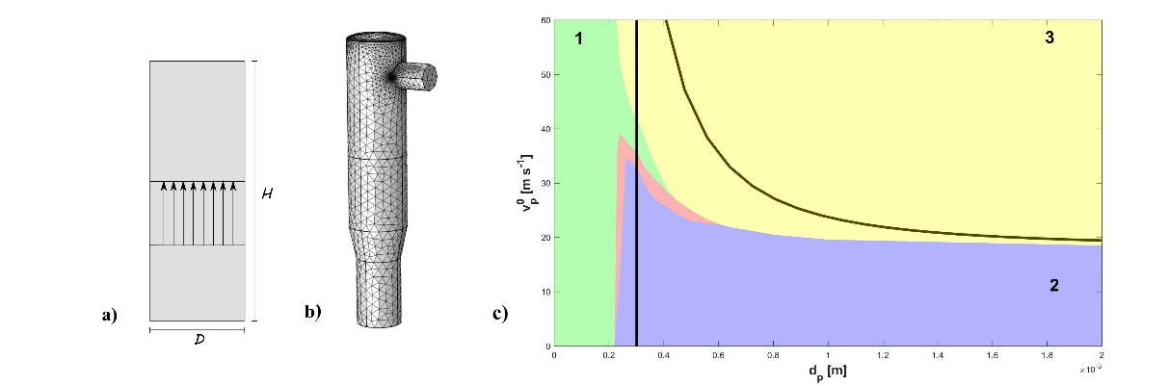
Figure 1. a) and b) Simulation domain, respectively, 2D and 3D; c) Comprehensive results representation (see text).

The analytical results show that particle density plays a less significant role compared to other parameters, so in what follows a mean particle density of 1500 kg m⁻³ has been considered.
With the analytically defined limiting conditions different particle behaviors can be recognized as a function of particle parameters (d_{p} , v_{p}⁰). In fig.1-c black lines distinguish three characteristic zones resulting from the preliminary analysis. The one on the left (1) represents particles (v_{p}^{t}>0) entrained and flowing out with the gas; on the right side (v_{p}^{t}<0), the zone below the black curve (2) represents particles falling back on the bed, while the zone above (3) represents particles whose destination is strictly related to reactor geometry. Considering all the simplifying assumptions made, the preliminary results show good agreement with those from the 3D simulation, represented by the colored areas depicted in fig.1-c. Indeed, green and violet areas represent particles with the same behavior, respectively, to those in zones (1) and (2). Further distinctions can be made for other particles, which can stick on the upper (yellow) and lateral (pink) walls of the reactor.

4. Conclusions
Comparison of the results with experimental surveys from industrial gasifier can allow an assessment of the magnitude of particle “ejection” and provide a strategy for the reduction of particle entrainment and crusts formation.
References
- Iaquaniello, G., Centi, G., Salladini, A., Palo, E., Perathoner, S. and Spadaccini, L., (2017). Bioresource Technology, 243, pp.611-619.
- Antonetti, E., Iaquaniello, G., Salladini, A., Spadaccini, L., Perathoner, S. and Centi, G., (2017) ChemSusChem, 10(5), pp.912-920.
- Scala, F. and Salatino, P., 2002. Chemical engineering science, 57(7), pp.1175-1196.

