Ionic Liquid Design and Process Simulation for Shale Gas Separation
Xinyan Liu¹, Yuqiu Chen, Xiangping Zhang², Suojiang Zhang², Xiaodong Liang¹, Rafiqul Gani³, Georgios M. Kontogeorgis^{1*}
1 Department of Chemical & Biochemical Engineering, Technical University of Denmark, DK 2800 Kgs. Lyngby, Denmark;
2 Beijing Key Laboratory of Ionic Liquids Clean Process, CAS State Key Laboratory of Green Process and Engineering, Institute of Process Engineering, Chinese Academy of Sciences, Beijing 100190, China;
3 PSE for SPEED, Skyttemosen 6, DK-3450 Allerod, Denmark
*Corresponding author: gk@kt.dtu.dk
Highlights
- A three-stage framework for IL-based shale gas separation is proposed.
- Two ILs are selected and designed based on a database and UNIFAC-IL model.
- An IL-based hybrid separation scheme for shale gas model has been designed with a potential energy-saving objective.
- IL-based gas separation has the potential to achieve a low energy consumption and economic cost.
1. Introduction
Shale gas, considered as the clean energy and a substitute for coal, has attracted increasing attention in recent years. It needs to go through a series of processing units to obtain the upgrading commercial gas. Traditional common technologies for shale gas separation include energy intensive distillation and solvent based absorption. Distillation is usually applied for light hydrocarbon gas separation in which the separated gas is recognized as an important raw gas for synthesizing many industrial chemicals. The process includes columns with large numbers of trays to get a high purity product at low temperatures and high pressures resulting in a high energy consumption and negative environmental impact. The solvent-based absorption technology is widely used for separating gases such as CO₂, H₂S which need to be removed in order to satisfy the emission standard of air pollutants. Having some advantages of non-volatility, flexible designing, ionic liquid (IL) has been paid much attention. It is reported that different ILs can be used for different gases absorption¹. Therefore, a strategy for a five-gas shale gas model separation process synthesis where both traditional distillation and IL-based absorption are employed has been developed. However, the numerous combinations of cation and anion make it a challenging task to search for the optimal one for this shale gas separation. Then selection-screening methods are proposed first. The associated process simulation and evaluation are performed.
2. Methods
In this work, we first establish an experimental database on gas solubility and Henry’s law constant in various ILs. Then database is applied for the predicted model development including corrected COSMO-RS model and UNIFAC-IL model. The activity coefficients of gas in ILs are calculated based on these predicted models so that the gas solubility in new ILs which is not included in experiments could be predicted ². A three-stage methodology proposed for the shale gas separation process design and evaluation will be highlighted. The first stage involves IL screening, where two options are applied. One is only based on the experimental database. The other is a computer-aided method which could be used to automatically obtain the optimal IL on the group contribution basis. The second stage is process design, where the important design issues are determined. Then overall separation scheme is generated. The third stage is process simulation and evaluation. Rigorous process simulation is conducted after the development and verification of related thermodynamic model. Here, a model shale gas containing five gases is assumed as a case study to highlight the application of this methodology.
3. Results and discussion
A five-component shale gas model, which consists of 80% CH₄, 7% CO₂, 7% C₂H₆, 3% C₂H₄, 3% H₂, is assumed in this work. Based on the experimental database, it’s found only CO₂ could be absorbed by IL. One optimal IL-a ([thtdp][phos]) has been selected with both high solubility of CO₂ and high selectivity of CO₂/CH₄. Besides, another IL-b ([MMPy][eFAP]) is designed based on a UNIFAC-IL model with a higher selectivity of CO₂/CH₄ than IL-a. Both these two ILs are applied for further simulation to be evaluated. Then a shale gas separation scheme is proposed including two parts: IL-based process for CO₂ removal and traditional distillation columns for other light hydrocarbon gas separation. Evaluated results for total energy consumption and economical cost are shown in Fig.1. IL-b based process gives an improved energy-based technology.
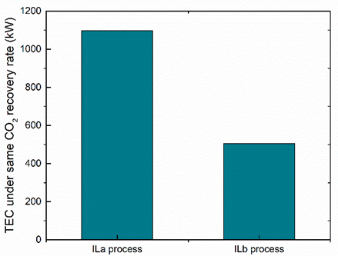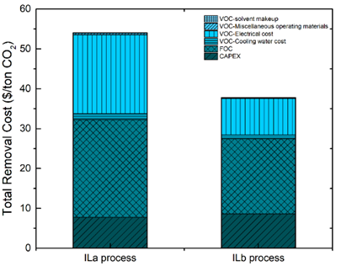
(a) (b)
Figure 1. Process evaluation on a) total energy consumption and b) total CO₂ removal rate
4. Conclusions
This work proposes a hybrid IL-based technology for shale gas separation where the IL is used to remove CO₂ and distillation is applied to obtain the desired final products. A three-stage methodology, in which systematic IL screening, process design and simulation, and process evaluation, is established. Two ILs are selected through two options. IL-b with its good separation results provides a promising recommendation for future solvent development of gas separation process. Future work would focus on further removing the hydrogen for syngas production combining with the removed CO₂ as well as separation and use of C₂H₄ and C₂H₆.
References
[1] Lei, Z., Dai, C. & Chen, B. Chem. Rev. 114, (2014) 1289–1326.
[2] Liu, X., Zhou, T., Zhang, X. et al. Chem. Eng. Sci. 192, (2018) 816–828.

