**Characterization of liquid-solid adsorption processes in recirculated differential bed (RDB) and spinning basket (SB) set-ups**

Simon Crelier1, Bryan Boisset, Rémy Dufresne, Djano Kandaswamy

*1 University of Applied Sciences and Arts Western Switzerland, CH-1950 Sion*

*\*Corresponding author: simon.crelier@hevs.ch*

**Highlights**

* RDB configuration enables an accurate control of experimental conditions
* Contrary to empirical models, mass transfer-based approaches enable a proper scaling-up of adsorption steps
* RDB configuration has been used successfully with various model systems
* SB configuration enables a more efficient liquid-solid mass transfer than RDB

**1. Introduction**

Liquid-solid adsorption is at the core of many industrial processes. The phenomenon is relatively easy to investigate at laboratory scale in a stirred vessel, but a proper design and dimensioning requires the acquisition of reliable equilibrium and kinetic data under well-mastered and characterized experimental conditions.

Similarly, the use of empirical rate laws (e.g. pseudo-2nd order, Elovich) to describe the kinetics of adsorption makes a proper scale-up of the adsorption step difficult. This is mainly because these models’ parameters are difficult to relate to those commonly used in process engineering such as mass transfer- or diffusion coefficient-related dimensionless numbers.

As a consequence very few of the promising applications that are described in the literature are developed further up to pilot scale operation, not to mention industrial implementation.

We propose here a simple approach that does not require any complex equipment, but nevertheless enables a systematic investigation of the adsorption process and a proper transfer to larger scale. It is based on the use of a recirculated differential bed such as the one described in Figure 1. This set-up allows a precise control of working conditions and an easy determination of process relevant parameters.

This approach has been successfully applied in our laboratory to various model systems. These include the adsorption of Methylene Blue or Allura Red on granulated activated charcoal (GAC), of copper ions on Amberlite IR 120, of 4-nitrophenol or cephalosporin on Amberlite XAD 16, and of BSA or IgG on chromatographic resins.

**2. Methods**

Measurements were performed at room temperature (20±1 °C). A known volume Vliq of a solution of adsorbate with an initial concentration C0 was contacted with a mass msor of sorbent.

The residual concentration of adsorbate in the liquid phase, C(t), was determined as a function of contacting time by spectrophotometry, ICP-MS or measurement of a colored complex. The corresponding adsorbed concentrations q(t) were calculated using the mass balance of Eq. 1:

$q\left(t\right)= \frac{V_{liq}}{m_{sor}}∙\left(C_{0}-C(t)\right)$ Eq. 1

**3. Results and discussion**

A short selection of results is shown here. The Recirculated Differential Bed configuration is shown on Figure 1 below. 400 mL of methylene blue solution (C0=12 mg/L) was pumped at various flow rates Qrec over a shallow fixed bed with 51.2 mg GAC (mean particle diameter 190 µm). The results are shown in Figure 2.

|  |  |
| --- | --- |
| **Figure 1.** The RDB configuration | increasing Qrec  **Figure 2.** Adsorption kinetics of MB on GAC at various flow rates |

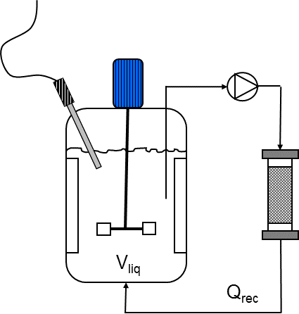External mass transfer coefficient kl was estimated from the initial slope of the C(t) kinetics curves, as described in [1]. The kl values ranged from 1.73·10-5 m/s at 2.8 ml/min to 1.18·10-4 m/s at 67 ml/min. This suggests a significant contribution of external mass transfer to the overall adsorption process, as described in [2].

External mass transfer coefficients were also measured with the spinning basket from SpinChem AB (Umeå, Sweden) during the adsorption of methylene blue (12 mg/L) on GAC (mean part. diam. 300 µm). The values of kl also increased with increasing rotation speed and they varied between 2.71·10-4 m/s at 100 rpm and 7.17·10-4 m/s at 300 rpm.

**4. Conclusions**

Although the spinning basket contactor enables to reach higher external mass transfer coefficients, the spinning rate is more difficult to relate to hydrodynamic parameters such as Reynolds number, due to a more complex flow pattern. In this respect and although less efficient, the recirculated differential bed gives a better control of operating conditions for characterization and scale-up.

**References**

1. Worch, E.: Adsorption technology in water treatment. Fundamentals, processes and modelling. De Gruyter, Berlin (2012)
2. S. H. Kim et al., Adsorption and Mass Transfer Characteristics of Metsulfuron-Methyl on Activated Carbon. Korean J. Chem. Eng. 18(2), 163-169 (2001)