Utilization of extraction methods for practical applications
Stanislav Sabata¹, Milena Rouskova¹, Ywetta Maleterova¹, Jiri Hanika¹, Olga Solcova¹, Milena Stranska²
1 Institute of Chemical Process Fundamentals of the CAS, v.v.i., Prague 6, Czech Republic;
2 University of Chemistry and Technology Prague, Prague 6, Czech Republic
*Corresponding author: sabata@icpf.cas.cz
Highlights
- Recovery of biomass components was studied.
- Extraction techniques for the isolation of valuable substances (antioxidants, carotenoids, waxes, fragrances) from plant sources was developed.
- Waste-less treatment is nowadays required for sustainable economy

1. Introduction
Bio-refining is a perspective branch that focuses on the development of separation methods for recovery of valuable substances from biomass or also for the processing of bio-waste from agriculture. The goal of the research was to propose a procedure for the waste-less treatment of plant material or the acquiring of health-beneficial substances suitable as e.g. dietary supplements.
2. Methods
Two ways of separating the monitored components from the solid matrix into a liquid solvent were tested. The first one was the extraction using Soxhlet´s apparatus, a highly efficient multistage process. The second more gentle process was a single-stage extraction in a stirred system at room temperature in an absence of light under inert atmosphere. From analytical methods mainly (U-)HPLC/MS was applied. The antioxidant activity of waste marc was determined using three methods: ABTS, DPPH and Folin-Ciocalteu.

3. Results
The aim of the study was the development of extraction technique for the isolation of carotenoids from medicinal plants (Calendula officinalis, Tagetes sp.), the separation of waxes from Miscanthus sp. stalks or the obtaining of fragrances from Magnolia × pruhoniciana blooms. From the waste biomass, the residual fresh marc after vine grapes pressing was processed to obtain resveratrol and other substances with antioxidant activity.
Raw processed biomass is shown on Figure 1.

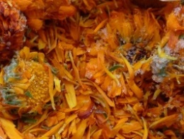 | 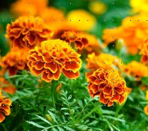  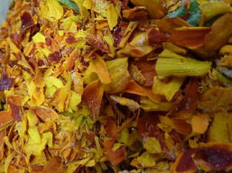 | 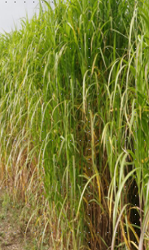 | 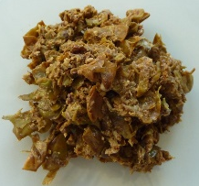  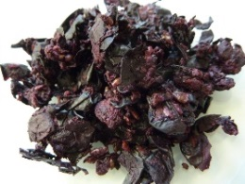 | 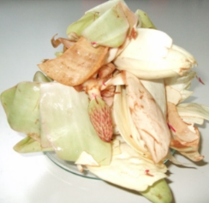
(a) | (b) | (c) | (d) | (e)

Figure 1. Processed biomass. Calendula (a), Tagetes (b), Miscanthus (c), marc of white and red grapes (d), Magnolia × pruhoniciana blooms (e).

4. Conclusions
Carotenoids, especially lutein, contained in larger quantities in Calendula and Tagetes, are used as a component of poultry feed or as a dye in food supplements. It plays an important role in human nutrition as it has antioxidant effects in neutralizing free radicals causing degenerative changes in the retina.
Tall stems of Miscanthus contain a broad spectrum of various substances being potentially exploitable in cosmetics. Waste biomass has, after being pressed into the form of pellets, the potential for energetic utilization as “green fuel”.
Wine grape marc as an agricultural waste was tested on the antioxidant activity and resveratrol content. It is a rich source of polyphenolic substances with the influence on heart and blood vessel diseases.
Fragrant essences obtained by extracting fresh flowers of Magnolia × pruhoniciana have been tested as face creams and fragrant ingredients and they could be useful for other various cosmetic products.
All processes were designed to maximize the biomass utilization with a view to waste-less eco-recovery of valuable bio-material substances.

Acknowledgement
Financial support of the Technology Agency of the Czech Republic the Competence Centre BIORAF (project No. TE01020080) and the National Competence Centre Biocirtech (project No. TN010000048) is acknowledged

