Boosting of Penicillium verruculosum cellulolytic complex with polysaccharide monooxigenase.
Ivan Zorov^{1,2*} , Aleksandra Rozhkova¹, Margarita Semenova¹, Vadim Telitsyn², Arkady Sinitsyn^{1,2}
¹ Federal Research Center «Fundamentals of Biotechnology» of the Russian Academy of Sciences, Moscow 119071, Russia; ² Department of Chemistry, M.V.Lomonosov Moscow State University, Moscow 119991, Russia
*Corresponding author: inzorov@mail.ru
Highlights
- Lytic polysaccharide monooxigenase (PMO) significantly boosts the hydrolytic activity of Penicillium verruculosum cellulases;
- New strains with optimized ratio of endoglucanases, cellobiohydrolases, β-glucosidases, and PMO were created;

1. Introduction
The use of renewable raw materials, such as agricultural by-products, is becoming increasingly important as a starting material for new biotech products. Agricultural and forestry materials, including (ligno) cellulose or starch, are first converted to sugars, which are later converted to chemicals, bioplastics, biofuels, and pharmaceuticals by fermentation [1]. Cellulose conversion occurs under the action of a complex of cellulolytic enzymes, which include exo-1,4-β-glucanase (CBH), endo-1,4-β-glucanase (EG) and β-glucosidase(BG). Cellobiohydrolases catalyze the degradation of the crystalline sections of cellulose, sequentially, by the processive mechanism, cleaving cellobiose from the ends of the polysaccharide chain. Endoglucanases catalyze the hydrolysis of amorphous sites of cellulose, splitting internal 1,4- β-glucosidic bonds by a disordered mechanism, thereby reducing the degree of substrate polymerization and creating new sites for the action of cellobiohydrolases. β-glucosidases hydrolyze cellobiose and cellooligosaccharides to the final product - glucose [2, 3]. Lytic polysaccharide monooxygenases (LPMO) catalyze oxidative cleavage of cellulose and cello-oligosaccharides. LPMOs are able to oxidise the C–H bond of the glycoside linkage connecting the sugar units in polysaccharides, which ultimately leads to cleavage of the glycoside link and hence boost generation of fermentable sugars. These enzymes are secreted by various fungal strains and are important components of enzyme cocktails used for industrial biomass conversion [4,5]. Improvement of the properties of new enzyme coctails and fine tuning of biocatalytical processes of cellulose-to-biofuels can lead to ecologically friendly and cost-efficient alternatives to fossil-based technologies.
LPMO from Penicillium verruculosum was overexpressed in the same fungal strain. The LPMO enzyme preparations with the “basal” cellulolytic enzyme complex, which contains EGs, CBHs, and bG were produced. The yield of fermentable sugars was 45 and 30% higher in microcrystalline cellulose (MCC) and pretreated aspen wood (AW) hydrolysis for some preparations.
2. Methods
LPMO was overexpressed in Penicillium verruculosum fungal strain; the number of strains, carrying 5-67% of LPMO were produced. Saccharification of MCC and AW (100 g/l in the reaction mixture) was performed under the action of basal cellulase enzymatic complex (CEC) and CEC+LPMO, normalized by protein to 5 mg/g of substrate or 0.5 mg/ml in the reaction mixture. The reaction conditions: 50mM sodium acetate pH 5.0, 40ºC, 5mM of gallic acid was added as an electron donor for LPMO. Samples for reducing sugars and glucose assay were taken after 6, 24, and 48 hours of hydrolysis.
3. Results and discussion
MCC and AW was efficiently hydrolyzed by Penicillium verruculosum enzyme preparations with 5-12% of cloned LPMO, while the efficiency decreases dramatically for preparations with higher content of LPMO (Fig. 1). The yield of reducing sugars was ~10% higher in case of AW to compare to MCC. The yield of glucose was also higher with LPMO-enriched enzyme preparations, while the xylose yield remains approximately the same.
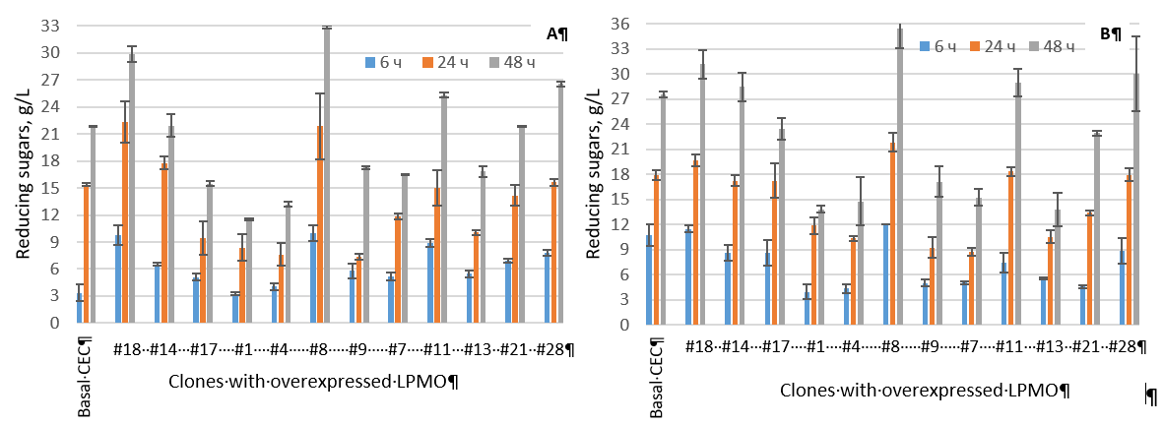
Figure 1. Reducing sugars release after 6, 24, and 48 hours hydrolysis of microcrystalline cellulose (A) and pretreated aspen wood (B) by different LPMO-enriched enzyme preparations. Substrate concentration 100 g/L, protein concentration 5 mg/g of substrate, 40 ^{о}С, рН 5,0.
4. Conclusions
New high productive Penicillium fungal strains with overexpression of LPMO were developed. The yield of reducing sugars as well as glucose were up to 45% higher for enzyme preparations with 5-12% of LPMO to compare to Penicillium basal cellulase enzyme complex. The level of total reducing sugars was approx. 10% higher in case of pretreated aspen wood hydrolysis to compare to microcrystalline cellulose. The content of LPMO does not affect much the level of xylose release in case of aspen wood.
Acknowledgments: the project is supported by Russian Fond of Basic Research, #18-54-80027\18
References
[1] R. Kumar, S.Singh, O.V.Singh, J. Industrial Microbiol.Biotechnol. 35 (2008) 377-391.
[2] S.T.Merino, J.Cherry, Adv. Biochem Eng/Biotechnology 108 (2007) 95-120.
[3] R.E.H. Sims, W.Mabee, J.N.Saddler, M.Taylor, Bioresource Technology 101 (2010) 1570-1580.
[4] M.A.S. Kadowaki, A. Várnai, J-K. Jameson, A.E.T. Leite et al., PLoS ONE 13(2018): e0202148. https://doi.org/10.1371/journal.pone.0202148
[5] E.D. Hedegård, U. Rydea, Chem Sci. (2018) 9(15) 3866–3880.

