CO₂ solubility on ionic liquid + tetraglyme mixtures.
D. Hospital-Benito*, J. Lemus, R. Santiago, J. Palomar
Chemical Engineering Department. Universidad Autónoma de Madrid. 28049, Madrid, Spain
*Corresponding author: daniel.hospital@uam.es
Highlights
- Ionic liquids (ILs) with chemical absorption show outstanding results for CO₂ capture application.
- Tetraglyme (TGM) is an effective additive in reducing ILs viscosity that also has a high CO₂ solubility.
- TGM/IL mixtures were found to be suitable for CO₂ capture application.

1. Introduction
The study of carbon dioxide (CO₂) solubility in different composition mixtures of ionic liquid (IL) and tetraglyme solvent (TGM) is interesting for the development of carbon capture and storage technologies ^{[1]}. In the present work, it was used four kind of ionic liquids, with different chemical and physical properties, implying different kinetic and thermodynamic results ^{[2]}. The ILs used in this study were two with chemical absorption by CO₂, such as [Bmim][Acetate] and [P66614][CNPyr], and two others with physical CO2 absorption, [Bmim][TCM] and [Bmim][MeSO₄].
2. Methods
The experiments were carried out using a high pressure termobalance that let us obtain high-pressure solubility of CO₂ in a wide range of TGM/IL mixtures (from 0 to 90 wt% TGM), measured at 303 K and at different pressures, from 1 up to 20 bar. The CO₂ capture performance of all composition mixtures of IL and TGM was evaluated using Aspen Plus commercial process simulator. To model the absorption operation in Aspen Plus using the ILs with chemical absorption by CO₂, a multiscale COSMO-based methodology developed in our group was used to include them into the simulator database. [Bmim][TCM] and [Bmim][MeSO₄] are contained in ILAUM database ^{[4]} and TGM and its COSMOSAC parameters are already included in Aspen Plus by default. The absorption column was simulated as a packed column using the RAD-FRAC rigorous model in Rate-Based mode. The solvent mass flow needed to achieve a capture rate of 90% was calculated.
3. Results and discussion
Tetraglyme as co-solvent improves the mass transfer kinetics by reducing viscosity and enhances CO₂ physical absorption. Promising TGM/IL mixtures were found using ILs with chemical absorption because of their high CO₂ solubility compared with TGM, so minimum solvent needs can be achieved as can be seen in Figure 1. Otherwise, ILs with physical CO₂ absorption due to their lower CO₂ solubility are useful at high operating pressures so do not seem a good alternative to TGM.
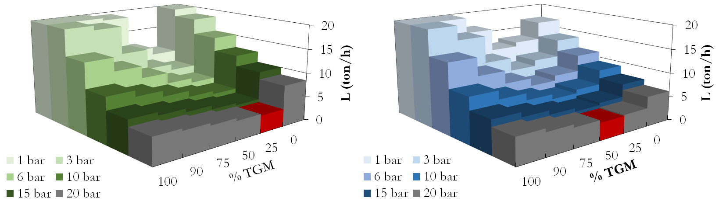
Figure 1. Solvent flow needed to reach a 90% CO2 captured rate by the solvent as a
function of the CO2 partial pressure and compositions mixtures IL/TGM calculated by Rate-based RADFRAC model using [P66614][CNPyr] (left) and [Bmim][Acetate] (right).
4. Conclusions
It can be concluded that although ILs with chemical absorption show outstanding results for CO₂ capture application, their relatively high viscosity presents a challenge for the mass transfer properties ^{[3]}. In this sense, this work shows that TGM, which has a relatively low vapor pressure at temperatures of interest for these applications, is an effective additive in reducing viscosity of the IL tested, improving drastically the kinetic of the process, without high weakening of the absorption capacity. In the case of ionic liquids with physical absorption, they present low solubility compared with TGM and they have to be used at high operating pressures.
References
[1] (Journal) Amaral M, Crespo EA, Dariva C, Vega LF, Carvalho PJ, Coutinho JAP. High-pressure solubility of CO2 in glymes. Chemical Society Reviews. 2018; 219:120-125.
[2] (Journal) Santiago R, Lemus J, Moreno D, Moya C, Larriba M, Alonso-Morales N, Gilarranz MA, Rodríguez JJ, Palomar J. From kinetics to equilibrium control in CO2 capture columns using Encapsulated Ionic Liquids (ENILs). Chem Eng. J. 2018; 348:661-666.
[3] (Journal) Fillion JJ, Bennett JE, Brennecke JF. The Viscosity and Density of Ionic Liquid + tetraglyme Mixtures and the Effect of Tetraglyme on CO2 Solubility. J. Chem. Eng. Data 2017;62:608−622.
[4] (Journal) Ferro V. R, Moya C, Moreno D, Santiago R, de Riva J, Pedrosa G, Larriba M, Diaz I, Palomar J. Enterprise Ionic Liquids Database (ILUAM) for Use in Aspen ONE Programs Suite with COSMO-Based Property Methods. Ind. Eng. Chem. Res. 2018; 57, 3:980-989.

