**High performance and repeated use of immobilized phospholipase A1 for hydrolysis of phospholipid involved with hydrophobicity of reaction media**

Yusuke Hayakawa1, Ryoichi Nakayama2*, Norikazu Namiki2, Masanao Imai1

*1 Course in Bioresource Utilization Sciences, Graduate School of Bioresource Sciences, Nihon University, 　1866 Kameino, Fujisawa, Kanagawa, 252-0880, JAPAN*

*2 Department of Environmental Chemistry & Chemical Engineering, School of Advanced Engineering, Kogakuin University, 2665-1 Nakano-machi, Hachioji, Tokyo, 192-0015, JAPAN*

*\*Corresponding author: bionakayama.ryo@cc.kogakuin.ac.jp*

***Highlights***

* Immobilized phospholipase A1 was successfully prepared.
* Reaction rate increased by glutaraldehyde treatment.
* Repeated use of immobilized phospholipase A1 was successfully appeared.

**1. Introduction**

Immobilized enzyme has been expected to industrial applications. Immobilized enzyme effectively enables to separate the enzyme from products, thus facilitating its recovery and repeated use. A hydrophobic material is most favorable to easy diffusion of substrate in inner pore of carrier in order to quick initiation of hydrophobic enzymatic reaction. Recently, hydrophobic materials, primarily a polypropylene porous commercial carrier called Accurel, has been proposed for lipid [1]. In this study, we focused on hydrophobic porous carrier on reactivity of immobilized phospholipase A1 progressing toward higher reaction rate and high yield in repeated use.

**2. Methods**

**2.1 Phospholipase A1 immobilization method**

Accurel MP 100 (Membrana GmbH, Germany) (Figure 1 and 2) was immersed in ethanol (99.5 v/v%) for 60min. And then, the Accurel carrier was placed into the PLA1 solution and then shaken to adsorbed PLA1 for 24h at 298K.

Next, the dried Accurel carrier with the adsorbed PLA1 was shaken in Glutaraldehyde (GA) solution (1.5~6 v/v%) for 60 min at 298 K. The desorbed amount of PLA1 in the GA solution was the measured. The immobilized PLA1 carrier was briefly washed in distilled water.

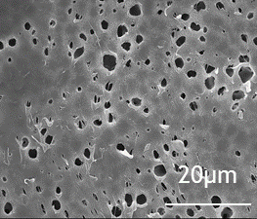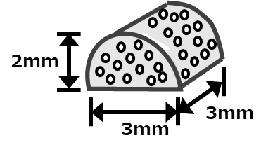

**Figure 1.** Schematic illustration of Accurel MP100. **Figure 2.** SEM image of Accurel surface.

**2.2 Hydrolysis of phospholipid using immobilized PLA1 in Accurel carrier**

Phospholipid (from soybean) was dissolved into the organic phase composed of 1-butanol/isooctane. The substrate solution (50mL) was placed in a glass vessel. And then, the substrate solution containing acetate buffer solution (pH5.0) were stirred magnetically for 10min in a water bath (313K). The reaction was initiated when the immobilized PLA1 on Accurel carrier was added to the W/O microemulsion phase. After the reaction was initiated, 0.2 mL of the sample was taken at the desired time in the reaction period. The concentration of produced fatty acid (palmitic acid) was determined by the Lowry-Tinsley colorimetric method [2].

**3. Results and discussion**

Figure 3 shows the effect of GA treatment on the initial reaction rate (Vi). The Vi increased with increasing GA concentration. Cross-linking of PLA1 by GA was very beneficial for attaining a higher reaction rate.

Figure 4 shows the time course of production of palmitic acid for the repeated use of immobilized PLA1. Repeated use of immobilized PLA1 was successfully appeared without lag time and preserved sufficiently high reaction yield until 2nd run. The activity site of immobilized PLA1 was not damaged after repeated processing.

 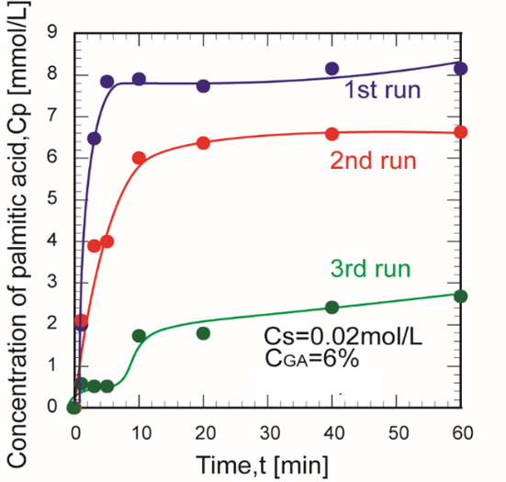

**Figure 3.** Effect of GA concentration on the Vi. **Figure 4.** Time course of production for the repeated use of immobilized PLA1.

**4. Conclusions**

High yield immobilization of phospholipase A1 and quick initiation of hydrolysis of phospholipid. Immobilized PLA1 was prepared using porous polypropylene carrier (Accurel MP100). Repeated used of immobilized PLA1 was attractively performed and stable. Accurel is expected to hydrophobic friendly phospholipase carrier progressing toward higher reaction rete and high yield in repeated use.

**References**

1. M. Naya, M. Imai, Asia-Pac. J. Chem. Eng. 7 (2012) S157-S165.
2. R.R. Lowry, I.J. Tinsley, J. Am. Oil Chem. Soc. 53 (1976) 470-472.