Wastewater Treatment Optimization of Nitration of Aromatics
Ákos Korbács¹, Alexandra Jakab-Nácsa¹, Károly Fodor¹, Árpád Markó¹, Nan Zhao¹
1 BorsodChem Ltd., Bolyai tér 1, H-3700 Kazincbarcika, Hungary
*Corresponding author: akos.korbacs@borsodchem.eu
Highlights
- Extraction, optimal extracting agent – Laboratory & ChemCAD simulations.
- Distillation, energy demands calculations – Laboratory & ChemCAD simulations.
- Pretreatment of waste water – Reaction & Chemical quantity optimization.
- Green chemistry – viewpoints and goals.

1. Introduction
Whether an aromatic chemical is nitrated via mixed acid processes [1] the nitrated products are washed with acidic, neutral and alkaline waters in order to purify them. Almost all water soluble side products will be dissolved from the products and will appear in the water phase in form of its salts [2].
The waste waters will have also products dissolved, which are unfavorable thus extraction is carried out. Product specific extraction is needed thus undesirable chemicals would not be extracted back. Optimization of extraction is a main target of our experiments, so intermediates and starting materials were tested to measure its capacity and selectivity.
2. Methods
First the technology and possibilities was checked. Alternative chemicals were measured, data were put into ChemCAD. After the data refresh, simulations were carried out [Figure 1]. Optimal solutions were tested in laboratory; results were measured by various analytical methods, HPLC, GC, UV-VIS and FTIR [3].
Energy optimizations and toxicity measurements were tested in ChemCAD and laboratory plant seed tests respectively.
3. Results and discussion
More comparison happened with the extracted waste waters, which was focused on alkaline washing water which is the richest in side-products. The main key factors were the distillation possibilities of the extracting agent, and the pre-treatment investigation related with Fenton oxidation.
Green chemistry factors were checked and examined, and we can say, with optimal extraction agent 60 wt% more products can be extracted from the waste water, which would be more pure because of better selectivity. The distillation energy needs is 80% less for the optimal extracting agent [4]. The pre-treatment requires 30 wt% less oxidation agent, and the total nitrate amount would decrease by 25 wt% in the alkaline waste water [5]. The toxicity of the waste water is reduced by 20% [5].
Fenton oxidation catalyst optimization might cause also reduced amount of waste iron catalyst in the pre-treatment system.

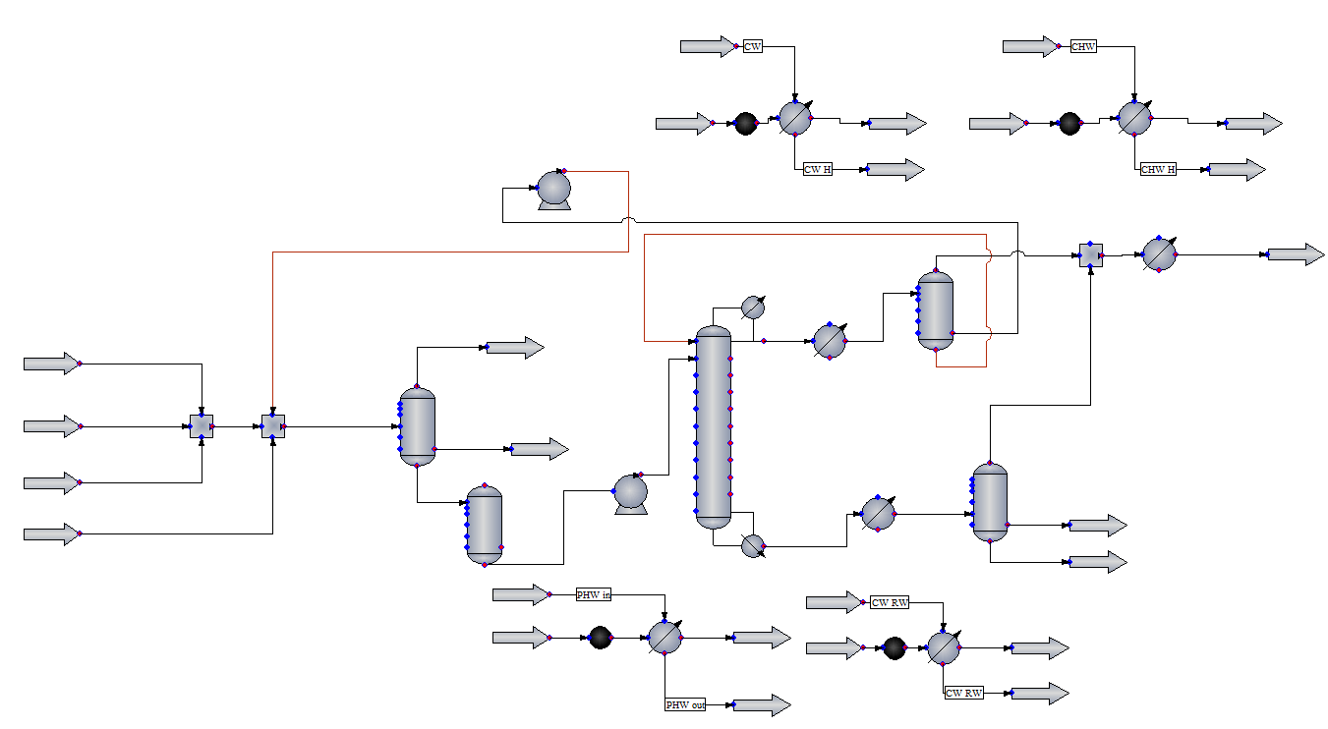
Figure 1. Simulations were set up in ChemCAD environment.
4. Conclusions
When choosing a good extracting agent, it is really important to follow the steams until it is disposed or treated in biological systems. Choosing the best can be difficult, but whether the data are correct that people have, it is recommended to calculate, measure and upscale if possible, before applying one technology. By using computational methods and simulations, cost reduction can appear, it makes easier to find the optimal chemical processes.
References
- W. J. Mazzafro, S. I. Clarke, M. S. Simpson, and R. Van Court Carr, “Weak acid process for producing dinitrotoluene - EP 0 903 336 B1,” 2003.
- D. J. L. Prak and D. W. O. Sullivan, “Solubility of 4-Nitrotoluene, 2,6-Dinitrotoluene, 2,3-Dinitrotoluene, and 1,3,5-Trinitrobenzene in Pure Water and Seawater,” J. Chem. Eng., pp. 2446–2450, 2007.
- F. Fiedler, H.-J. Schöbel, and M. Otto, “Identification of Nitrogen Compounds from Degradation of Dinitrotoluene and Toluylenediamine Isomers Within an Industrial Purification Plant,” Microchim. Acta, vol. 135, no. 1–2, pp. 1–7, 2000.
- Á. Korbács, B. R. Zsanett, A. Rodriguez, and L. Farkas, “Reducing of DNT Content in Red Water Formed During TDI Production,” Mater. Sci. Eng., vol. 43, no. 1, pp. 71–78, 2018.
- Á. Korbács, É. Szabó, Á. Markó, K. Fodor, and L. Farkas, “Development option for industrial waste water treatment at BorsodChem Ltd. TDI plant in order to decrease the nitrate anion concentration,” in 24th International Conference on Chemistry, PhD Student Plenary Presentations, Applied and Chemical Engineering Section, 2018.

