**Zeolitic imidazole frameworks-8 derived ZnO/carbon nanocubes: a broad-spectrum solid-phase microextraction coating**

Xingru Hu, Jiansheng Li *

*Key Laboratory of Jiangsu Province for Chemical Pollution Control and Resources Reuse, School of Environment and Biological Engineering, Nanjing University of Science and Technology, Nanjing 210094, China.*

*\*Corresponding author: lijsh@njust.edu.cn*

**Highlights**

* ZIF-8 derived ZnO/C was prepared and used as adsorbent for SPME.
* The dispersed composition endows ZnO/C with broad-spectrum extraction capability.
* The double-shelled hollow structure is beneficial for the sensitive extraction.
* The resultant fiber is applied for the determination of the analytes from water samples.

**1. Introduction**

Development of high-efficient determination of the environmental pollutants is of great significance. [1] Solid phase microextraction (SPME), as a solvent-free extraction method, is very widely used for the sensitive detection of emerging pollutants.[2] The properties of the coating materials generally determine the extraction performance.[3] It is thus a marked research interest in developing a kind of SPME fiber coating that can provide sensitive extraction capability for broad-spectrum analytes from the complex samples. Recently, metal-organic frameworks (MOF) has been considered as the promising precursor to synthesize functional materials directly by high-temperature pyrolysis.[4] In order to broaden the utilization and improve the performance of the MOFs-derived materials, hollow structure with abundant active sites has been designed and fabricated.[5] Encouragingly, the MOF-derived double-shelled hollow materials seems to be a potential choice for the broad-spectrum and sensitive SPME of the environmental pollutants. In this study, we develop a SPME fiber based on zeolitic imidazole frameworks-8 (ZIF-8)-derived double-shelled hollow ZnO/carbon (ZnO/C) materials. The ZnO/C coated fiber is used to investigate its simultaneous extraction ability for polar and nonpolar compounds. The highly synergistic effect of carbon networks and ZnO crystals leads to the broad-spectrum extraction of the ZnO/C-F. Moreover, the double-shelled hollow structure improves the sensitive extraction for the analysts.

**2. Methods**

The ZIF-8 nanocubes were first prepared by mixing the HMI, Zn(NO3)2•6H2O and CTAB. After tannic acid etching treatment, these nanocubes could be converted into double-shelled hollow structure. Then the DSH-ZIF-8 experienced a thermal annealing at 500 oC to synthesis the ZnO/C. Finally, the resultant ZnO/C was directly coated on the SSW by the glue method to form the SPME fiber.

**3. Results and discussion**

As shown in Fig. 1a, the morphology of ZnO/C is kept after carbonization. Besides, the broken particle (inset in Fig. 1a) suggests the presence of the double-shelled structure. From TEM characterization (Fig. 1b,c), the void space and structure can be clearly testified. Obvious lattice fringes with an spacing of 0.25 nm in the high-resolution TEM image (Fig. 1d) and bright diffraction rings in SAED pattern (Fig. 1d inset) have been observed for the ZnO/C, corresponding well to the (101) planes of ZnO. The elemental mapping data presented in Fig. 1e reveals that the C, O and Zn elements are distributed uniformly on the particle. As shown in Fig. 1g, the sharp peaks of ZnO/C show the typical structure for ZnO crystal phase, which is consistent with the SAED pattern.

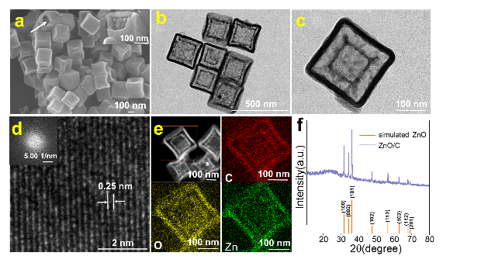

**Figure 1**. (a)SEM image, TEM images at low (b) and high (c) magnification, (d) high-resolution TEM image (inset: SAED pattern), (e) elemental mapping showing C, O and Zn of ZnO/C. (f) XRD patterns of simulated ZnO and ZnO/C.

To evaluate the extraction performance, ZnO/C-F was compared with the commercial PDMS/DVB fiber, which has been proved for SPME of both nonpolar and polar compounds. The ZnO/C-F displays a prominent advantage in extracting both the BTEX and CPs (Figure 2). The excellent performance could attribute to the combined effect of the ZnO/carbon composition and double-shelled hollow structure.



**Figure 2**. Peak areas comparison of ZnO/C-F with S-ZnO/C-F and commercial PDMS/DVB fiber.

**4. Conclusions**

In conclusion, the MOF-derived double-shelled hollow ZnO/C materials have been prepared. Then they were coated on the surface of a stainless steel wire to form the SPME fiber. Compared with the commercial fiber, ZnO/C-F displayed superior extraction efficiency owe to the combined effect of the ZnO/C composition and double-shelled hollow structure.

**References [Calibri 10]**

1. E. Y. Zeng, J. A. Noblet. Environ. Sci. Technol. 36 (2002) 3385-3392.
2. É. A. Souza-Silva, R. Jiang, Gionfriddo, J. Pawliszyn. TrAC Trends Anal. Chem.71 (2015) 224-235.
3. F. Wang, J. Zheng, J. Qiu, S. Liu, G. Chen, G. Ouyang. ACS Appl. Mater. Interfaces 9 (2017) 1840-1846.
4. H. B. Wu, B. Y. Xia, L. Yu, X. Yu, X. W. Lou. Nat. Commun, 6 (2015) 6512.
5. L. Zhang, L. Shi, L. Huang, J. Zhang, R. Gao, D. Zhang. ACS Catal., 4 (2014) 1753-1763.