Impact of variation of rheological properties on pressure drop calculation
Ehsan Farno¹, Nicky Eshtiaghi^{1,*}
1 Chemical and Environmental Engineering, School of Engineering, RMIT University, VIC, 3000, Australia
*Corresponding author: nicky.eshtiaghi@rmit.edu.au
Highlights
- Impact of variation of rheological properties on pressure drop calculation
- Adopted Re3 friction loss model from mineral industries into sewage sludge

1. Introduction
Wastewater treatment is an integral part of the sustainable development of modern cities. Factors such as population growth, water shortage and stricter environmental regulations demand a considerable increase in increasing the capacity of treatment plants as well as improving its efficiency [1].
A large portion of the total energy consumption in wastewater treatment plants is used for pumping wastewater sludge within the treatment processes [2]. Although the energy usage of the sludge transportation systems is critically important, pumping systems are not commonly operating in their best efficiency points. By improving the pumping systems, better energy efficiency of treatment processes can be achieved. Several reasons underlies the inefficient operation of sludge pumping systems. One of them is the variation of sludge rheology which sometimes can be an order of magnitude difference. It is vitally important to identify the impact of rheological variations on the variation in pressure drop of sludge pipeline to be designed. This is even more important for concentrated sludge as it is highly non-Newtonian and, because of that, the pressure drop is more sensitive to the variation of rheological parameters. This paper investigates the impact of variation of sludge rheology on the calculation of pressure drop for highly concentrated sludge pipeline.
2. Methods
Digested sludge was collected at the concertation of about 2% from Eastern Treatment Plant, Melbourne over one year. Sludge was concentrated to 4% and 5.5% using vacuum filtrations process. Samples flow curve was measured using controlled-stress rheometer equipped with a cup-and-bob (with 1 mm gap) and a vane-and-rough cup (with 8 mm gap) geometries for dilute and concentrated sludge, respectively. Flow curve was fitted with the Herschel-Bulkley model using the robust least-squares method of MATLAB.
3. Results and discussion
Figure 1.a depicts the variation in rheological parameters of sludge over the measurement period. And Figure 1.b shows the variation in calculated pressure drop for a typical sludge pipeline resulted from the variation of rheological parameters.
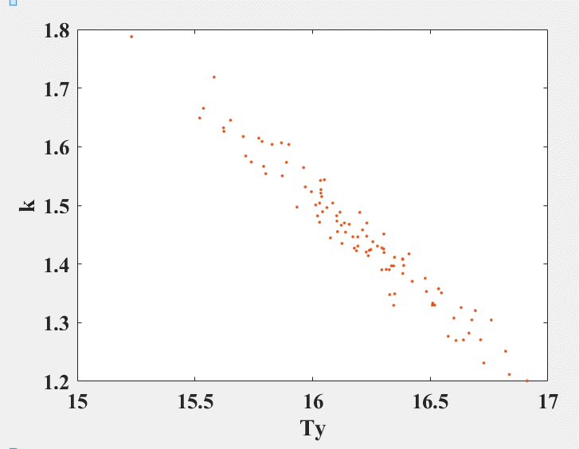
µ = 2.48×10⁵
σ = 190
Figure 1. (a) Variation in rheological parameters of sludge (b) variation in calculated pressure drop

Table 1 presents a sensitivity analysis of the pressure drop calculation procedure in respect to variation in the model parameters. As shown in Table 1 [3], pressure drops were mostly correlated to the variation of k while variation in τ_{H} was the least influential factor on the calculated pressure drop.
Table 1. sensitivity analysis of pressure drop calculation procedure
Model parameter | τ_{H} | k | n
Sensitivity | 5% | 60% | 33%

Table 2 shows variations of pressure drop as a results of increasing solid concentration. This is almost four times when solid content of sludge increases from 2.3% to 4% and it is doubled for increase of solid content from 4% to 5.5%. Besides, the flow regime will change from turbulent to laminar as Reynolds number drops to below 1600 and 800 for 4% and 5.5% digested sludge, respectively.
Table 2. variation in calculated pressure drop [kPa] for the nominated pipeline
TS | 24.6 L/s | 40.8 L/s | Reynolds₃*
2.3% | 263 ±50 | 263 ±50 | 8500 - 20000
4% | 1041 ±80 | 1041 ±80 | 300 - 1600
5.5% | 1914 ±100 | 2034 ±100 | 150 - 800
4. Conclusions
Results compare the variation in the calculated pressure drop between different sludge concentrations. This study shows that a small variation in rheological parameters of concentrated sludge creates large variations in pressure drop calculation. This variation needs to be considered for the accurate design of sludge pipelines.
References [Calibri 10]
- Munro-Smith, H. (2018). IBISWorld Industry Report Waste Treatment and Disposal Services in Australia.
- Longo, S., B. M. d’Antoni, M. Bongards, A. Chaparro, A. Cronrath, F. Fatone, J. M. Lema, M. Mauricio-Iglesias, A. Soares and A. Hospido (2016). "Monitoring and diagnosis of energy consumption in wastewater treatment plants. A state of the art and proposals for improvement." Applied Energy 179: 1251-1268.
- Farno, E., K. Coventry, P. Slatter and N. Eshtiaghi (2018). "Role of regression analysis and variation of rheological data in calculation of pressure drop for sludge pipelines." Water Research 137: 1-8.

