Numerical Investigation of the Shear-Induced Hetero-Aggregation of Oppositely Charged Particles.
Graziano Frungieri¹, Matthäus Bäbler², Marco Vanni¹
¹ Dept of Applied Science and Technology, Politecnico di Torino, Corso Duca degli Abruzzi 24, Torino;
² Dept of Chemical Engineering and Technology, KTH Royal Institute of Technology, Teknikringen 42, Stockholm, Sweden
*Corresponding author: graziano.frungieri@polito.it
Highlights
- Modelling of hetero-aggregation by a Monte Carlo – Discrete Element Method.
- Size stabilization by hetero-aggregation.

1. Introduction
Over the last decades much research has been devoted to the study of the aggregation of identical particles (homo-aggregation), but little is known about hetero-aggregation, i.e. the aggregation occurring in systems in which dispersed particles differ in one or more characteristics. The present work aims to simulate the shear-induced aggregation process occurring in a dilute suspension where particles with opposite surface charges are dispersed.
2. Methods
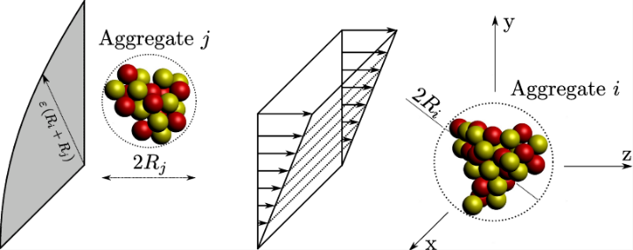
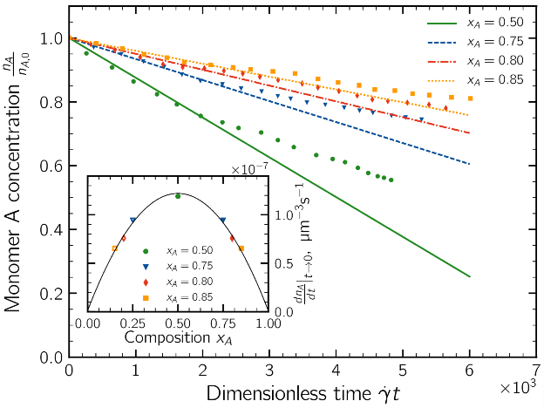
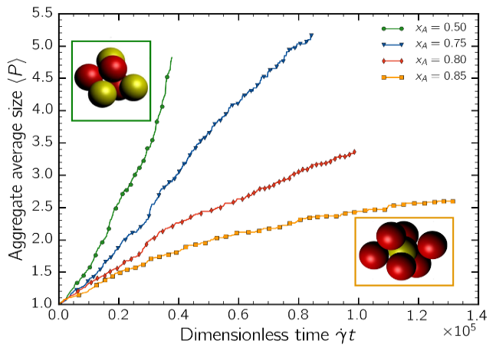
We studied the shear-induced aggregation process occurring in aqueous dilute suspensions of spherical polystyrene particles, with 500 nm radius. Particles bearing opposite surface charges with low surface potentials (±40 mV) and surrounded by a thin electrical double layer (10 nm) are considered. A relatively mild shear rate is assumed to act on the suspension (10 s⁻¹). For this set of parameters, only aggregation between unlike particles can occur. In dilute conditions, it is reasonable to reduce the aggregation dynamics to a sequence of binary aggregation events i.e., events which involve two aggregates at a time. Based on this assumption, we developed a mixed stochastic-deterministic method built on a combination of a Monte Carlo (MC) algorithm and a Discrete Element Method (DEM), built in the framework of Stokesian Dynamics. Based on the flow and population statistics, the MC is used to sample a statistically expected sequence of encounter events, whereas the DEM is used to simulate in detail each aggregation event [1]. Figure 1 represents the typical initial setup of a DEM simulation.
Figure 1. Typical initial setup of an aggregation event in shear flow. The DEM tracks the trajectory of each primary particles

Figure 2. Aggregation kinetics for four different values of the population composition, expressed in terms of number fraction of cationic particles x_{A}. a) Temporal trend of the concentration of cationic particles. The inset report the dimer formation rate. b) Temporal trend of the aggregate average size, in terms of number of constituent primary particles. The insets show two small sample aggregates (red particles are the majority particles)

a)
b)
3. Results and discussion
Simulations were performed to ascertain the effect of the suspension composition, in terms of relative concentration of cationic (A) and anionic (B) particles, on both aggregation kinetics and aggregate morphology. Figure 2a reports the temporal trend of the concentration of cationic primary particles in the early stage of the process; as apparent the rate of disappearance is strongly affected by the population composition: when cationic and anionic particles are present in an equal amount (x_{A}=0.5) the aggregation is fast. As the composition parameter increases, the aggregation rate slows down. This effect is made more apparent in the inset of Figure 2a, where the rate of dimer formation is plotted together with the theoretical expected one. The late stage dynamics is also remarkably affected by the population composition. Figure 2b reports the aggregate average size as a function of time. In the symmetric system, the growth dynamics shows a self-accelerating behavior, with aggregates that soon reach large size. As the population is enriched in majority particles, the aggregation slows down and for concentration around 85% the aggregation rate progressively reduces in time, until a size stabilization takes place. Stable aggregates with a core-shell structure appear; such aggregates are seen to be formed by a core, in which the particles of the two classes are both present and by an external shell fully covered by majority particles, which provide a shielding effect against further growth.
4. Conclusions
The hetero-aggregation of oppositely charged particles is studied in the present work. Results reveal that in such systems a size stabilization effect should be expected when a large concentration disproportion between the two classes of particle is present.
References
- G. Frungieri, M. Vanni, Can. J. Chem. Eng. J. 95 (2017) 1768-1780.

