Single cell mass spectrometry:
Measuring productivities of microbes, one cell at a time
Christian Dusny^{1,}*, Martin Schirmer¹ and Andreas Schmid¹
1 Helmholtz-Centre for Environmental Research, UFZ, Leipzig – Permoserstr. 15, 04318 Leipzig
*Corresponding author: christian.dusny@ufz.de
Highlights
- Quantitative and label-free analysis of single, living microbial cells via MS
- Determination of uptake and production rates of single cells

1. Introduction
Microbial cells can be used as biocatalysts for complex syntheses of chemicals and energy carriers at physiological conditions and with high efficiency. Although microbial cells have been applied for thousands of years for the production of value-added compounds, there is still little quantitative knowledge about the contribution of the minimal catalytic unit, the single cell, to the macroscopic output of bioprocesses.¹ Up to now, mainly optical analyses have been applied for disclosing a remarkable heterogeneity in cellular features like gene expression, regulatory mechanisms or growth.^{2,3} However, absolute numbers on uptake and production rates in single cells are inexistent.⁴
We demonstrate how the label-free quantification of catalytic performance in single cells can be
2. Methods
We applied chip-coupled microfluidics (negative dielectrophoresis cell traps and microdroplets) for analyzing the production of L-lysine by Corynebacterium glutamicum via mass spectrometry.
3. Results and discussion
achieved with chip-coupled mass spectrometry.⁵ The presented approaches are capable of directly resolving catalytic heterogeneities. This knowledge is key for understanding and improving the efficiency of bioprocesses.
With microfluidic cultivation formats, such as the Envirostat or microdroplets, single cells are isolated and trapped under defined extracellular reaction conditions.⁶ By interfacing microfluidic reactor formats with high-sensitivity mass spectrometry, the quantitative analysis of molecules produced by single cells is now possible for the first time. The concept is demonstrated with L-lysine-producing single cells of Corynebacterium glutamicum.
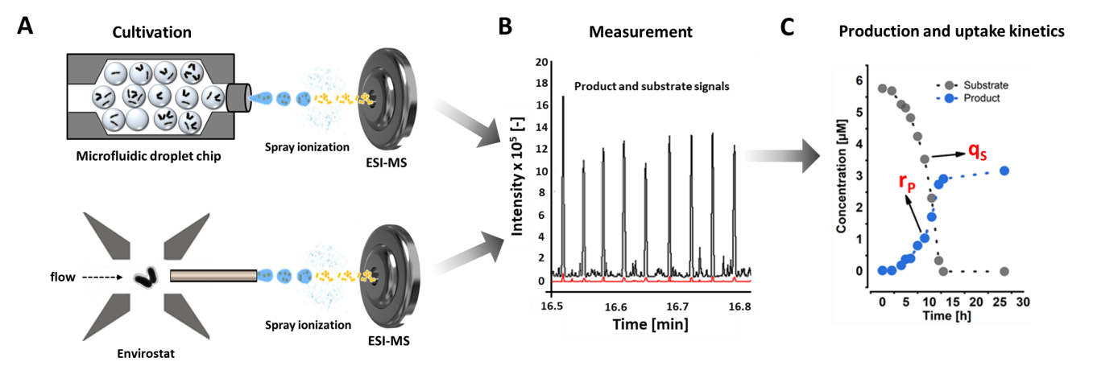
Figure 1. Cultivation and measurement of substrate and product concentrations in microfluidic cultivation setups. A) On-chip cell encapsulation in droplets and deterministic trapping of single cells and small co-cultures with the Envirostat. The analytes in the aqueous medium are ionized via ESI and transferred to the MS. B) Substrate and product concentrations are quantified with isotopically-labelled standards spiked the cultivation media. C) From the uptake and production profiles, production kinetics r_{P} and uptake kinetics q_{S} of single cells and small populations are determined.
4. Conclusions
Our approach enables the characterization of the catalytic structure of microbial populations based on single cell activity data and opens the door towards novel approaches for population modeling and improving biocatalytic processes.
References

[1] K. Rosenthal; V. Oehling; C. Dusny; A. Schmid, FEMS Microbiol. Rev. 2017, 41 (6), 751-780.
[2.] F. Delvigne; P. Goffin, Biotechnol. J. 2014, 9 (1), 61-72.
[3] S. Muller; H. Harms; T. Bley, Curr. Opin. Biotechnol. 2010, 21 (1), 100-13.
[4] P. Hammar; S. A. Angermayr; S. L. Sjostrom; J. van der Meer; K. J. Hellingwerf; E. P. Hudson; H. N. Joensson, Biotechnol. Biofuels. 2015, 8, 193.
[5] C. Dusny; M. Lohse; T. Reemtsma; A. Schmid; O. J. Lechtenfeld, Anal. Chem. 2019.
[6] K. Rosenthal; F. Falke; O. Frick; C. Dusny; A. Schmid, Micromachines 2015, 6 (12), 1836-1855.

