Effect of flow regimes on reaction yield in a T-shaped micro-reactor.
Matteo Antonelli, Alessandro Mariotti, Chiara Galletti, Maria Vittoria Salvetti, Roberto Mauri, Elisabetta Brunazzi*
Dipartimento di Ingegneria Civile e Industriale, Università di Pisa, Largo L. Lazzarino 2, 56122 Pisa, Italy
*Corresponding author: elisabetta.brunazzi@unipi.it
Highlights
- Experimental and numerical reaction yields in a T-shaped micro-reactor.
- Reaction yield depends on both Reynolds number, Re, and Damköler number, Da.
- With segregated flow regimes, the reaction yield decreases with increasing Re.
- In the engulfment regime, the reaction yield increases with increasing Re.

1. Introduction
Micro-devices, constituted by channels with typical dimensions < 1 mm, are well suited for many applications ranging from mixing to chemical reaction, dispersion and emulsification. Micro-reactors could allow a large intensification of many pharmaceutical and fine-chemistry processes, due to continuous operation, enhanced heat transfer and well controlled residence time, resulting in an increase of the reaction yield. A key role is played by the mixing that, however, should be promoted with special techniques because the flow in micro-channels is laminar; a simple way to enhance mixing is to design micro-devices where the flow symmetries are broken, and a transverse convection is induced. A large variety of micro-mixer geometries has been proposed. The simplest configuration is the T-shaped micro-rector, whose mixing behavior has been largely characterized in literature both experimentally and numerically by feeding it with water. Although its simplicity, several complex flow regimes, even time periodic ones, have been found, depending on Reynolds number, i.e. Re [1][2]. So far, large attention has been payed to the characterization of the mixing process in these regimes, but there is scarce knowledge about their effect on the yield of a chemical reaction. In particular, the reaction yield is affected not only by the manner the reactants come into contact (i.e. mixing), but also by the reaction kinetics (chemical reaction). Hence, an important role is played by the Damköhler number, i.e. Da, representing the flow to chemical time-scale ratio.
The present work is aimed at investigating the effect of Da and Re on the yield of a chemical reaction in a T-junction, by combining experiments and computational fluid dynamics (CFD).
2. Methods
A T-shaped micro-reactor, shown in Fig. 1a, is used to carry out flow visualization experiments. The reaction that has been chosen is A+BC+D and a large excess of B was used to have a pseudo-first order kinetic, i.e. $\frac{dC_{A}}{dt}=-kC_{A}$, where $C_{A}$ is the concentration of A. Moreover, the reaction is catalyzed by an acid E, so that the kinetic constant $k=f\left(C_{E}\right).$ The reaction can be observed experimentally through flow visualization as the reactant A has a color that disappears while converting into products. A syringe pump feeds the mixer inlets with equal flow rates. One inlet stream is an aqueous solution of A and E, while the other stream is an aqueous solution of B. By arranging the concentrations of B and E, the kinetic constant $k$ is varied in the range from 1 to 20 s⁻¹ to span a range of Da in addition to Re.
An upright microscope with a magnifying lens of 4x and a halogen lamp are used to observe the mixing of the streams inside the mixer. The images are collected by using a monochromatic high-speed camera having a resolution of 920x2048 pixels and a frame rate up to 387 frames/s. Flow visualization images are processed off line to convert pixel intensities into normalized depth-averaged A concentration images [1] and thus to estimate the reaction yield.
Numerical modeling was carried out by solving continuity, momentum and chemical species transport equations using ANSYS Fluent v19 code [3]. In order to better capture the reaction region, the grid was refined in the region of high reaction rates through the mesh adaption technique.
3. Results and discussion
Both the numerical and the experimental investigations were carried varying the Re from 10 to 260 and k from1 to 22 s⁻¹. Fig. 2b shows for example the average concentration of A along the mixing channel as estimated from the CFD and from the experimental image analysis for $k$ = 10 s⁻¹ and for different Re, in the range Re = 10-60. A good agreement between experiments and CFD can be observed. Moreover, with increasing Re, the concentration of A in the outlet increases indicating lower yield. This is due to the lower residence time in the reactor.
(a)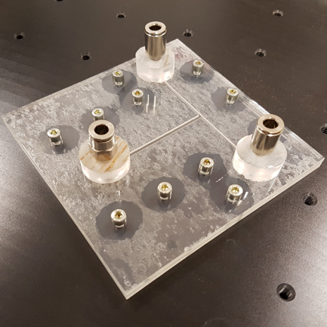(b) 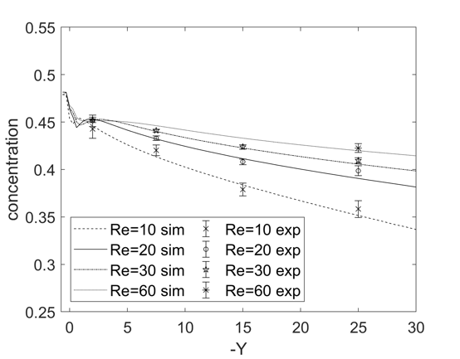
Figure 1. (a) T-junction. (b) Concentration of A along the mixing channel as a function of Re.
4. Conclusions
The effect of both Da and Re on the reaction yield in a T-junction is investigated experimentally and numerically. At low Re, with segregated flow regimes, the reaction yield decreases with increasing Re because of the lower residence time. Instead, increasing Re in the engulfment regime, leads to an increase of reaction because the enhanced mixing.
References
- A. Mariotti, C. Galletti, R. Mauri, M.V. Salvetti, E. Brunazzi, Chem. Eng. J. 341, (2018) 414-431.
- C. Galletti, E. Brunazzi, R. Mauri, Chem. Eng. Sci. 164 (2017) 333-343.
- C. Galletti, A. Mariotti, L. Siconolfi, R. Mauri, E. Brunazzi, Can. J. Chem. Eng. 97 (2019) 528-541.

