Microstructured Reactor Development and Detailed Investigation into Catalyst Performance for Decentralized Power-To-Gas Applications.
Sarvenaz Farsi*, Wolfgang Olbrich, Peter Pfeifer, Roland Dittmeyer
Karlsruhe Institute of Technology, Eggenstein-Leopoldshafen/ Germany
*Corresponding author: Sarvenaz.farsi@kit.edu
Highlights
- A detailed study of the methanation kinetics was carried out.
- A novel microreactor with internal cooling structure for hot spot control in methanation was developed and validated.
- Influence of different process parameters on reactor performance was studied.

1. Introduction
The growing interest in renewable energies calls for development of energy storage processes which support a balanced energy supply and demand and provide a stable power grid. In order to meet the problem of storing energy from renewable sources and to be carbon dioxide neutral, Power-to-Gas (PtG) applying CO₂ as carbon source is recognized as a promising future technology. The resulting synthetic natural gas (SNG) from methanation reaction can be either stored or injected without limits unlike H₂ into a natural gas grid, since the infrastructure for its transportation and storage already exists [1]. Moreover, steam generated from the highly exothermic methanation of carbon dioxide may be used for considerably increasing the overall process efficiency by feeding a steam electrolysis unit.
In the framework of Kopernikus project Power-to-X, we study the methanation reaction of carbon dioxide from both, reaction fundamentals as well as reactor development point of view.
2. Methods
To reveal the underlying kinetics of the methanation reaction, a microstructured packed bed reactor with highly efficient internal cross-flow cooling obtained at IMVT-KIT has been fabricated.
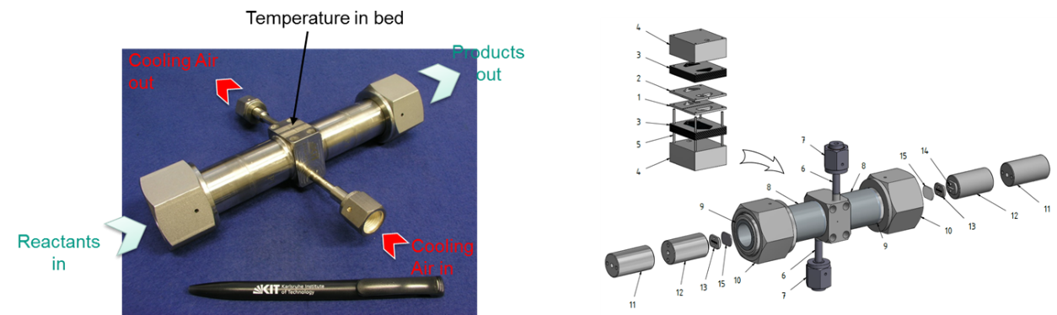
Figure 1 Packed-bed microstructured reactor used for kinetic measurements
Another focus of the work is dedicated to development and examination of a novel and compact evaporation cooled microstructured packed bed reactor for catalytic methanation of pure CO₂ for syngas throughputs of up to 2 Nm³/h. The reactor (Figure 1) consists of two parallel reaction chambers in form of rectangular ducts. The heat management is accomplished by means of cooling channels above/below the reaction chambers and five heating cartridges between the reaction slits [2].
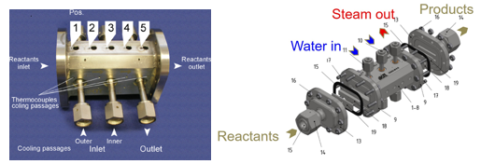
Figure 2 The microstructured reactor designed for methanation with two cooling inlets and one cooling outlet
3. Results and discussion
In the kinetic studies, the operation temperature, composition of the components in reaction and WHSV were varied to investigate their influence on reaction rate and stability of the catalyst. The results contributed to validation of the models for the catalytic methane production based on literature data for a stable and selective Ni₃Fe catalyst [3].
With regard to evaporation cooling, efficient heat removal and hot spot control by variation of the parameters of water feed were investigated. To assess the reactor behavior in cooperation with INERATEC GmbH, supply of pressurized water up to 20 bar to the cooling structures in different amount and distribution between the inlets was tested.
4. Conclusions
The in the current contribution parameters for reliable models for a wide range of process conditions are developed. The derived model can be applied to a microstructured reactor with internal evaporation cooling. The latter was also validated through this study.
References
[1] M. Götz, J. Lefebvre, F. Mörs, A. McDaniel Koch, F. Graf, S. Bajohr, R. Reimert, T. Kolb, J. Renewable Energy 85, 1371−1390, 2016.
[2] M. Belimov, D. Metzger, P. Pfeifer, J. AIChE 63, 120-129, 2017.
[3] B. Mutz, M. Belimov, W. Wang, P. Sprenger, M-A. Serrer, D. Wang, P. Pfeifer, W. Kleist, J.-D. Grunwaldt. ACS Catalysis 7 (10), 6802-6814, 2017.

