Explosibility characterization of combustible dusts from Italian industries
Luca Marmo¹, Almerinda Di Benedetto², Roberto Sanchirico³, Valeria Di Sarli³, Enrico Danzi¹
1 Applied Science and Technology Dept. Politecnico di Torino, Cso Duca degli Abruzzi 24, 10129 Turin (Italy); 2 Dipartimento di Ingegneria Chimica, dei Materiali e della Produzione Industriale, Università Federico II Napoli, P.le Tecchio 80, 80125 Naples (Italy); 3 CNR IRC, P.le Tecchio 80, 80125 Naples (Italy)
*luca.marmo @polito.it
Highlights
- Dust explosion hazard
- Testing the explosibility of industrial dust waste may not be completely fulfilled by current norm
- Explosion hazard assessment requires proper dust characteristics measurement
1. Introduction
The first documented dust explosion in the world is that occurred in Turin (Italy) in 1785. Many years have passed since then, but dust explosion phenomena are still being investigated as they pose several open issues. Literature studies have been mostly focused on how to deal and protect industrial equipment, where fine solid particles are involved, both as processing powder and as waste material to be disposed. Powdered materials could also be produced accidentally, due to mechanical or thermal stress, such as working operations aiming to refine or reduce shape of raw materials, but also when brittle solid materials are handled or stored. Most of the dusts generated by these operations are heterogeneous in shape and particle size distribution, as well as in volatile content and chemical composition. Testing combustible dusts coming from industries means to deal with samples which are mostly not pure, but mixture of combustible and inert materials. The assessment of the likeliness of a combustible dust to explode in certain conditions is not an easy task, even though several standards could be used to determine the explosive properties, such as the recent ISO 80079-20-2:2016. Nevertheless, dust explosion hazard is based on the known “pentagon”, a side of which represents the dispersibility of the material that often plays a critical role. Non-spherical dusts, such as fibers, scraps or shavings from finishing operations are difficult to disperse with traditional testing procedures, but this could not a priori exclude their unsafe behavior in industrial equipment, or in peculiar conditions: dispersibility dynamics of such type of dusts is not well understood.
This paper summarizes results and draw conclusions obtained from the testing of over two hundred of dust samples, collected in industrial facilities from all over Italy, deriving from different type of processes, with different chemical nature and morphology.
2. Methods
Dust samples were subjected to preliminary characterization tests, as to measure those properties which could significantly influence dust explosivity parameters. Metal oxide content was measured when dealing with dust coming from metal industrial plants, while CHN analysis was performed on most organic dusts. Moisture content was also determined for all samples as to verify its inerting effect on the explosion strength of dusts. PSD was obtained for all samples, both through a pile of sieves, operated by a mechanical sieving machine, and by laser granulometric analysis (ISO 13320:2009). Dust ignition sensitivity was evaluated through the measurement of Minimum Ignition Temperature (in cloud and in layer), Minimum Ignition Energy and with the Explosibility screening test (ISO 80079-20-2:2016). Dust explosion violence was measured according to EU standard 14034:2011, defining maximum rate of pressure rise (or K_{ST}, deflagration index), maximum pressure rise and Lower Explosibility Limit (LEL).
3. Results and discussion
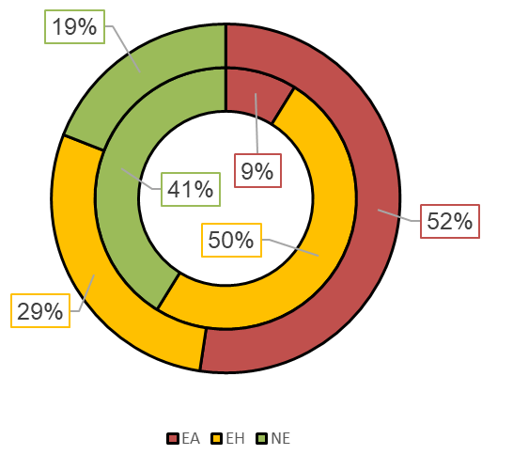
Figure 1. K_{St} value vs tenth percentile diameter of particles, where red dots represent plastic samples, blue metal, green textiles, black wood, yellow food, magenta feed, cyan others (left); Speditive explosibility test results sort by sample origin (inner ring inorganic samples, outer ring organic samples) (right).
4. Conclusions
Assessing the explosion hazards related to combustible dusts derived from industrial processes and waste is a challenging task for many reasons: samples are rarely pure dusts, but mixtures; PSD and morphology, among other variables, could vary extensively through the dust sample due to collecting procedures; actual industrial conditions and material handling are difficult to recreate in laboratory scale [1]. In this work, more than hundreds of samples were tested, deriving from different industrial realities: dusts produced by plastic manufacturing plants presented higher hazards in terms of explosion violence (K_{St} class 2), followed by samples from metal waste, with higher metallic content [2]. Organic samples constituted a potential explosion risk, as only about 20% of them did not imply an explosion behavior, while inorganic non explosible samples are two times higher. Care must be paid when dealing with non-traditional dusts (such as those generated from manipulation of textile fibers), as relative high value of K_{St} are registered, even though standard explosibility test devices could not disperse efficiently those type of samples [3].
References
- Danzi, E., Marmo, L., & Riccio, D. (2015). Journal of Loss Prevention in the Process Industries Minimum Ignition Temperature of layer and cloud dust mixtures. J. Loss Prev. Process Ind., 36, 326-334.
- Marmo, L., Riccio, D., & Danzi, E. (2017). Explosibility of metallic waste dusts. Process Safety and Environmental Protection, 107, 69-80.
- Marmo, L., Sanchirico, R., Di Benedetto, A., Di Sarli, V., Riccio, D., & Danzi, E. (2018). Study of the explosible properties of textile dusts. J. Loss Prev. Process Ind. 54, 110-122.

