Choosing the Right Packing in Millimetric Packed Bed Reactors.
Vittorio Petrazzuoli¹, Matthieu Rolland¹, Adrien Mekki Berrada¹, Yves Schuurman²
1 IFP Energies nouvelles, Rond-point de l'échangeur de Solaize, BP 3, 69360 Solaize - France
2 IRCELYON, CNRS, University Lyon 1, 2 Av. Albert Einstein, 69626 Villeurbanne - France
*Corresponding author: vittorio.petrazzuoli@ifpen.fr
Highlights
- Gas solid RTD measurements in millipacked beds show a steep Pe increase for D/d_{p} > 4
- Insertion of fine inert powder in the bed porosity improves Pe, but the effect is not appreciable for very small reactor diameters (~2 mm)
- Reactive performances are improved by the use of inert powder

1. Introduction
Over the decades, fixed bed reactors for catalyst testing have faced a reduction in size and now they commonly have diameters below 1 cm, the limit being the catalyst pellet size (~1-3 mm). The advantages of these reactors are numerous: less catalyst used, less amount of reactant used and of wastes produced, better temperature control, reduced safety risks and easier implementation of parallel reactor systems [1-3]. Those reactors were designed for catalyst screening, so that hydrodynamics was not really an issue as long as the ranking and uncertainty were correct. As those reactors produce a large amount of data, a new question arises: can we use those results to build models for catalyst performance prediction? This work aims at improving our understanding of these small reactors. Do we need to use a hydrodynamic model? When is it interesting to use fine powder to fill the porosity between the catalyst pellets? The results of two experimental campaigns will be presented:
- Measurements of residence time distributions for gas-solid millireactors with reactor (D) to particle (d_{p}) diameter ratio less than 8, with and without porosity filler;
- Effect of packing on reactive performances.
2. G/S RTD measurements
2.1 Methods
RTD measurements are performed using the concentration step technique, with N₂ as carrier gas and He as tracer. The reactor and particle dimensions are varied between 1-7 mm. The particles are non-porous, in spherical or cylindrical form. The tests are performed with superficial velocities between 0.013-0.06 m/s. A 1D dispersion model is used in order to estimate the void fraction (ε) and the axial dispersion coefficient (D_{ax}) of the reactors.
2.2. Results and discussion
The results of the RTD studies show that, at constant flow rate, it is preferable to work under conditions of δ=D/Dp > 4 (Figure 1). We relate this to the change from structured to random packing that occurs when increasing δ: structured packings offer more potential for channeling than random beds. Provided that the bed is long enough, the Pe number is sufficient to consider the reactors as ideal (plug flow) for most applications. The addition of inert powder to lower the bed porosity improves the Pe number but the RTD shows an additional contribution. An explanation can be the presence of dead volumes in case of the use of a porosity filler. For very small reactor diameters (~2 mm), the improvement is no longer appreciable.
3. Effect of the packing on n-heptane reforming reaction
The effect of the packing is measured by comparing the conversion in reactors with different packings in a 8-parallel reactor system (Avantium FLOWRENCE). The reaction is the n-heptane reforming over chlorinated Pd/Alumina catalyst at 10 barg, T=450-500 °C with conversions in the range of 60-90%. The reactor internal diameters are 2 mm, and they are packed with cylindrical catalyst particles (d_{p}=1.6 mm). The parameters investigated are the fine powder size and type. N-heptane conversion increases when adding inert powder to the catalytic bed, with even better results for finer and rounder particles (Figure 1). As at this conversion levels the reactor is always ideal, this difference cannot be explained by an improvement of the Pe number, but may be due to a better heat control or a better mass transfer.
4. Conclusions and perspectives
Gas phase RTD measurements indicate that, if long enough, millipacked bed reactors exhibit a pseudo-ideal behavior. The value of D/d_{p} has an effect probably related to the passage from structured to random beds. This aspect will be further investigated by CFD.
Addition of small spherical powder showed an improvement of the performance of a gas-solid mass transfer limited reaction. Next step is to discriminate between thermal and mass transfer effects.
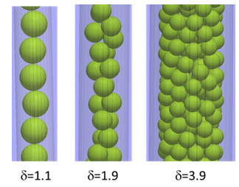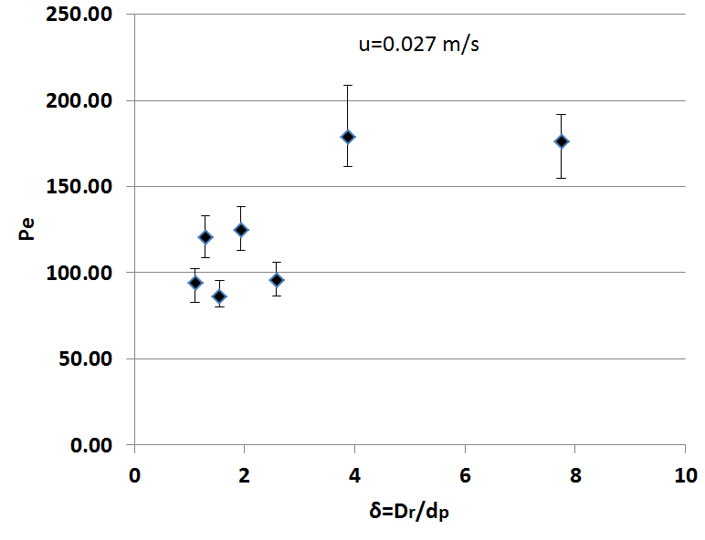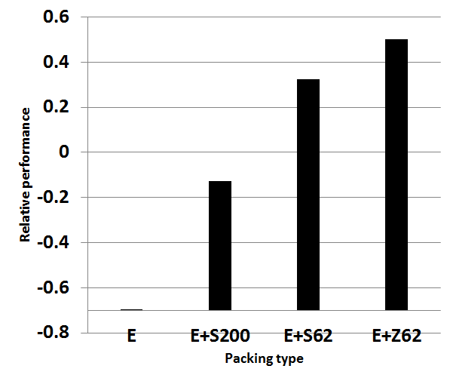
Figure 1. Left: Example of packing. Middle: Effect of δ=D/dp on the Pe number for spheres (L=18.2 cm, u=2.7 cm/s). Right: Relative performance of different packings on n-heptane conversion
References
- Zhang J., Teixeira A.R., Jensen K.F. (2017) Automated measurements of gas-liquid mass transfer in micropacked bed reactors, AIChE J. 36, 8, 3292.
- Moonen R., Alles J., Ras E.j., Harvey C., Moulijn J.A. (2017) Performance Testing of Hydrodesulfurization Catalysts Using a Single-Pellet-String Reactor, Chem. Eng. Technol. 40, 11, 2025–2034.
- Moulijn J., Pérez-Ramı́rez J., Berger R., Hamminga G., Mul G., Kapteijn F. (2003) High-throughput experimentation in catalyst testing and in kinetic studies for heterogeneous catalysis, Catalysis Today 81, 3, 457–471W.

