**Intensified stereoselective secondary nucleation in solid state deracemization via microwave-assisted temperature cycles**

Fabio Cameli1, Christos Xiouras1,2, Georgios D. Stefanidis1

*1 Process Engineering for Sustainable Systems (ProcESS), Department of Chemical Engineering KU Leuven, Celestijnenlaan 200F, 3001 Leuven, Belgium*

*2 Crystallization Technology Unit (CTU), Janssen Pharmaceutical Companies of Johnson & Johnson, Janssen Research & Development, Tournhoutseweg 30, 2340, Beerse, Belgium*

* georgios.stefanidis@kuleuven.be

**Highlights**

* The high supersaturation ratios attained through the sharp thermal cycles performed in a microwave set-up favor the occurrence of secondary nucleation.
* Enantioselective secondary nucleation greatly affects deracemization rate in temperature cycling-induced deracemization.

**1. Introduction**

The need for single enantiomers is becoming central in the pharmaceutical and fine chemical industry. To this direction, various methods have been designed to produce single handed compounds, either by asymmetric synthesis or by downstream separation of a racemic mixture [1]. The latter approach has proved more efficient in terms of industrial feasibility, as cost effective and established separation techniques, such as crystallization processes (in the framework of deracemization methods) allow for high productivity of the target compound.

Among the most promising solid-state deracemization techniques, substantial attention has been lately given to temperature cycling-induced deracemization. This technique is based on thermal fluctuations, which induce partial dissolution and subsequent crystallization of a racemic suspension, whose liquid phase is maintained in a chemical equilibrium by a catalyzed racemization reaction [2].

As the process time of this kind of techniques is intrinsically long, cycle duration can be significantly reduced by efficient heating and fast cooling which can be easily performed, for example, in a microwave apparatus [3]. On the other hand, the high supersaturation levels achieved upon cooling are likely to result in the generation of secondary nuclei. Up to date, the occurrence of secondary nucleation as main pathway for the depletion of the solute supersaturation has been regarded as detrimental for deracemization due to the expected racemic nature of the produced crystals. However, a thorough evaluation of the handedness of the generated particles has not been performed yet, therefore this study aims at establishing the role of secondary nucleation in the framework of temperature cycling-induced deracemization and the connection between the magnitude of secondary nucleation and deracemization rate.

**2. Methods**

A chiral suspension of conglomerate crystals of 2-isopropyl-3-hydroxy-3-phenylisoindolin-1-one in toluene with catalytic amount of 1,8-diazabicyclo[5.4.0]undec-7-ene (DBU) was subjected to temperature cycles in a monomode microwave reactor capable of attaining rapid thermal cycles in which dissolution and crystallization phases can be run isothermally at the two temperature limits of the sweeps. Thus, the extreme operating windows employed in this study allow for investigation into the main factors affecting the occurrence of secondary nucleation which are namely:

* Solute supersaturation ratio
* Suspension density
* Stirring rate

**3. Results and discussion**

The sharp temperature cycles performed in the microwave apparatus induce high solute supersaturation ratios that are responsible for the generation of secondary nuclei during the low temperature period. The deracemization rate is positively affected by the increase in supersaturation up to a certain threshold, beyond which competition between stereoselective and non-stereoselective secondary nucleation hinders the rate of the process. On the other hand, increasing suspension density intensifies the stereoselective production of new particles leading to higher deracemization rate per unit mass. Lastly, vigorous stirring can deliver extensive generation of secondary nuclei that contribute to higher specific surface area of the overall crystals population (Figure 1a). The chirality of the new particles is seemingly influenced by the parent crystals in an autocatalytic manner resulting in enhanced deracemization as displayed in Figure 1b.

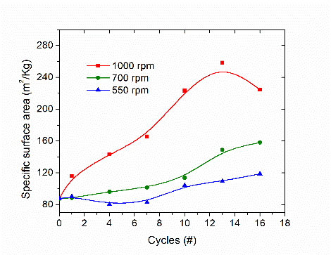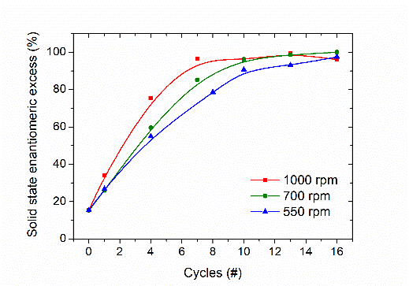

**Figure 1.** (a) Specific surface area and (b) enantiomeric excess trends of the particles obtained from experiments run under the same thermal profile but with different agitation conditions (in legend).

**4. Conclusions**

Enantioselective secondary nucleation plays a crucial role in solid-state deracemization via temperature cycles under intensified running conditions attainable within a microwave set-up. This physical phenomenon is greatly affected by operating parameters such as solute supersaturation, suspension density and agitation rate. Therefore, by optimizing these factors the total process time can be significantly enhanced.

**References**

1. Lorenz, H. and Seidel‐Morgenstern, A., Angew. Chem. Int. Ed., 2014, 53, 1218 – 1250.
2. K. Suwannasang, A. E. Flood, C. Rougeot, and G. Coquerel. Cryst. Growth Des. 2013, 13, 3498−3504.
3. F. Cameli, C. Xiouras, and G. D. Stefanidis. CrystEngComm, 2018, 20, 2897.