Mathematical modeling of the hydrolysis process of sucrose
Vittorio Romano*¹, Brunella Ascione¹, Rino Apicella¹
1 University of Salerno, Department of Industrial Engineering
*Corresponding author: vromano@unisa.it
Highlights
- Hydrolysis process of sucrose
- Michaelis-Menten equation with enzymatic inhibitions
- Mathematical modeling
- Finite Element Method

1. Introduction
Simulations of the enzymatic hydrolysis of sucrose were conducted for a Michaelis-Menten kinetic with product and substrate inhibitions in a tubular reactor with axial and radial dispersion.
2. Methods
The sucrose enzymatic hydrolysis process was modeled as a laminar flow with average velocity v_{m} inside a tubular reactor of radius R=0.04 m and length L=0.3 m, triggered by a pressure drop between inlet and outlet sections, that generates a velocity component v_{z} (r,t). The transient sucrose concentration and temperature profiles result to be dependent both on the radial and the axial direction: Cs (r, z, t); T (r, z, t). The unsteady equations of mass and energy, including molecular and convective transport, were developed on a differential volume ∆V = 2πr ∆r ∆z, considering a cylindrical coordinate system (r, θ, z).
$$μ\left(\frac{1}{r}\frac{∂}{∂r}\left(r{\frac{∂v_{z}}{∂r}}_{s}\right)\right)+\frac{P_{in}-P_{out}}{L}=ρ\frac{∂v_{z}}{∂t}$$
$${-2v}_{m}\left[1-{\left(\frac{r}{R}\right)}^{2}\right]\frac{∂C_{s}}{∂z}+D\frac{∂^{2}C_{s}}{{∂z}^{2}}+D\left(\frac{1}{r}\frac{∂C_{s}}{∂r}+\frac{∂^{2}C_{s}}{{∂r}^{2}}\right)-\left(-r_{s}\right)=\frac{∂C_{s}}{∂t}$$
$${-2ρcpv}_{m}\left[1-{\left(\frac{r}{R}\right)}^{2}\right]\frac{∂T}{∂z}+k\frac{∂^{2}T}{{∂z}^{2}}+k\left(\frac{1}{r}\frac{∂T}{∂r}+\frac{∂^{2}T}{{∂r}^{2}}\right)-\left(-r_{s}\right)\left(-ΔH_{r}\right)+16μ{v_{m}}^{2}\frac{r^{2}}{R^{4}}=ρcp\frac{∂T}{∂t}$$
$$(-r_{s}) = \frac{K_{3}C_{eT}C_{S}}{k_{m}\left(1+\frac{C_{S0}-C_{S}}{k_{I}}\right)+ C_{S}+ \frac{C_{S}^{2}}{k_{III}}}$$
$$\begin{matrix} t=0 & \begin{matrix}v_{z}=0 & C_{S}=C_{S0} & T=T_{0}\end{matrix} & ∀z,∀r\end{matrix}$$
$$\begin{matrix}r=0 & \begin{matrix}\frac{∂v_{z}}{∂r}=0 & \frac{∂C_{s}}{∂r}=0 & \frac{∂T}{∂r}=0\end{matrix}\end{matrix} \begin{matrix}r=R & \begin{matrix}v_{z}=0 & \frac{∂C_{s}}{∂r}=0 & \frac{∂T}{∂r}=0\end{matrix} & ∀z,∀t>0 \end{matrix}$$
$$\begin{matrix} z=0 & \begin{matrix}C_{s}=C_{s0} & T=T_{0}\end{matrix} & \begin{matrix}z=L & \begin{matrix}\frac{∂C_{s}}{∂z}=0 & \frac{∂T}{∂z}=0\end{matrix} & ∀r,∀t>0 \end{matrix}\end{matrix}$$
The differential equations system was solved numerically by the finite element method.
3. Results and discussion
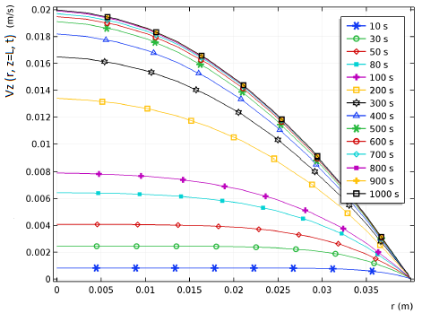 | 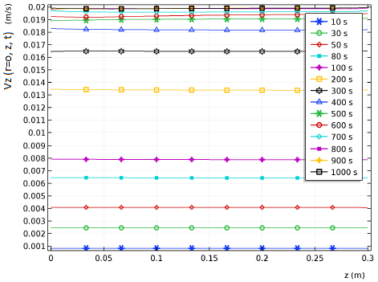
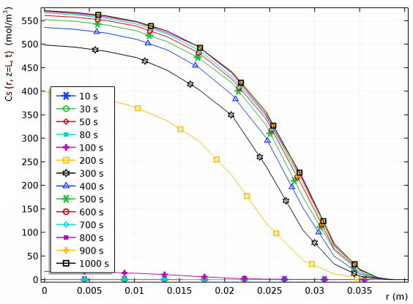 | 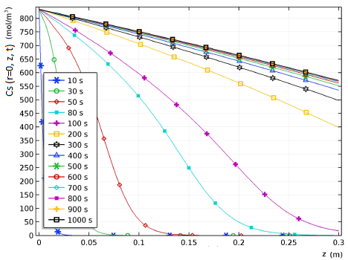
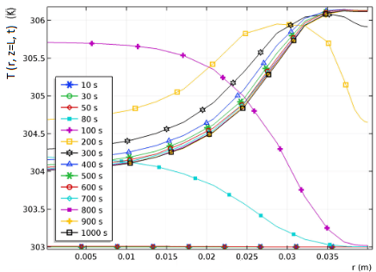 | 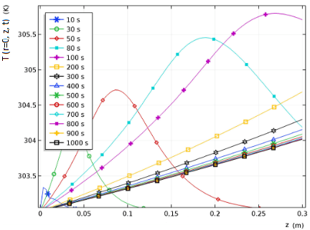
Time parametric line graphs of velocity (top), substrate concentration (middle) and temperature (bottom) against radial direction (left) and axial direction (right)
4. Conclusions
The radial concentration distribution is strongly influenced by the velocity profile, whereas along axial direction the only effect is due to the temporal evolution of the velocity. On the other hand, the temperature increasing for long times derives from the concentration consumption, considering that the reaction is exothermic.
References
[1] D.M. Himmelblau and K.B. Bischoff, Process analysis and simulation
[2] L.Bowski, R. Saini, Kinetic modeling of the hydrolysis of sucrose by invertase (1971)
[3] D.Combes ,P.Monsan, Sucrose hydrolysis by invertase. Characterization of product and substrate inhibition (1982)
[4] Y. Queneau, A Jarosz et Al., Sucrose chemistry (2007)
[5] S.M. Cuesta, S.A. Rahman, et Al.,The classification and evolution of enzyme function (2015)
[6] Z. I. Kertesz, J. Amer. Chem. Soc. 1935, 57, 1277-1279.

