Soybean Protein: a Potential Additive to Improve the Saccharification of Lignocellulosic Biomass in Biorefineries
Mariana G. Brondi^{1,2}, Roberto C. Giordano¹, Cristiane S. Farinas^{1,2*}
¹ Graduate Program of Chemical Engineering, Federal University of São Carlos, São Carlos, Brazil;
² Embrapa Instrumentação, São Carlos, Brazil
*Corresponding author: cristiane.farinas@embrapa.br
Highlights
- Soybean protein improves biomass saccharification.
- Soybean protein can be used as cost-effective additive.
- Gain of soybean protein is comparable to BSA.

1. Introduction
The conversion of renewable lignocellulosic biomass into biofuels and other bioproducts employing the biochemical route has been considered as a sustainable alternative to implement future biorefineries. However, this process still presents several technological challenges related to the low yield of the enzymatic hydrolysis step and the high cost of the cellulolytic enzymes. Among the strategies to increase the efficiency of the enzymatic hydrolysis reactions of the biomass, the use of additives has shown very positive effects, since they decrease the unproductive adsorption of the cellulases in the lignin, thus reducing the loss of enzymes in the process [1,2,3]. However, there is a clear need to find more cost-effective additives for use in large-scale processes. Here, soybean protein was evaluated as an alternative low-cost additive in the saccharification of pretreated sugarcane bagasse using a commercial enzymatic cocktail.

2. Methods
Liquid hot water pretreated bagasse (LHW) was prepared as described in [3]. Soybean protein (soybean protein isolate with 90% protein content, from Bremil, Brazil) was used at 12% (w/w) per wt of biomass (on a dry basis). The enzymatic hydrolysis experiments were carried out in 5 mL tubes placed in a hybridization incubator operated at an agitation speed of 30 rpm. Solids loadings of 15% (w/v, dry weight basis) of biomass and enzyme loadings of 5, 10, 15 and 20 FPU/g dry biomass were used, at 50 °C, in sodium citrate buffer (50 mM and pH 4.8). Samples were withdrawn every 24, 48 and 72 h for glucose determination using a D-glucose enzymatic assay kit (Labtest, Brazil).

3. Results and discussion
The addition of soybean protein had positive effects on glucose release during the hydrolysis of LHW pretreated sugarcane bagasse, with gains up to 26% when 12% (w/w) soybean protein was used (Figure 1). These improvements were comparable to those obtained using bovine serum albumin (BSA), a much more expensive protein that has been widely reported for such an application [2]. Moreover, addition of soybean protein led to a saving of 48 hours in the hydrolysis reaction time, corresponding to a 66% decrease in the reactor operation time required. In order to achieve the same hydrolysis yield without the soybean additive, the enzyme loading would need to be increased by 50%. Similar gains were also observed when using steam exploded pretreated sugarcane bagasse [2], thus showing the potential of soybean protein for other types of pretreated biomass.

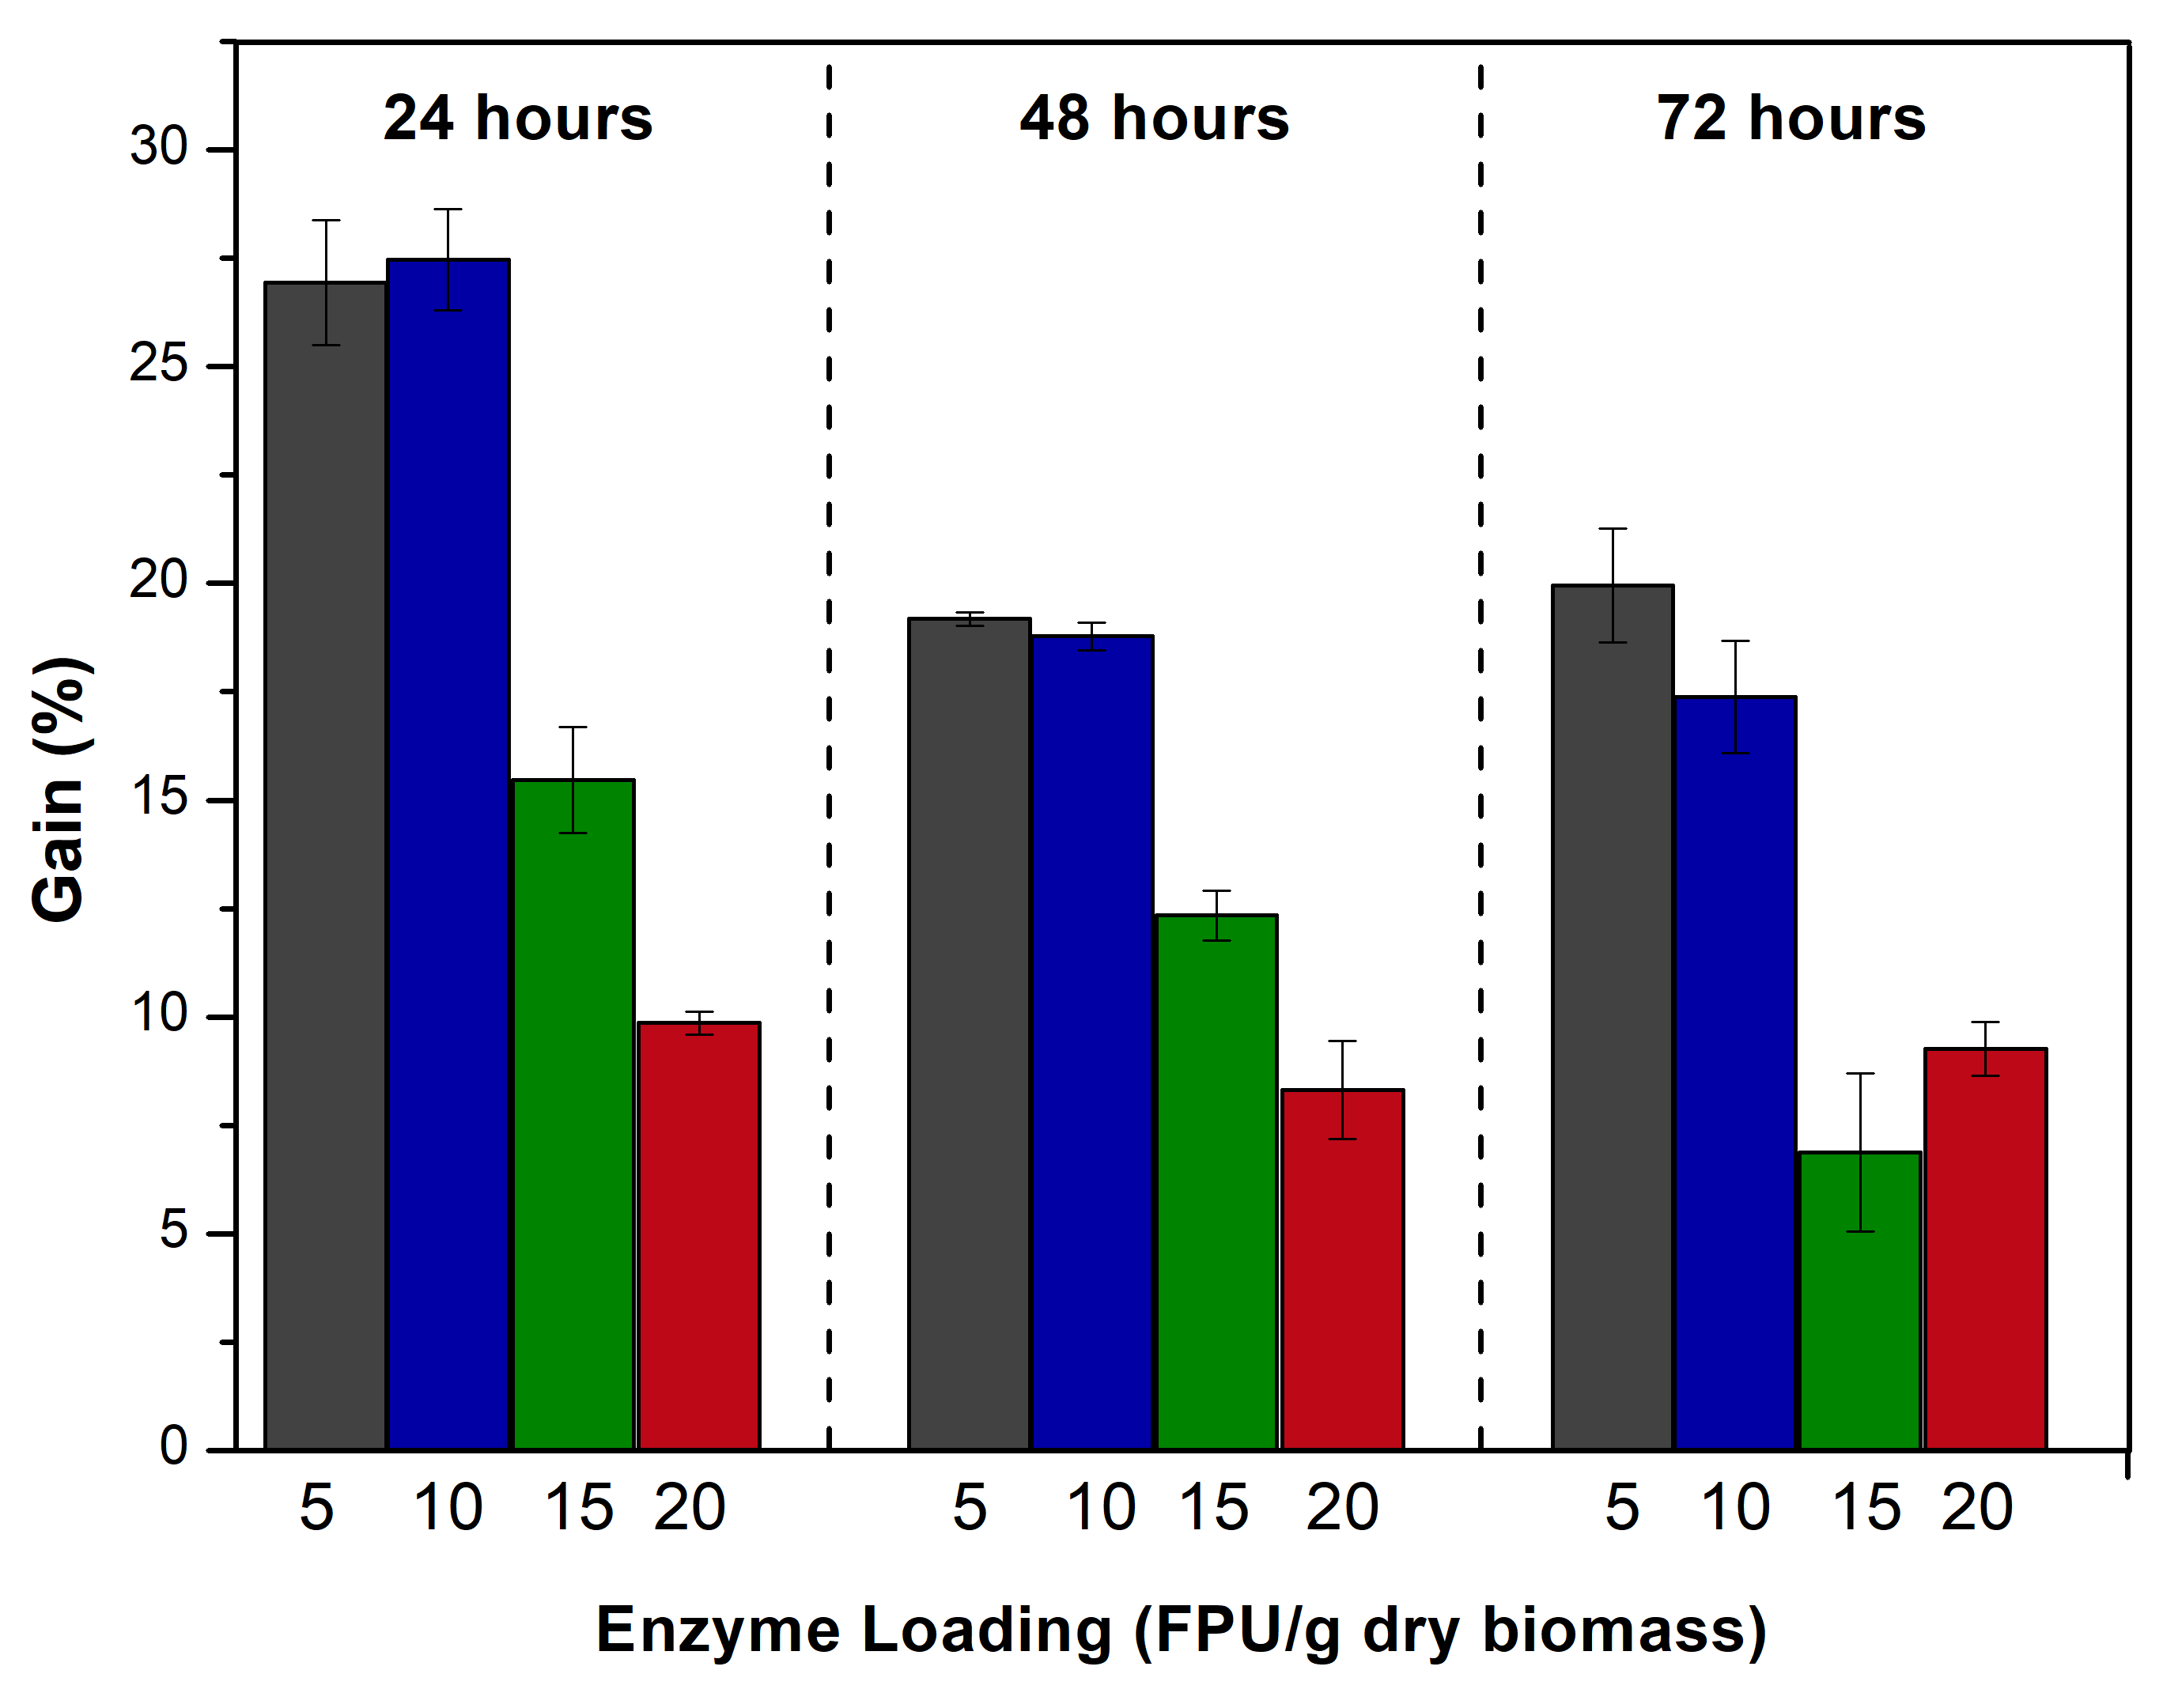
Figure 1. Increase in glucose release after the addition of soybean protein (12% w/w) compared to the bagasse hydrolysis without additive (Gain). The hydrolysis were performed with an enzyme loading of 5, 10, 15 and 20 FPU/g dry biomass, solids loading of 15% (w/v) for 24, 48 and 72 hours.
4. Conclusions
These findings suggest that soybean protein supplementation during enzymatic hydrolysis by commercially available enzymes is an effective strategy for achieving higher saccharification yields from pretreated lignocellulosic biomass, hence improving overall efficiency of future biorefineries.
References
- Florencio, C., Badino, A. C. and Farinas, C.S. Bioresour Technol. 221 (2016) 172-180.
- Brondi, M. G., Vasconcellos, V. M., Giordano, R. C. and Farinas, C. S. Appl. Biochem. Biotechnol. (2018) https://doi.org/10.1007/s12010-018-2834-z
- Florencio, C., Badino, A. C. and Farinas, C.S. BioEnergy Res. (2019) https://doi.org/ 10.1007/s12155-018-9956-6.

