Antibody variant ion-exchange separation and recovery at varying ligand densities
Greta Jasulaityte¹, Hans Johansson², Daniel Bracewell^{1*}
1 Department of Biochemical Engineering, University College London, Bernard Katz Building, Gower Street, London WC1E 6BT, United Kingdom; 2 Purolite, Unit D, Llantrisant Business Park, Llantrisant, South Wales CF72 8LF, United Kingdom
*Corresponding author: d.bracewell@ucl.ac.uk
Highlights
- Ratio between charged variants and main antibody changed with ligand density and pH.
- mAb recovery decreased with increasing ligand density and decreasing pH.
- Analytical studies revealed conformational changes to the mAb.

1. Introduction
Charge variant separation from the main monoclonal antibody is often challenging due to their similarities in charge and size [1]. Numerous separation techniques have been suggested including pH as well as salt gradients, a combination of both, or using different resin types [2,3]. In some cases, these conditions have been linked to a reversible or irreversible two-peak elution profile induced by protein unfolding, aggregation, or presence of specific charge-dependant amino acids [4-6]. In order to understand whether the presence of charge variants can affect the two-peak behaviour, we performed the separation using varying ligand density resins and buffer pH.
2. Methods
Antibody containing high levels of charge variants was run on columns packed with five cation exchange resins containing different ligand densities. The separation was carried out under an increasing salt gradient at three pH conditions. Analytical techniques such as size exclusion chromatography, circular dichroism, isoelectric focusing electrophoresis, and mass spectrometry were used to examine elution peaks.
3. Results and discussion
We found that the two-peak ratio and total protein recovery changed with buffer pH and ligand density. Protein recovery decreased by up to 27% with increasing ligand density, and by up to 51% with decreasing pH. No aggregation or reversible protein association was detected. However, circular dichroism data revealed conformational changes to the antibody structure, whereas isoelectric focusing electrophoresis showed the presence of different charge variants in the two peaks. Further analysis using mass spectrometry was undertaken to understand what caused reduction in protein yield and changes to the two-peak behaviour.

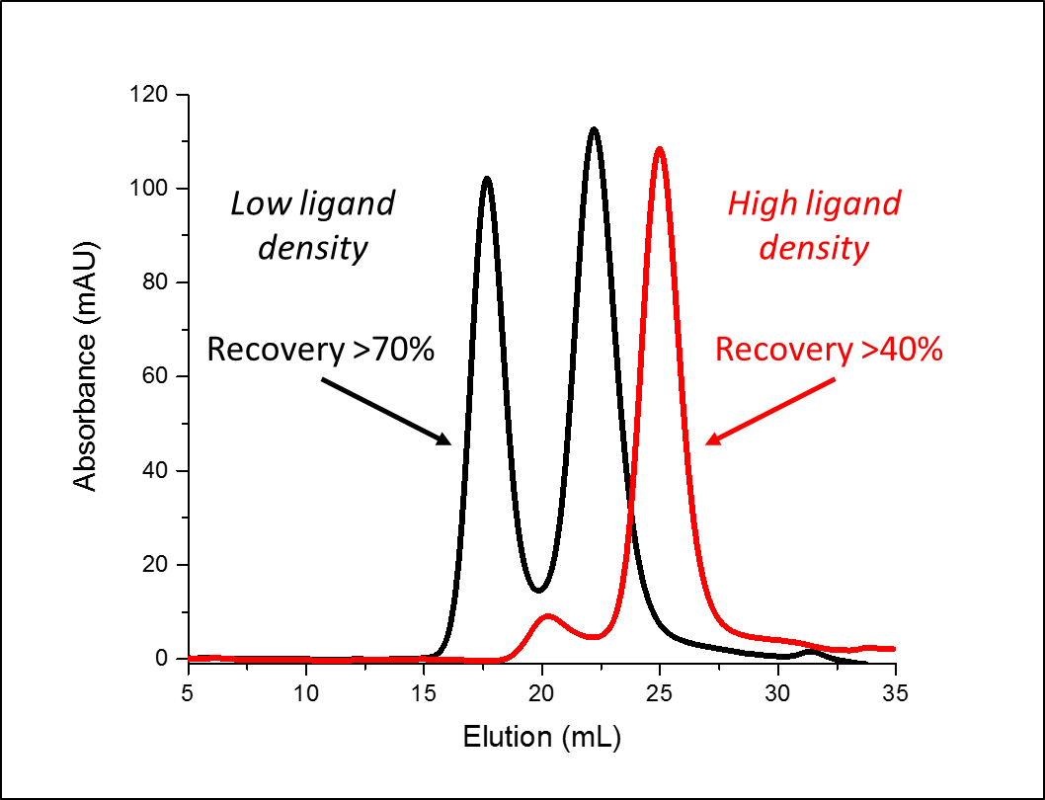
Figure 1. Antibody elution profile and recovery using low and high ligand density resins.
4. Conclusions
The results indicate that ligand density and buffer pH can affect the elution profile and protein recovery. We hypothesize that charge variants become unstable as a result of induced conformational changes.
References
- L.A. Khawli, S. Goswami, R. Hutchinson, Z.W. Kwong, J. Yang, X. Wang, et al., MAbs. 2 (2010) 613-624.
- T.M. Pabst, G. Carta, N. Ramasubramanyan, A.K. Hunter, P. Mensah, M.E. Gustafson, Biotechnol. Prog. 24 (2008) 1096-1106.
- S. Fekete, A. Beck, J. Fekete, D. Guillarme, J. Pharm. Biomed. Anal. 102 (2015) 33-44.
- H. Luo, N. Macapagal, K. Newell, A. Man, A. Parupudi, Y. Li, Y. Li, J. Chromatogr. A. 1362 (2014) 186-193.
- J. Guo, G. Carta, J. Chromatogr. A. 1388 (2015) 184-194.
- H. Luo, M. Cao, K. Newell, C. Afdahl, J. Wang, W.K. Wang, Y. Li, J. Chromatogr. A. 1424 (2015) 92-101.

