Adsorption of Anionic Surfactant on Activated Carbon inside a Semipermeable Membrane.
Israel Chavez-Sumarriva^{*,1,2}, Teodardo Cardenas¹, Luz Eyzaguirre²
1 Faculty of Chemical and Textile Engineering. National University of Engineering. Av. Tupac Amaru 210. Rimac, Lima, Peru; 2 Graduate Unit of the Faculty of Petroleum, Natural Gas and Petrochemical Engineering. National University of Engineering. Av. Tupac Amaru 210. Rimac, Lima, Peru
*Corresponding author:
Highlights
- Adsorption of Sodium dodecylbenzenesulfonate (SDBS) on activated carbon.
- Activated carbon was placed inside a semipermeable membrane.
- The adsorbed amount of SDBS does not decrease with the use of a semipermeable membrane.

1. Introduction
Surfactants are chemical compounds used in many chemical processes e.g. enhance oil recovery in petroleum industry, textile and paper industry, etc. Surfactants are also used in many products and formulations, such as detergents, cosmetics, paints, inks, etc.[1] Unfortunately, large usage of surfactants has led to water pollution. Sodium dodecylbenzenesulfonate (SDBS) is a widely used anionic surfactant. SDBS is biodegradable under anaerobic conditions[2] but the amount of this anionic surfactant in water is high and therefore is still difficult to eliminate them. Nowadays, SDBS is removed by different methods, such as chemical oxidation,[3] coagulation,[4] biological degradation,[5] electrochemical removal[6] and adsorption on soils,[7] clay[8] and carbonaceous materials.[9,10] Adsorption on carbonaceous materials such as activated carbon is widely used because is easy to operate and cheap but sometimes the activated carbon used for eliminate the SDBS can polluted the aqueous media. A solution is proposed in this research, the activated carbon is placed inside a semipermeable membrane for avoid pollution of the aqueous media.

2. Methods
Determination of SDBS Concentration
The SDBS concentration in solution before/after adsorption with activated carbon without/inside semipermeable membrane (regenerated cellulose) was determined using a Shimadzu UV−Vis spectrophotometer at 224 nm.
3. Results and discussion
Based on adsorption kinetics studies of activated carbon inside a semipermeable membrane, the time to reach the equilibrium adsorption capacity was 24 hours, a security factor was added and the time used in all adsorption tests was 30 hours. Adsorption tests were made (T = 298 K) to determine if the semipermeable membrane decreases the equilibrium adsorption capacity. Figure 1 shows the adsorption tests of Sodium Dodecylbenzenesulfonate (SDBS) on activated carbon without / inside semipermeable membrane, it can be seen that the equilibrium adsorption capacity (q_{eq}) does not change when the activated carbon is placed inside a semipermeable membrane. The influence of temperature was studied with activated carbon inside a semipermeable membrane at 298 K, 308 K, 318 K and 328 K. The results showed that when the temperature increases the adsorption capacity decreases. The influence of pH was also studied with activated carbon inside a semipermeable membranes (T=298 K). The pH was varied between 4 and 11; the results showed that the adsorption capacity does not change with pH which confirms that there are no electrostatic interactions between the SDBS and the activated carbon. After determining the optimal adsorption parameters (time, pH, Temperature) an adsorption isotherm was made (see Figure 2). The adsorption capacity of activated carbon inside semipermeable membrane founded was ca. 271 mg_{SDBS} g_{C}⁻¹.

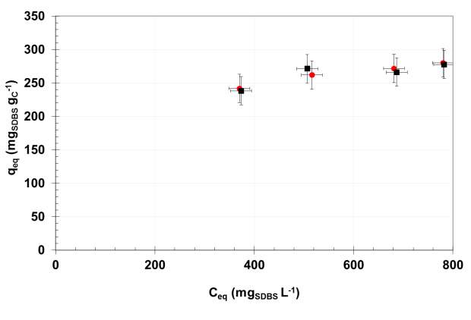 | 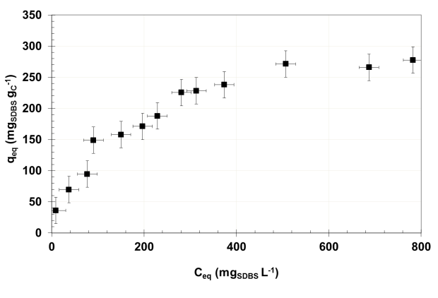
Figure 1. Effect of semipermeable membrane on the adsorption capacity of SDBS on activated carbon; red circles: without semipermeable membrane; black squares: with semipermeable membrane. | Figure 2. Adsorption isotherms of SDBS on activated carbon placed inside a semipermeable membrane (initial conditions; T=298 K, pH=7, 30 h contact time).
4. Conclusions
The results demonstrated that the amount absorbed of the anionic surfactant Sodium Dodecylbenzenesulfonate (SDBS) on activated carbon does not change with the use of a semipermeable membrane, therefore the proposed method could be used in industrial applications in which is needed to remove SDBS from an aqueous solution and it is not desired to contaminate this aqueous solution with small particles of activated carbon.
References
- M.J. Rosen, J.T. Kunjappu, Surfactants and Interfacial Phenomena, Fourth ed., John Wiley & Sons, Inc., Hoboken, 2012.
- D. Prats, F. Ruiz, B. Vázquez, M. Rodriguez-Pastor, Water Res. 31(1997) 1925-30
- J.D. Mendez-Diaz, M. Sanchez-Polo, J. Rivera-Utrilla, M.I. Bautista-Toledo. Water Res. 43(2009) 1621-9
- J. Beltrán-Heredia, J. Sánchez-Martín, C. Solera-Hernández, Chem Eng J. 153(2009) 56-61
- M.T. Garcia, E. Campos, I. Ribosa, A. Latorre, J. Sanchez-Leal, Chemosphere. 60(2005):1636-43
- E. Onder, A. Koparal, U. Ogutveren, Sep. Purif. Technol. 52(2007):527-32
- Z. Ou, A. Yediler, Y. He, L. Jia , A. Kettrup, T. Sun, Chemosphere. 32(1996) 827-39
- D.C. Rodrı́guez-Sarmiento, J.A. Pinzón-Bello, Appl Clay Sci. 18(2001) 173-81
- S.D. Gupta, S.S. Bhagwat, J Disper Sci Technol. 26(2005) 111-20
- E. Ayranci, O. Duman, J Hazard Mater 148(2007) 75-82

