The effect of improved liquid distribution on the gas-liquid contacting in a rotating packed bed
Jasper Hacking^{1 *}, Michiel de Beer², John van der Schaaf¹
1 - Chemical Reactor Engineering group, Department of Chemical Engineering and Chemistry, TU Eindhoven, De Rondom 70, 5612AZ Eindhoven, The Netherlands; 2 – Expert Capability Group – Process Technology, Akzo Nobel Chemicals B.V., Zutphenseweg 10, 7418AJ Deventer, The Netherlands
*Corresponding author: j.hacking@tue.nl
Highlights
- Introduction of redistribution rings in a rotating packed bed reactor.
- Improved liquid distribution in angular and axial direction.
- Results show that angular maldistributions of up to 90° can be mitigated.

1. Introduction
Rotating packed beds (RPB) have been a promising technology for process intensification since their introduction [1][2], enabling increased gas-liquid mass transfer rates [3] due to the application of a centrifugal field. Although a significant amount of possible applications have been reported in literature [4], a major challenge in industrial application of the technology is the absence of proper design correlations leading to ineffective scale-up of the RPB. The effectiveness of gas-liquid mass transfer decreases with increasing radius [3], mainly due to severe maldistribution in the tangential direction at large radii [5][6]. In the current work, a novel design rotating packed bed reactor is proposed, which employs redistribution rings at regular radial intervals, similar to redistributor plates in conventional columns.
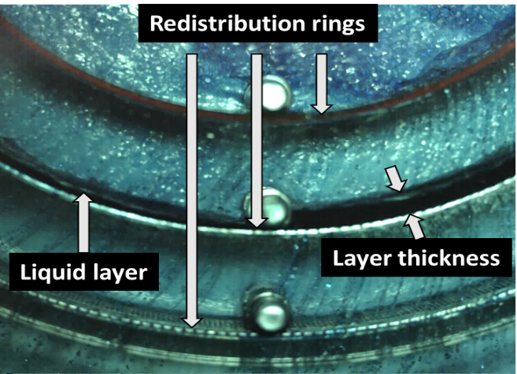 | 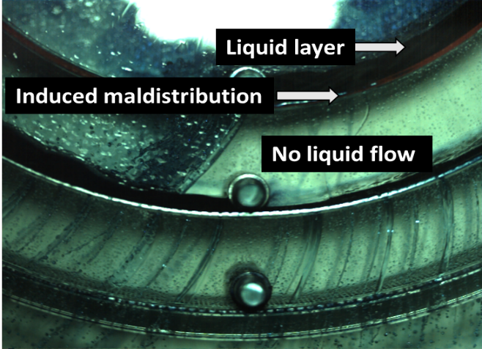
Figure 1. Experimental view of the water layer at a rotational speed of 1200 RPM and a liquid flow of 1000 L/h with (A) no induced maldistribution and with (B) a 90° induced maldistribution.
2. Methods
Perforated rings are placed at regular intervals inside the bed to redistribute the liquid both in angular and axial direction. This is shown in the top-down image in Figure 1A, where the liquid layer accumulates against the ring and is subsequently redistributed. To further test the effectiveness of the redistribution rings a maldistribution was induced in the inner of the three rings and the effect of the liquid distribution in the other two rings was analyzed. An example of an induced maldistribution of 90° can be found in figure 1B.
3. Results and discussion
The mean and deviation of the liquid layer thickness in the middle ring are used to determine the effectiveness of the redistribution rings: the smaller the standard deviation, the more even the liquid is spread angularly, and consequently, the more uniform the liquid flow. An example of the results for an experiment with no maldistribution can be seen in Figure 2A, where the fitted normal distribution yields both the average liquid layer thickness (14.16 mm) and the standard deviation of this layer (1.10 mm). An induced maldistribution of 90° at the same process conditions yields the results as shown in Figure 2B. Without redistribution rings the results would show two peaks: one around 0 mm corresponding to the area behind the maldistribution and one at the average water layer. These results clearly show a single normal distribution with a slightly larger standard deviation as compared with the reactor without induced maldistribution.
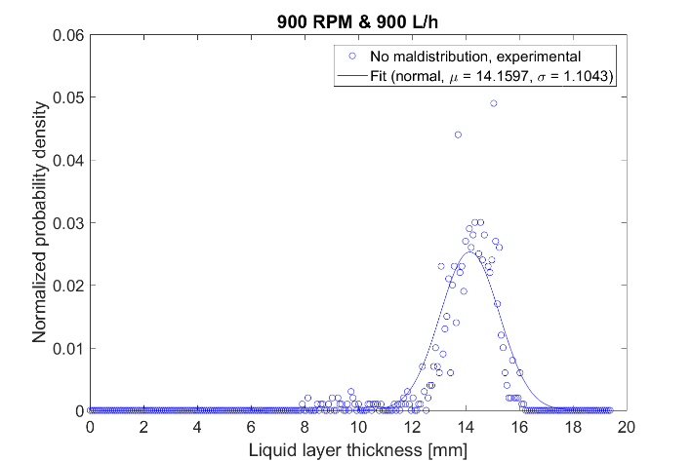 | 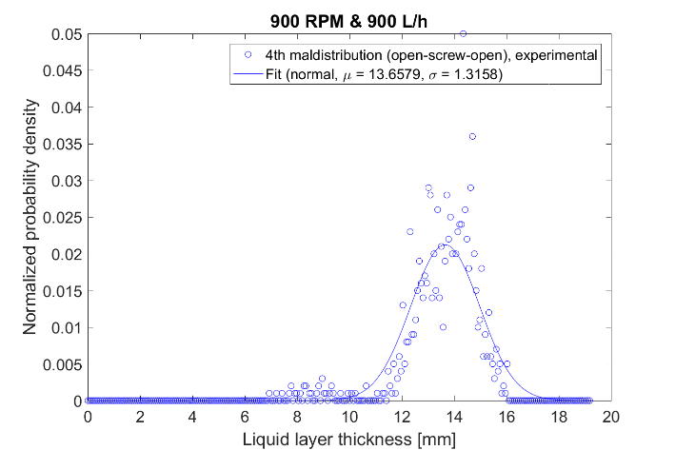
Figure 2. Results of the experiments at a rotational speed of 900 RPM and a liquid flow of 900 L/h for an experiment with (A) no induced maldistribution and with (B) an induced maldistribution of 90°.
4. Conclusions
The efficacy of the redistribution rings is demonstrated here without a packing present, mainly for visualization purposes. Experiments with a packing present have shown a similar behavior, indicating the redistribution rings can also be applied to actual rotating packed beds. It is therefore concluded that the redistribution rings improve the liquid distribution over the entire radial length of the packed bed, which in turn results in a more efficient use of the packing and a higher overall gas liquid mass transfer rate. Therefore, the novel design is a promising tool in enabling a more efficient scale-up of rotating packed beds.
References
[1] C. Ramshaw and R. H. Mallinson, “Mass transfer process,” US4283255, 27-Nov-1978.
[2] C. W. Pilo and S. W. Dahlbeck, US2941872, 09-Jun-1959.
[3] Y.-S. Chen, C.-C. Lin, and H.-S. Liu, Ind. Eng. Chem. Res., vol. 44, no. 20, pp. 7868–7875, Sep. 2005.
[4] K. Neumann et al., Chem. Eng. Res. Des., vol. 134, pp. 443–462, Jun. 2018.
[5] J. R. Burns and C. Ramshaw, Chem. Eng. Sci., vol. 51, no. 8, pp. 1347–1352, Apr. 1996.
[6] K. Groß et al., Chemie Ing. Tech., no. 00, pp. 1–10, 2019.

