Challenges during the Start-up of Anaerobic Reactors for Wastewater Treatment
Borja Ojembarrena¹; Noemi Merayo^{1,2}; Angeles Blanco¹; Carlos Negro¹
1 Complutense University of Madrid, Dpt. Ingeniería Química y de Materiales, Avda. Complutense s/n, 28040, Madrid, Spain; 2 Universidad Politécnica de Madrid, ETSIDI, Dpt. Ing. Mecánica, Química y Diseño Industrial, Ronda de Valencia 3, 28012 Madrid, Spain
*Corresponding author: cnegro@ucm.es
Highlights
- Start-up of anaerobic reactor is a critical stage
- Time required for start-up is one of the main limitations for anaerobic process
- Time required for the start-up depends on the scale of the treatment
- At full scale, start-up time increases regarding pilot plants and laboratory

1. Introduction
The start-up of the anaerobic reactors is a critical stage to assure a good performance of the anaerobic treatment during normal operation. Contrarily to aerobic reactors, anaerobic ones require long time to growth the appropriate consortia of microorganisms that are able to degrade the substrate provided (the wastewater) and additionally, to generate the maximum amount of biogas to be used as source of energy [1]. Not only are the anaerobic conditions that should be maintained constrain for the start-up process, but also the acclimatization and adaptation to a particular wastewater. The relevance of the start-up phase in anaerobic reactor is related to the operability of the reactor, because if the start-up is not well performed, this will affect the subsequent process operation [2].
2. Purpose
Both the lag between research and development levels, in terms of overall start-up strategies, and the challenge to obtain good quality anaerobic inoculum, particularly in developing countries, prove the necessity of further investigation in the field of the reduction of acclimation period [3].
Therefore, the aim of this work is to evaluate different factors of the anaerobic process, such as microorganism population, reactor design, treated wastewater, etc. that can affect the start-up of the anaerobic process; establishing the degree of influence they have on this step, considering the time required for the start-up, the stability of the microorganism population and any difficulties found. Furthermore, approaches to improve start-up step of the anaerobic treatment were analyzed and compare to show their actual effect.
3. Results and discussion
A successful start-up leads to improve methane production by the biomass, requiring at the beginning both low loads and long time for acclimatization and adaptation of the biomass [4]. Furthermore, the lack of acclimated biomass must be considered because it further leads to instability and failure, [5].
As it can be seen in figure 1, the scale of the treatment has a considerable effect on the time required for the start-up step of the anaerobic treatment. As long as the scale grows, the start-up time tends to increase as well. Therefore, it is important to consider that the results obtained at the laboratory scale for the start-up step of the process must be further checked at bigger volumes to predict what will happen at the full scale.
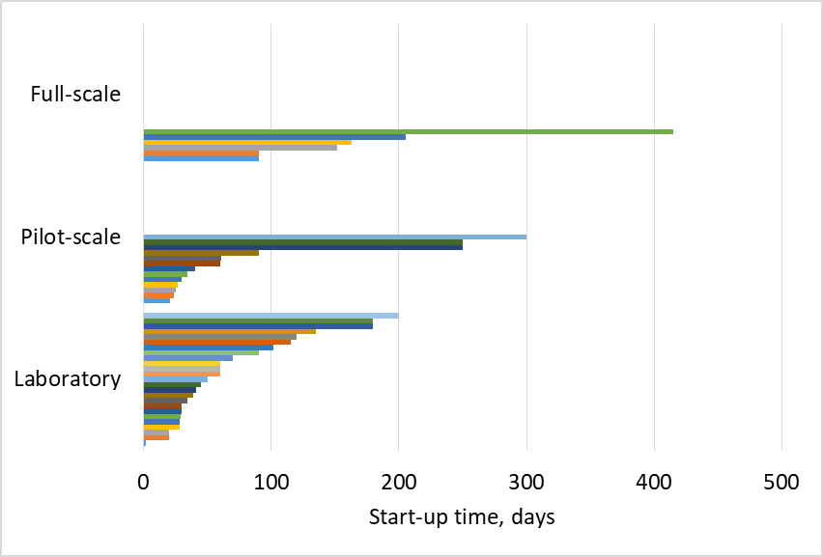
Figure 1. Effect of the scale of the anaerobic treatment on the time required for the start-up step.
The configuration and design of the anaerobic reactor also have a significant impact on the start-up of the process, such as the case of using of multistage reactors, which favors an acidification zone at the front of the reactor and a methanogenic zone at its end and improving the pH control in the reactor [6].
4. Conclusions
Start-up of the anaerobic treatment is a key factor to make this process available and easily implemental. In this communication, several factors will be presented and analysed to show their effect on the time required for the start-up step of the anaerobic treatment of wastewater.
References
- G. Skouteris, D. Hermosilla, P. López, C. Negro, A. Blanco, Chem. Eng. J. 198 (2012) 138-148.
- M.A. De la Rubia, V. Riau, F. Raposo, R. Borja, Crit. Rev. Biotechnol. 33 (2013) 448-460.
- R. Maroun, M. El Fadel, Environ. Sci. Technol. 41 (2007) 6808-6814.
- A. Akram, D.C. Stuckey. Environmental technology, Taylor & Francis, 2008, pp. 1053-1065.
- M. El-Fadel, P. Saikaly, S. Ghanimeh, Crit. Rev. Env. Sci. Tec. 43 (2013) 2685-2721.
- H.M. Zwain, S.R. Hassan, N.Q. Zaman, H.A. Aziz, I. Dahlan, J. Env. Chem. Eng. 1 (2013) 61-64.

