Addressing limitations to implement ternary phase diagrams into the systematic prediction of membrane morphology by phase inversion
Marta Romay^{1*}, Nazely Diban¹, Ane Urtiaga¹
1 Chemical and Biomolecular Engineering department, University of Cantabria, Santander, Spain
*Corresponding author: romaym@unican.es
Highlights
- Assessment of morphology membrane prediction based on Flory-Huggins model.
- Thermodynamic evaluation of the ternary system PVDF/solvent/water.
- Addressing the systematic determination of solvent-non-solvent interaction parameters.

1. Introduction
Phase inversion by Non-solvent Induced Phase Separation (NIPS) is a widely implemented technique for the synthesis of polymeric membranes [1]. This mechanism is thermodynamically explained through the Flory-Huggins theory based on the Gibbs free energy and interaction parameters of the components: polymer, solvent and non-solvent. Moreover, solvent/non-solvent miscibility importantly affects the rate of their exchange that will ultimately define the membrane morphology. Overall, the membranes morphology prepared by NIPS strongly depends on both thermodynamics and kinetics of the ternary system.
Traditionally, membranes by NIPS have been prepared by arbitrarily selecting the set of components polymer/solvent/non-solvent, which implies an experimental trial-and-error procedure. Currently, several works have attempted to find ways to systematize the selection of the components based on thermodynamic and/or kinetic interactions and tried to correlate these data with morphological parameters of different NIPS-prepared membranes [2-4]
Binodal curves of ternary systems, which represent the polymer/solvent/non-solvent composition ratios, where a polymeric solution precipitates, are usually obtained experimentally and fitted to Flory-Huggins model. However, interaction parameters are usually estimated through different empirical equations or by estimation procedures which depend importantly on the experimental points of the binodal curves. In order to systematize this as a design tool for the synthesis of membranes by NIPS techniques, broadly valid empirical equations for the estimation of interaction parameters should be defined. Moreover, the revision of the best methodology for the experimental determination of the binodal cloud points should be done.
2. Methods
In the present work, the production of PVDF membranes by NIPS is selected as a case study to explore the potential of the ternary phase diagrams in the prediction of certain membrane morphology.
The Flory- Huggins model for a ternary mixing is already developed in the literature [2,3]. The Flory-Huggins interaction parameters for the studied system were obtained before a comprehensive review of the literature. Different strategies were developed to determine the interaction parameters among polymer/solvent/non-solvent simultaneously [3]. However, it was founded a huge amount of different empirical equations that describes solvent/non-solvent interaction parameter. The search of the empirical equation that could be valid over a broad range of systems and conditions was done from the comparison of different equations proposed in the literature using Aspen Custom Modeler as solving software.
3. Results and discussion
The comparison of the experimental binodal curves reported in the literature for different systems PVDF/solvent/water, where the solvent could be dimethyleacetamide (DMAc), N-methylpirrolidone (NMP) and dimethylformamide (DMF), has been done. Broad differences could be found among different authors for the same ternary system. Thus, see for instance in Figure 1 the experimental points of the binodal curves for the system PVDF/NMP/water, reported by different authors. This experimental uncertainty hampered model fitting. Therefore, a detailed study of the experimental methodologies of the literature has been done in order to propose a reliable procedure to implement in following works.
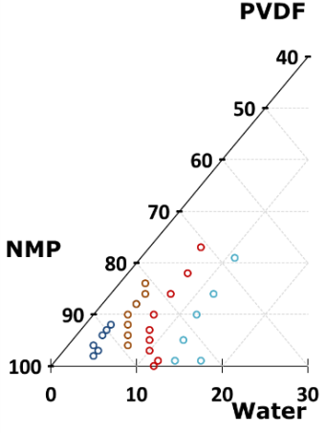
Figure 1. Comparison of experimental points of the binodal curves for the ternary system PVDF/NMP/Water attained from the literature [4-7]
4. Conclusions
The uncertainty in the experimental data of binodal curves due to the experimental difficulty limits the ability to determine broadly valid empirical equations for interaction parameters. Therefore, an experimental protocol to determine the binodal curves has to be proposed out of a thorough literature revision.
Financial support of project CTM2016-75509-R (MINECO-FEDER) and FPI grant BES-2017-081112 are acknowledged.
References
- S. Mohsenpour, F. Esmaeilzadeh, J. Mol. Liq. 224 (2016) 776–785
- Y. Wei, Z. Xu, Desalination 192 (2006) 91-104
- L. Xu, F. Qiu, Polymer 55 (2014) 6795-6802
- A. Bottino, G. Camera-Roda, J. Memb. Sci. 57 (1991) 1-20
- H. Fashandi, A. Yegane, Fibers Polym. 6(2) (2015) 326-344
- M. Enayatzadeh, T. Mohammadi, J. App. Polym. Sci. 135 (27) (2018)
- F. Liu, N. Awanis, J. Memb. Sci. 375 (2011) 1-27

