Thin gap bubble column with a non-Newtonian liquid phase: study of the hydrodynamics and gas-liquid mass transfer
Sikandar ALMANI¹, Abdallah HAYDAR¹, Walid BLEL¹, Emilie GADOIN¹, Caroline GENTRIC^{1*}
¹GEPEA, CNRS-UMR 6144, Saint-Nazaire Cedex, France.
*Corresponding author: caroline.gentric@univ-nantes.fr

Highlights
- Mimicking microalgae culture at high concentration using shear thinning liquid phase.
- Identification of flow regimes and their transition.
- Determination of mixing time and gas liquid mass transfer coefficient.
- Optimization of hydrodynamic conditions for higher biomass productivity.
1. Introduction
Bubble column technology is particularly adapted to photosynthetic microorganism culture because the injection of air enriched with CO₂ allows mixing as well as feeding the culture with inorganic carbon. Nevertheless, technological advances are still required to reduce production costs and environmental impacts. In this context, intensification of performances via an increase of culture concentration in photosynthetic microorganisms is a promising way to optimize production systems. However, it has been shown that the increase in cell concentration is accompanied by the increase of the viscosity and the modification of the rheological properties of the microalgae suspension [1]. Moreover, to reach high cell concentration, reducing PBR thickness is required to ensure light availability on the whole reactor gap. Confinement and rheological characteristics impact the bubbling effect on hydrodynamics and gas-liquid mass transfer [2]. The objective of this work is to characterize hydrodynamics as well as gas-liquid mass transfer for non-Newtonian liquid phase in a 2D bubble column having gap of 4 mm [2], for different gas injection conditions (sparger size and gas flow rate). For this purpose, non-Newtonian shear thinning solutions are used to mimic the high concentration of Chlorella vulgaris cultures at 30-40 g/L. Solutions of Xanthan gum (XG) and Carboxymethyl cellulose (CMC) are used respectively at the concentrations of 1 g/L and 2 g/L. The rheological characterization is performed using the PAAR Physica® MCR500 rheometer and the power law equation is used for modelling the rheological behaviour. Gas sparging is achieved using 15 capillaries which can have 5 different diameters (0.1016, 0.254, 0.508, 0.762 and 1.016 mm) in order to vary the size of the injected bubbles. A wide range of superficial gas velocities is also explored to investigate the effect of sparging on the global hydrodynamics of a non-Newtonian liquid phase in this thin gap bubble column.
2. Methods
Experimentally, the gas phase is characterized locally through the shadowgraphy method using DANTEC DYNAMICS Shadow Strobe, which allows to obtain the size, the shape and the velocity of bubbles. The hydrodynamics of the continuous phase is characterized by Particle image velocimetry (PIV) technique. Secondly, flow regimes and their transitions are investigated by studying gas holdup determined by liquid height or by hydrostatic pressure measurements. Identification of regime transition is obtained from gas holdup using three different methods based on gas retention as a function of superficial gas velocity or swarm velocity method or drift method. The mixing time characterization is carried out using a tracer method which consists in the injection of 2 mL of NaCl Solution at 200 g/L and follow-up the conductivity of the liquid over time until stabilization. Finally, to determine the volumetric mass transfer coefficient, kLa, the classical dynamic gassing-out gassing-in method is employed [2]. The obtained results are compared to those presented in the literature for non-Newtonian solutions in unconfined bubble columns in order to emphasize the confinement effect on hydrodynamics and gas-liquid mass transfer[3].
3. Results and discussion Figures 1 and 2 present respectively gas holdup and mixing time vs the superficial gas velocity for an injection with capillaries of 0.508 mm of diameter. Whatever the nature of the fluid, three flow regimes are observed: homogeneous, transition and heterogeneous regimes. For the three tested liquids, the overall gas holdup increased with the increase of the superficial gas velocity. Besides, at the same superficial gas velocity, the overall gas holdup in non-Newtonian liquids was larger than those in the water [Fig 1]. This result disagrees to one available in the literature ([3][4]and[5]) using unconfined column operating with non-Newtonian fluids. This result could be explained by the effect of the confinement between bubbles and column walls. Indeed, the experiments for an isolated bubble in this column showed that low terminal velocities have been observed in the case of non-Newtonian phase compared to the Newtonian one. Consequently, higher residence time of bubbles is observed with CMC and XG solutions. Comparison between the two non-Newtonian fluids shows that CMC and XG have similar gas hold-ups, certainly due to their similar rheological properties. It could be noted that the regime transitions between the homogeneous and the intermediate regimes appear at lower superficial gas velocity with non-Newtonian fluids due to their coalescence tendency. Higher gas hold-up is obtained in the XG solution than in the CMC, this phenomenon was already observed by [3] which they explained by elastic effects of XG solution.
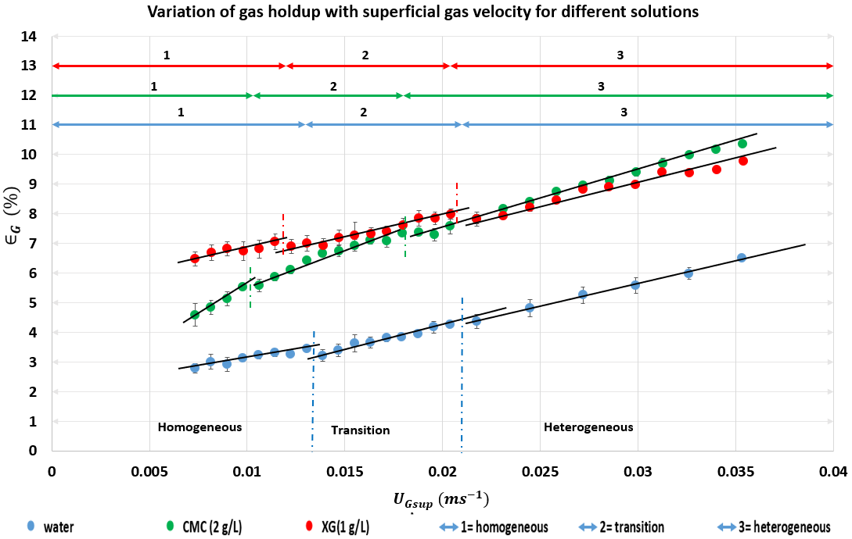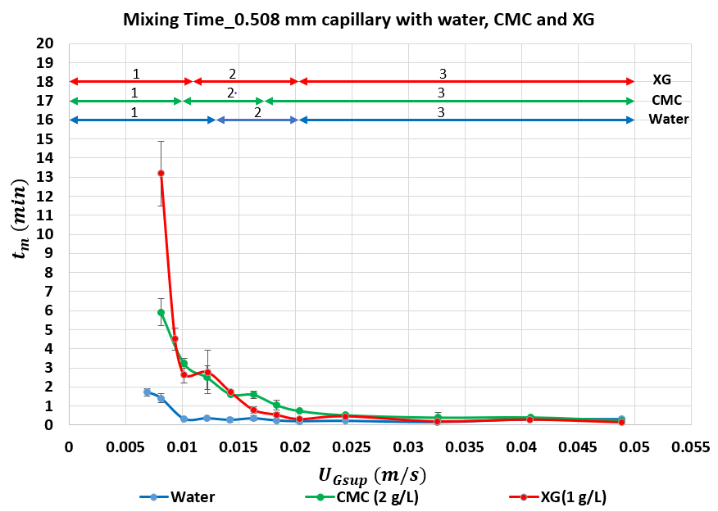
Figure 1. Effect of superficial gas velocity on gas holdup. Figure 2. Effect of superficial gas velocity on mixing time

Concerning the mixing time, Fig 2 shows a decrease of this parameter with the increase in the superficial gas velocity. The mixing time in water decreases rapidly during the homogeneous regime (UGsup < 0.01 m.$s^{-1}$) and then is quite constant for higher values of Ugsup. For CMC and XG solutions, the important decrease is observed during the homogeneous and the transition regimes. Increasing the capillary diameter generates large bubbles which leads to the lower mixing times for all solutions. With all capillaries studied, the mixing time in XG solution is higher than in the two other solutions, especially in homogeneous regime.
4. Conclusions
Global hydrodynamics characterization of a thin gap bubble column shows that the gas holdup in non-Newtonian liquid phase is higher than Newtonian one due to the higher residence time. The regime characterization, performed using various methods, shows that regime transitions for non-Newtonian liquids appear at slightly lower superficial gas velocities than the Newtonian one. The mixing time experiments show that mixing in non-Newtonian liquids is quite poor at low gas flowrates, especially during the homogeneous and transition regime with mixing time values up to 10-15 times higher than those observed in the heterogeneous regime. An important increase of the mixing time with the viscosity was also observed. The work for gas liquid mass transfer and experiments with PIV technique are in process to determine the other aspects that can affect hydrodynamics in this thin gap bubble column with non-Newtonian liquid in order to optimize culture conditions for higher biomass productivity.

References
[1] A. Souliès, J. Pruvost, J. Legrand, C. Castelain, and T. I. Burghelea, “Rheological properties of suspensions of the green microalga Chlorella vulgaris at various volume fractions,” Rheol. Acta, vol. 52, no. 6, pp. 589–605, Jun. 2013.
[2] C. Thobie, E. Gadoin, W. Blel, J. Pruvost, and C. Gentric, “Global characterization of hydrodynamics and gas-liquid mass transfer in a thin-gap bubble column intended for microalgae cultivation,” Chem. Eng. Process. Process Intensif., vol. 122, pp. 76–89, 2017.
[3] A. Esmaeili, C. Guy, and J. Chaouki, “The effects of liquid phase rheology on the hydrodynamics of a gas – liquid bubble column reactor,” Chem. Eng. Sci., vol. 129, pp. 193–207, 2015.
[4] M. Mokhtari and J. Chaouki, “New technique for simultaneous measurement of the local solid and gas holdup by using optical fiber probes in the slurry bubble column,” Chem. Eng. J., vol. 358, pp. 831–841, 2019.
[5] E. Fransolet, M. Crine, P. Marchot, and D. Toye, “Analysis of gas holdup in bubble columns with non-Newtonian fluid using electrical resistance tomography and dynamic gas disengagement technique,” Chem. Eng. Sci., vol. 60, no. 22, pp. 6118–6123, 2005.

