Biomass hydrothermal liquefaction: use of metal catalysts, Zn and Ni, to enhance bio-oil yield and quality.
Benedetta de Caprariis¹, Paolo De Filippis, Lingyu Tai, Paola Bracciale
1 Department of Chemical Engineering, Sapienza University of Rome
*benedetta.decaprariis@uniroma1.it
Highlights
- The use of Zn and Ni in HTL of oak wood improves oil yields of about 20 %.
- Zn is completely oxidized during the reaction and the obtained bio-oil is richer in H.
- Ni is not oxidized and the resulting oil has higher amount of C (15 % more)
1. Introduction
Hydrothermal liquefaction (HTL) is one of the most promising technologies for the production of bio-oils from biomass. HTL process works at medium temperature (250-400 °C) and high pressure (10-25 MPa) in presence of water which at the used operative conditions acts as a reagent in the biomass decomposition reactions. With respect to the traditional thermochemical processes such as pyrolysis HTL does not need expensive biomass drying pre-treatments and furthermore, the obtained bio-oil has lower oxygen content and thus higher calorific value [1]. HTL has been extensively studied in literature in batch mode and in the last years the first continuous plants have been developed [2,3]. The use of catalysts in order to increase the yields and quality of the bio-oil is of fundamental importance. Alkaline catalysts such as Na2CO3, NaOH, K2CO3, KOH and Ca(OH)2 have been widely employed to enhance bio-oil yields but they do not have any effect on its composition [4]. The use of metal catalyst, in particular Fe, have demonstrated to lead to bio-oil quality improvement by the production of hydrogen in the reaction mass which is used for in situ hydrogenation reactions of bio-oil fragments [5,6].
In this work for the first time the use of Ni and Zn as catalysts for HTL of oak wood was investigated in a range of temperature of 260-340 °C. The effect of the addition of catalysts on the bio-oil yield and quality was attributed to the oxidation of the metal in the reaction condition and thus in the formation of hydrogen.
2. Methods
The tests were conducted in small autoclave having a volume of 10 mL; the reactors were heated in a sand bath with a heating rate of 60 °C/min. The biomass was loaded into the reactor with water in a ratio of 1:5. The amount of catalyst was fixed to 10 % with respect to the biomass weight. The reaction time was set to 15 min. At the end of the reaction time the reactors were quenched, the four products, gas, water insoluble organic phase (bio-oil), water phase containing the soluble organics and solid residue (catalyst+char), were separated as described in [ref]. The bio-oils were characterized with GC-MS and elemental analyses. The state of the metal after the reaction was evaluated by X-ray diffraction. The organic content of the water phase was measured with TOC analysis.
3. Results and discussion
The results reported in Fig 1a show that the use of catalysts lead to higher bio-oil yields. The highest production of oil is reached with Ni at 330 °C (36 % with respect to the biomass weight). The use of Zn leads to lower increase of the oily phase but promotes the formation of organic compounds soluble in water, in fact the TOC of the water phase obtained using Zn at 330 °C is 21100 ppm compared with 17000 ppm and 15000 ppm obtained using Ni and without catalyst, respectively. The elemental analyses of the oils reported in Fig 1b point out a slight enhancement of the bio-oil quality in terms of decrease of oxygen content. It has to be noted that in the case of the use of Ni this decrease is due to a higher carbon amount in the oil while for the oil produced using Zn the oxygen decrease is related to an increase of the hydrogen amount. This result is consistent with the XRD analyses which report that Zn is completely oxidized to ZnO, demonstrating the H2 production, while Ni is still in its metallic form.
a) | b)
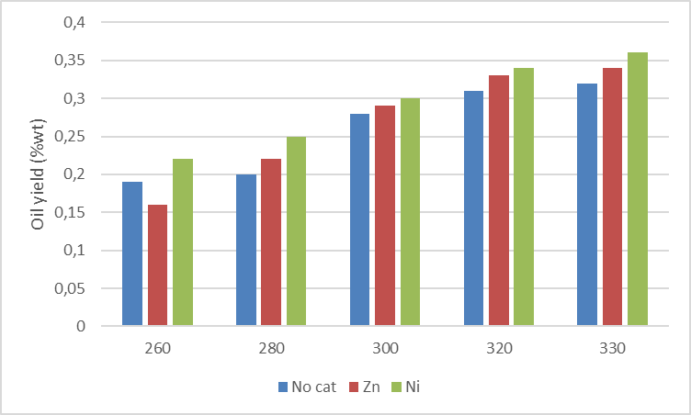 | 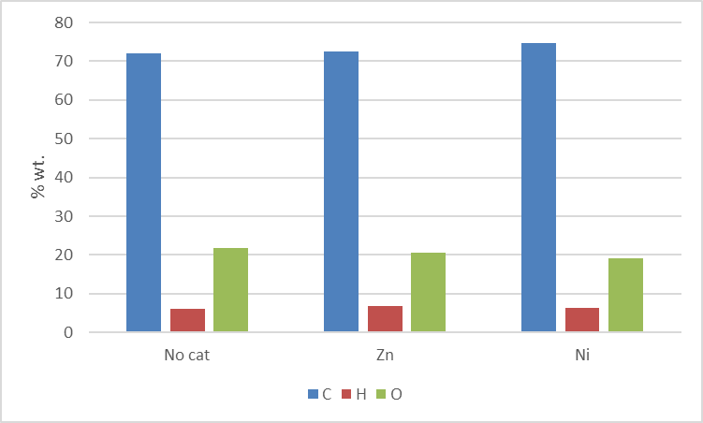

Figure 1. a) Oil yields as a function of catalysts and temperature b) Elemental oil composition.
4. Conclusions
Metal catalysts promotes the formation of the oily phase in the HTL of oak wood; with Ni the enhancement is about 25 % while with Zn 15 %. The quality of the oil is improved, the oxygen amount decrease leading to an increased calorific value which is 28.1 MJ/kg and 30.4 MJ/kg for the oils obtained without catalyst and Ni, respectively.
References
- L. Yang, L. Nazari, Z. Yuan, K. Corscadden, C.C. Xu, Q.S. He, Biomass Bioenerg 86 (2016) 191-198.
- I.M. Sintamarean, I.F. Grigoras, C.U. Jensen, S.S. Toor, T.H. Pedersen, L.A. Rosendahl, Biomass Convers. Biorefinery 7 (2017) 425–435.
- D.C. Elliott, T.R. Hart, G.G. Neuenschwander, L.J. Rotness, G. Roesijadi, A.H. Zacher, J.K. Magnuson, ACS Sustain. Chem. Eng. 2 (2014) 207–215.
- A. Dimitriadis, S. Bezergianni, Renew. Sustain. Energy Rev. 68 (2017) 113–125.
- Y. Miyata, K. Sagata, M. Hirose, Y. Yamazaki, A. Nishimura, N. Okuda, Y. Arita, Y. Hirano, Y. Kita, ACS Sustain. Chem. Eng. 5 (2017) 3562–3569
- B. de Caprariis, I. Bavasso, M.P. Bracciale, M. Damizia, P. De Filippis, M. Scarsella, J Anal Appl Pyrolysis 139 (2019) 123-130.

