Modelling of binary nucleation in Laminar Co-Flow Tube.
Tereza Trávníčková¹, Jaromír Havlica^{1,2}, Jan Hrubý³, Vladimír Ždímal⁴
1 Institute of Chemical Process Fundamentals of the CAS, v. v. i., Department of Multiphase Reactors, Prague, Czech Republic; 2 University of Jan Evangelista Purkinje, Ústí nad Labem, Czech Republic; 3 Institute of Thermomechanics of the CAS, v. v. i., Department D 2 - Thermodynamics, Prague, Czech Republic; 4 Institute of Chemical Process Fundamentals of the CAS, v. v. i., Department of Aerosols Chemistry and Physics, Prague, Czech Republic
*Corresponding author: travnickovat@icpf.cas.cz
Highlights
- Binary nucleation of H₂SO₄ and H₂O
- Measuring at Laminar Co-Flow Tube.
- Numerical and analytical models comparison.

1. Introduction
Particle nucleation is one of the important phenomena encountered in both chemical engineering and environmental studies. The Laminar Co-Flow Tube (LCFT) was designed for experimental measurement of binary and ternary nucleation of mixtures of atmospheric aerosols at laboratory conditions, most often H₂SO₄ + H₂O + amines (MEA, TEA)/terpenes (α-pinene, limonene). When nucleating components are entrained co-currently with H₂S0₄ in the axial flow, a clearly defined nucleation zone can be formed in the axial region of the chamber. As a result, the losses of the formed particles on the device walls are minimized. Laminar flow allows mathematical modeling of velocity and partial pressure profiles in the chamber. From these, it is then possible to predict the shape and size of the nucleation zone and subsequently the nucleation rate. Two models were used for mathematical modeling of momentum and mass transfer in the LFDC; 2D axisymmetric CFD model and simplified 1D analytical model. A parametric study was carried out using both models and the influence of the individual simplifications of analytical model on overall behavior of the system was discussed.
2. Methods
The measurement of H₂SO₄ nucleation with water vapor using LCFT is described in detail in publication [1]. The LCFT device consists of two coaxial tubes. A mixture of nitrogen (inert gas) with sulfuric acid is led into the inner tube. A nitrogen mixture with water vapor flows parallel within the inner and outer tube annulus. When laminar profiles are developed, axial flow merges with the annular one. The magnitudes and ratio of flow rates are set, so that the flow remains laminar after opening of the inner tube and both mixtures are in diffusional contact. When the concentrations of H₂SO₄ and water vapors are sufficiently high, in the nucleation zone, stable clusters are formed at a nucleation rate J. The nucleated particles grown to detectable size are counted by PSM (Particle Size Magnifier) counter.
To obtain nucleation isotherms, the experimental measurements were supplemented with numerical CFD simulations. 2D axisymmetric CFD model solves Navier-Stokes equations with equation of continuity and component mass balance equations. Simplified analytical 1D model assumes uniform (plug flow) velocity profile and negligible diffusion in axial direction. For nucleation rate modeling, a model of Wyslouzil et al. was used [2]. All results were normalized for relative humidity Rh = 0.38.
3. Results and discussion
The resulting nucleation isotherms obtained by experiment and subsequent modeling using the numerical model (v_{z}=v_{z}(r)) and analytical model with three different choices of plug flow velocities v_{z}=v_{avg} (average val. of radial laminar vel. profile), v_{z}=v_{max} (maximum of radial vel. profile in co-flow section), v_{z}=v_{i,max} (maximum of inner tube radial vel. profile) are clearly illustrated in the figure 1.
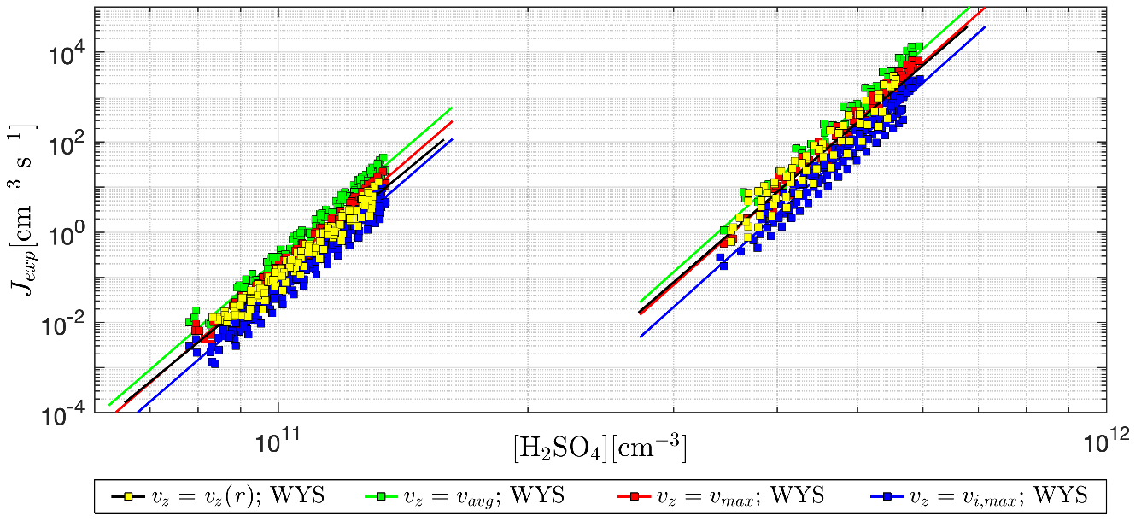
Figure 1. Comparison of nucleation isotherms 15 and 27°C computed by CFD numerical model v_{z}=v_{z}(r) and analytical model with different plug flow velocities: v_{z}=v_{avg,} v_{z}=v_{max} and v_{z}=v_{i,max}.
Deviations in the maximal experimental nucleation velocity are caused by different modeling of gas flow in the region of nucleation zone. For most of our experimental flow rate settings, plug flow rate v = v_{max} is the best choice, when the experimental nucleation rate can be underestimated down to 0.3 times and overestimated up to 2.3 times in comparison to 2D axisymmetric numerical model.
4. Conclusions
By appropriately selecting value of the plug flow rate in the analytical model, it is possible to achieve, that the location and shape of the nucleation zone will be similar and also the resulting nucleation rates will be estimated with sufficient precision. Usage of the analytical model is suitable for this type of nucleation experiments with the advantage of a significant saving the computing time.
Acknowledgement: This work was supported by the Czech Science Foundation [grant number 17-19798S]
References
[1] T. Travnickova, L. Skrabalova, J. Havlica, P. Krejci, J. Hruby, V. Zdimal, Tellus B, 70 (2018).
[2] B.E. Wyslouzil, J.H. Seinfeld, R.C. Flagan, K. Okuyama, J. Chem. Phys., 94 (1991) 6842-6850.

