The Power-to-Liquid Concept: A Novel process for the production of (Poly-) Oxymethylene Dimethyl Ether (OME)
Franz Mantei^{1, 2}, Lara Theiss¹, Mohamed Ouda¹, Dr. Achim Schaadt¹
1 Fraunhofer Institute for Solar Energy Systems ISE, Heidenhofstraße 2, 79110 Freiburg, Germany 2 Chair of Chemical & Process Engineering, TU Berlin, Fraunhoferstraße 33-36, 10587 Berlin, Germany
*Corresponding author: franz.mantei@ise.fraunhofer.de
Highlights
- A sustainable and efficient production of OME
- Overall Process energy efficiency of > 55 % starting from H₂ and CO₂
- Yield of > 45 % OME starting from H₂ and CO₂
1. Introduction
OME have interesting thermophysical and chemical properties which make them suitable for different applications as CO₂ absorption, solvent, in direct oxidation fuel cells (DOFC) and as diesel fuel blend or alternative. [1-3] OME have a relatively high energy density and are environmental benign which adds to their advantages as a fuel or chemical/solvent candidate. Especially OME_{n} with the chain length of n = 3-5 show fuel properties close to diesel fuel. Due to their high molecular bound oxygen content and missing C-C bounds, already low blends to diesel fuel can reduce soot emission considerably which enables a reduction for NO_{x} emissions. [4]
However studies regarding their applications and potential use as alternative fuel are extensive; a sustainable, economical, scalable and efficient industrial process for the production of OME₃₋₅ is still not realized. In this work a simple and efficient OME synthesis process will be introduced. The aim is to reduce the number of process units and to increase the process energy efficiency and total yield of OME₃₋₅ while considering scalability and economic feasibility. [5] The novel process addressed in this work comprises two steps, namely: (1) the oxidative dehydrogenation of MeOH towards Formaldehyde (FA) and OME₁ in a single reactor unit. (2) This mixture can subsequently be converted to OME₃₋₅ at mild conditions. A major challenge for the OME processes is the water management, since it is produced as a side product of the reactions starting from MeOH. Its separation using thermal separation units is a complex challenge due to the formation of several azeotropes, reactions and miscibility gaps, thus some research is done investigating alternative separation tehnologies using membranes, adsorption or extraction. [6, 7]
2. Methods
In order to evaluate the potential of the investigated process based on the oxidative dehydrogenation of MeOH to produce OME, the process was simulated using commercial process simulation software. Different process units were experimentally validated to ensure realistic behavior of the applied models. To increase the process energy efficiency, heat integration was conducted for the whole process covering the MeOH synthesis based on H₂ and CO₂ and the subsequent OME synthesis. To compare this process with alternative OME synthesis processes, key performance indicators (KPIs) were evaluated. Finally preliminary production cost estimation was conducted identifying the economic advantage of the investigated process.
3. Results and discussion
The production capacity of 35 kt OME per annum starting from H₂ and CO₂ to MeOH and further oxidative dehydrogenation to FA and OME₁, water separation and finally OME_{n} synthesis, is introduced. A scheme of the process is shown in Figure 1. The KPIs show great potential for the process in terms of process energy efficiency > 55% and yield of OME_{n} > 45% with estimated costs of > 1000 US$/t_{OME}. The costs are mainly influenced by the scale of the process and the costs for renewable H₂ which can be reduced in regions with lower costs for renewable electricity.
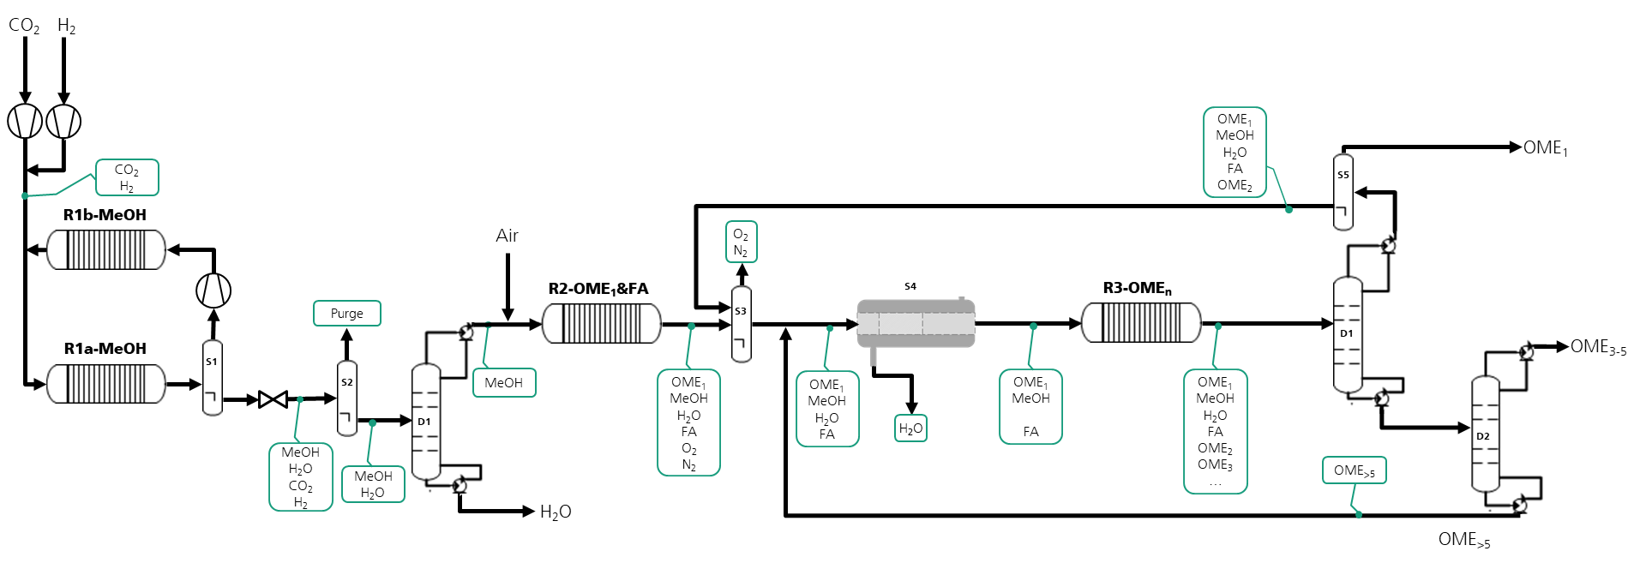
Figure 1 Scheme for the production of OME_{n} via oxidative dehydrogenation of MeOH starting from H₂ and CO₂
4. Conclusions
OME show promising properties for different applications. However, a sustainable, economical, scalable and efficient industrial process for the production of OME₃₋₅ is still not realized. A novel process for a sustainable and efficient production of OME at high yield > 45% and high process energy efficiency > 55% with production costs of ca. 1000 US$/t_{OME} was introduced. This cost is rather high for fuel applications but is promising for the chemicals and solvent market. The process steps are being validated in lab- and mini-plant scale and should be scaled up to several kt/a to validate the industrial application. In conclusion, the introduced process with the discussed KPIs offers a sustainable and economically feasible solution for the production of OME.
References

[1] Schappals, Breug-Nissen, Langenbach, Burger, Hasse, Journal of Chemical & Engineering Data, 2017, DOI: 10.1021/acs.jced.7b00718
[2] Ouda, Mantei, Hesterwerth, Bargiacchi, Klein, White, Reaction Chemistry & Engineering, 2018, DOI: 10.1039/C8RE00100F
[3] Gaukel, Pélerin, Härtl, Wachtmeister, Burger, Maus, Jacob, 37. Internationales Wiener Motorensymposium, 2016, 193–223
[4] Iannuzzi, Barro, Boulouchos, Burger, Fuel, 2017, DOI: 10.1016/j.fuel.2017.04.089
[5] Schmitz, Breitkreuz, Ströfer, Burger, Chemical Engineering Transactions, 2018, DOI: 10.3303/CET1869036
[6] Schmitz, Breitkreuz, Ströfer, Burger, Hasse, Chemical Engineering and Processing - Process Intensification, 2018, DOI: 10.1016/j.cep.2018.06.012
[7] Schmitz, Breitkreuz, Ströfer, Burger, Hasse, Journal of Membrane Science, 2018, DOI: 10.1016/j.memsci.2018.07.053

