Anaerobic digestion of model food waste at high and low concentration for the production of chemicals
Davide Dionisi, * Claudia Fernandez Martin, Serena Simonetti
University of Aberdeen, School of Engineering, Chemical and Materials Group, Aberdeen AB24 3UE, Aberdeen, Scotland, UK
*Corresponding author: davidedionisi@abdn.ac.uk
Highlights
- Anaerobic digestion of model food waste was investigated with waste concentration in the range 25-400 gCOD/l
- The total product yield at the end of the experiments was in the range 10-13 % (COD basis), unaffected by the feed concentration
- Lactic acid and acetic acids were the main products in experiments at high and low feed concentration, respectively.

1. Introduction
Short-chain organic acids (e.g. acetic, propionic, butyric, lactic) and alcohols are usually commercially produced from fossil fuels (e.g. natural gas) or food crops (e.g. bioethanol production from corn). The production of these chemicals from the anaerobic digestion of organic waste would be in principle a more attractive and sustainable process [1, 2]. So far research on the production of these chemicals using anaerobic digestion has been mainly carried out at relatively low feed concentration, with, correspondingly, low concentration of the products, low process productivity and high separation costs. This study aims to investigate the effect of feed concentration on the anaerobic fermentation of model food waste, with the aim at achieving the highest possible product concentration and yield and process productivity.
2. Methods
The model food waste was prepared based on the estimated composition of unavoidable food waste in the UK [3]. The composition of the most concentrated waste (feed A) included the following: yeast extract 80 g/l; wheat grass powder 72.1 g/l; sucrose 66.6 g/l; oleic acid 52.6 g/l; starch 45.7 g/l; peptone 26 g/l. Distilled water was used to prepare feed A (which had a concentration of 429 gCOD/l) and the diluted feeds B (1:2 dilution, 214 gCOD/l), C (1:4, 107 gCOD/l), D (1:8, 54 gCOD/l), E (1:16, 27 gCOD/l). The batch tests were carried out in agitated 300 ml glass vessels, operated at room temperature (24-26 ^{O}C), with uncontrolled pH and inoculated with the effluent of a completely-mixed commercial digester fed with organic and food waste. The batch tests lasted 42 days and were run in duplicate.
3. Results and discussion
Figure 1 shows the main results. The concentration of total products generally increased over time and reached 40 g/l with the most concentrated feed. Interestingly, the total product yield was virtually unaffected by the feed concentration, being in the range 10-13 % COD/COD. The pH dropped rapidly and remained acidic for feed A-D, while it increased to approximately 6.5 in the reactor with the most diluted feed (feed E), indicating some conversion of the acids into methane. A strong effect of feed concentration was observed on product distribution. The reactors with the most concentrated feeds (A, B) produced mainly lactic acid (about 80 % of the total products). The most diluted feeds (C, D, E) produced a wider spectrum of products, acetic acid being the main product, with low lactic acid concentrations. COD removal (not shown) from the liquid phase was very low with the concentrated feeds (A, B) and was the highest for the most diluted feed (E) (30 % COD removal), confirming that for this feed concentration some of the COD was converted to methane.
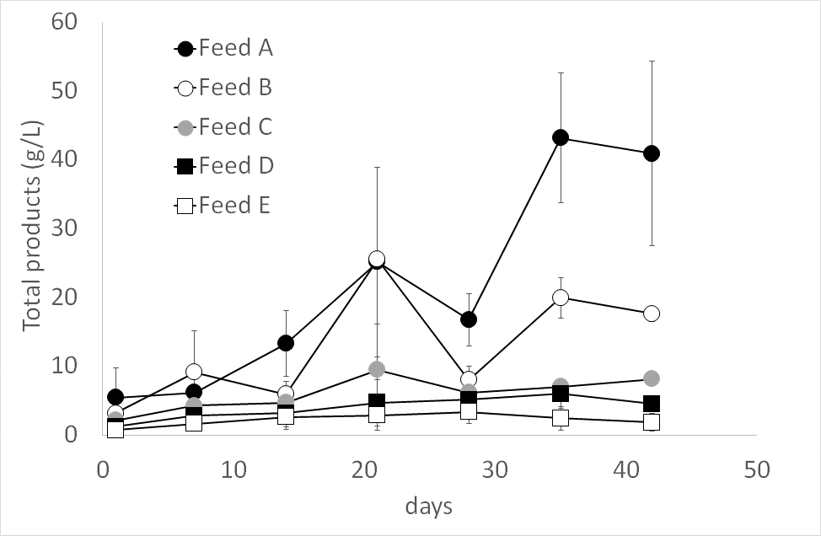 | 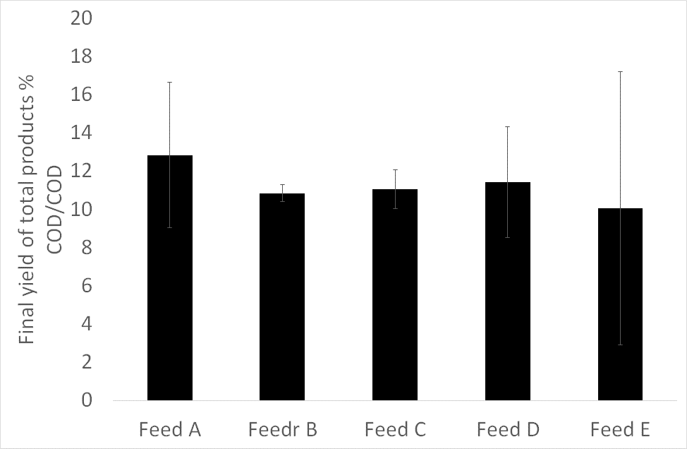
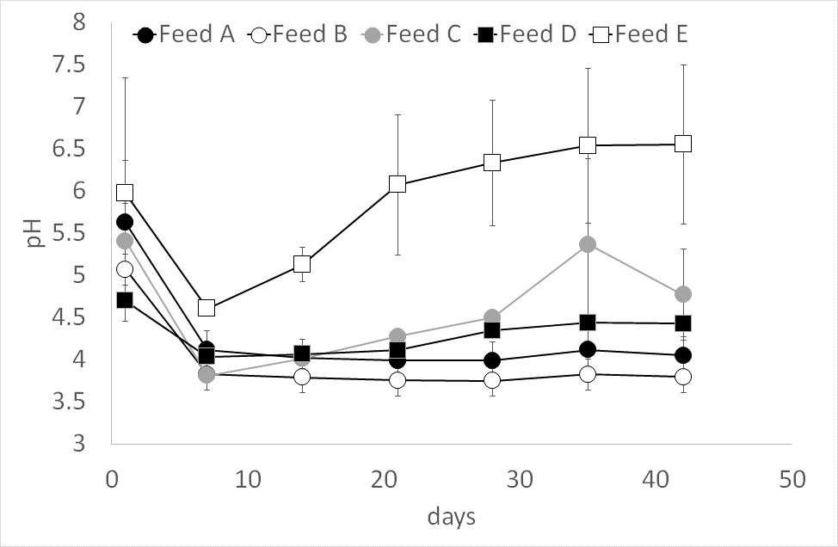 | 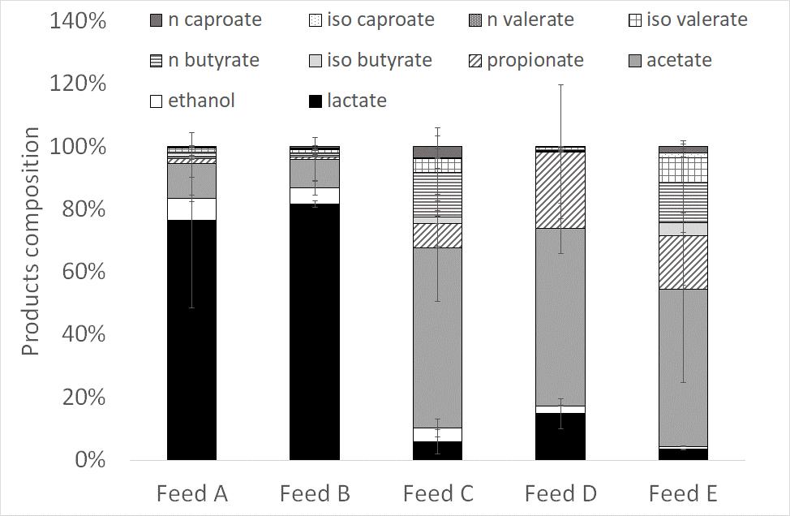
Figure 1. Main results of the batch tests
4. Conclusions
The results indicate that anaerobic digestion of food waste for the production of chemicals is feasible even with very high concentrations of the feed and with no pH correction, with no inhibition observed even a feed concentration of up to 429 gCOD/l. The research is ongoing with the aim to increase the product yield, concentration and productivity, using a combination of batch tests and SBR (Sequencing Batch Reactors) runs.
References
- D. Dionisi, I.M.O. Silva, Rev. Env. Sci. Biotechnol. 15 (2016) 213–242.
- J. Placido, Y. Zhang, Biom. Conv. Bioref. 8 (2018), 621-634.
- WRAP, 2009, Household Food and Drink Waste in the UK. Report prepared by WRAP. Banbury (UK).

