Up-scale fractionation of phenolic compounds using centrifugal partition chromatography
Sónia Ventura¹, João Santos¹, Mafalda Almeida¹, Ana Dias², Mara Freire¹, João Coutinho¹
1 CICECO, Departamento de Química, Universidade de Aveiro, 3810-193 Aveiro, Portugal
2 CESAM – Centre for Environmental and Marine Studies, Department of
Environment and Planning, University of Aveiro, 3810-193 Aveiro, Portugal
*Corresponding author: spventura@ua.pt
Highlights
- Phenolic compounds recognized as relevant building blocks.
- ABS were efficiently applied on their fractionation.
- CPC was efficiently applied on the scale-up of the process.

1. Introduction
Phenolic compounds are ubiquitous biomolecules exhibiting a wide range of physiological properties, with a wide range of different applications. In this work, aqueous biphasic systems (ABS) formed by polyethylene glycol and sodium polyacrylate, and electrolytes (inorganic salts or ionic liquids) were applied for the purification of caffeic, ferulic and protocatechuic acids, vanillin and syringaldehyde. The up-scale of the technology was assessed by successfully applying a centrifugal partition chromatography (CPC).
2. Methods
All materials and methods used are reported in detail in our previous work [1].
3. Results and discussion
Phenolic compounds are relevant biomass building blocks described by their many applications as the most versatile and important industrial organic chemicals. In this sense, these products are considered as economically attractive. In this work, polymer-based ABS (with PEG 8000 + NaPA 8000) using ionic liquids or inorganic salts as electrolytes, were studied in the separation of five model phenolic compounds (caffeic, ferulic and protocatechuic acids, and vanillin and syringaldehyde), all originated from lignocellulosic depolymerisation. The selection of the best ABS and its optimization was performed, followed by its application in CPC to reinforce the technique scale-up. After the development and characterization of the integrated process to fractionate the mixture of phenolic compounds, an environmental evaluation was done considering the carbon footprint as the main output. After the identification of the best ABS platform to separate each phenolic compound (PEG 8000/NaPA 8000/NaCl), its use in CPC followed. After optimizing the CPC operational conditions, it was also proved the success of the scale-up process, since, not only the results defined for the batch system were obtained but also the final process (Figure 1) developed showed to be simultaneously efficient and of low carbon footprint (36% of carbon footprint reduction for the best scenario explored). In this context, high recovery values were obtained, respectively, 87%, 84% and 65% for caffeic, ferulic and protocatechuic acids, and 82% for the aldehyde-rich fraction (composed of vanillin and syringaldehyde).
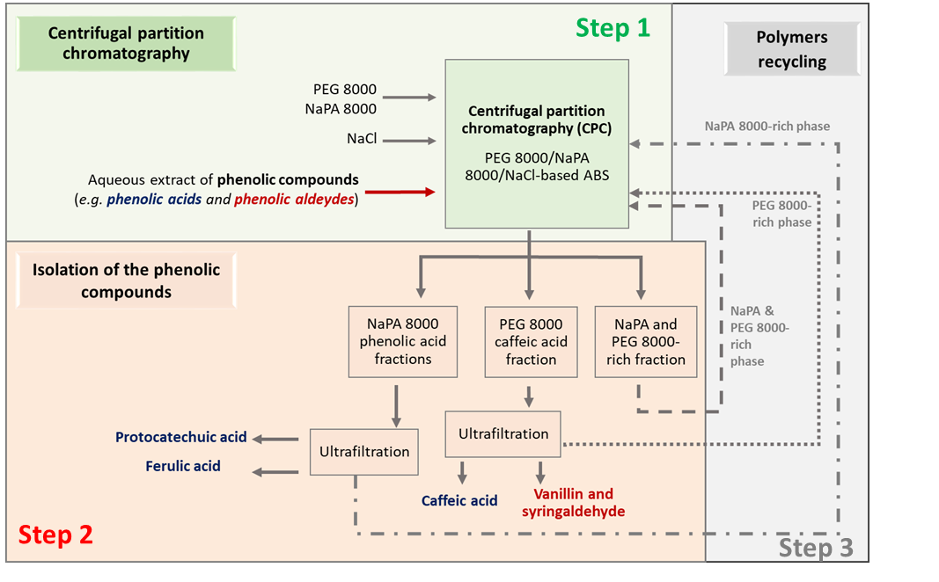
Figure 1. Schematic representation of the process developed. Adapted from [1].
4. Conclusions
An efficient and low carbon footprint up-scale process using CPC was successfully developed to separate phenolic compounds, showing its applicability for the processing of real matrices like agro-forestry and biomass wastes.

Acknowledgements:
This work was developed within the scope of the project CICECO-Aveiro Institute of Materials, FCT Ref. UID/CTM/50011/2019, financed by national funds through the FCT/MCTES. The authors are grateful for the financial support of the FCT for the doctoral grant of SFRH/BD/102915/2014 of J.H.P.M. Santos. S.P.M. Ventura acknowledges for contract IF/00402/2015. M. G. F. acknowledges the European Research Council (ERC) for the grant ERC-2013-StG-337753. The authors acknowledge the FCT funding through the project “Multipurpose strategies for broadband agro-forest and fisheries byproducts valorisation: a step forward for a truly integrated biorefinery (PAC – Programa de atividades Conjuntas) ref: SAICTPAC/0040/2015. A.C.R.V. Dias acknowledges FCT/MCTES for a contract under Investigador FCT 2013 contract number IF/00587/2013, and for the financial support to CESAM (UID/AMB/50017/2019), through national funds, and the cofunding by FEDER, within the PT2020 Partnership Agreement and Compete 2020.
References
- J.H.P.M. Santos, M.R. Almeida, C.I.R. Martins, A.C.R.V. Dias, M.G. Freire, J.A.P. Coutinho, S.P.M. Ventura, Green Chem. 20 (2018) 1906-1916.

