Aerosol Photobioreactors: a New Possibility for Cultivation of Phototrophic Biofilms.
Judith Stiefelmaier¹, Dorina Strieth¹, Björn Wrabl¹, Roland Ulber¹*
1 Chair of Bioprocess Engineering, TU Kaiserslautern, Gottlieb-Daimler-Str. 49, 67663 Kaiserslautern, Germany
*Corresponding author: ulber@mv.uni-kl.de
Highlights
- Terrestrial cyanobacteria are versatile organisms but only sparsely investigated.
- Aerosol photobioreactors for surface-associated cultivation of terrestrial biofilms.
- Investigation of biofilm growth under varied cultivation conditions possible.
- Investigation of surface-adhesion of biofilms on different substrates.

1. Introduction
Cyanobacteria, belonging to the oldest known microorganisms, are a diverse group of phototrophic bacteria with a wide product spectrum. For instance, cyanobacterial biomass is already used as food additive and pigments can be used as natural stains in foods, cosmetics or clothing, which fits costumer preferences. Several antimicrobial substances have already been discovered in different cyanobacterial strains and in their extracellular polymeric substances (EPS). In addition, EPS amongst others contain various polysaccharides. A subcategory of cyanobacteria represent the so-called terrestrial cyanobacteria. Those generally grow in biofilms embedded in EPS and are attached to air-exposed surfaces such as stone, soil or bark. However, due to a lack of suitable cultivation systems, terrestrial cyanobacteria have only been sparsely investigated. The emerse photobioreactors (ePBR) developed at the Chair of Bioprocess Engineering (TU Kaiserslautern, Germany) provide a possibility for the surface-associated cultivation of terrestrial cyanobacteria with media-supply via an aerosol [1]. This enables the more detailed investigation of terrestrial cyanobacteria with the prospect of finding new products.
2. Methods
The hexagonal emerse photobioreactor (hePBR) (see Figure 1 A) consists of a hexagonal glass vessel with a plastic lid, a holding for three variable cultivation surfaces and several connections. Due to the reactor geometry the biofilm on the cultivations surfaces can be lighted uniformly with LEDs. The aerosol for media-supply is generated in an extra vessel by an ultrasonic transducer based on a patent by Schmidt and Just [2] and subsequently transferred into the reactor vessel. After cultivation in the hePBR the cyanobacterial biomass was analyzed concerning EPS and pigment content. To evaluate biofilm adhesion to the cultivation surface, grown biofilms were overflown with liquid medium at different flow speeds. Biofilm deformation and peel off were documented by optical coherence tomography (OCT).

3. Results and discussion
Cultivations in the hePBR were conducted successfully at different temperatures, on different substrates and with different wavelengths of light. Hereby, the effect on biomass and EPS formation and pigment composition was investigated. Variations of cultivation conditions revealed a differing impact on biomass productivity as well as on EPS content (Figure 1 B). Furthermore, by varying light wavelengths pigment composition and content could be influenced (data not shown). Increasing adhesion of the biofilm to the cultivation surface during emerse cultivation could be shown by OCT while applying different flow velocities. This set-up allows the comparison of adhesion to different substrates and of different cyanobacterial strains.
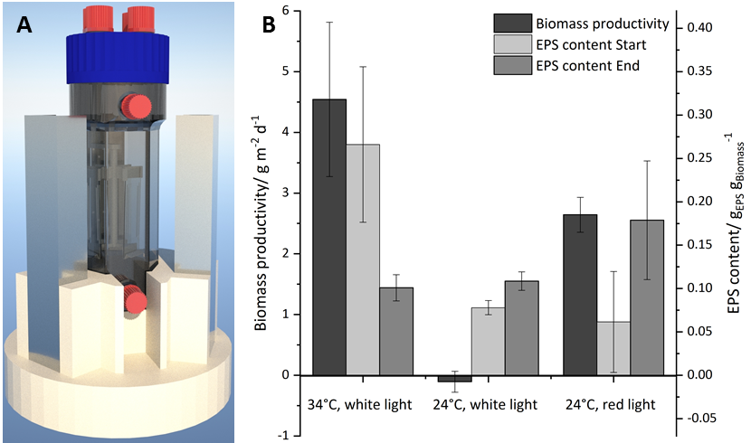
Figure 1. A: CAD model of the hePBR; B: Effect of different temperatures and light colors on biomass productivity and EPS content of Coleofasciculus chthonoplastes
4. Conclusions
The hePBR offers a possibility for surface-associated cultivation of terrestrial cyanobacteria. This allows the enhanced research of these microorganisms under conditions mimicking their natural habitat, which can help discovering further potential products.
References
- D. Strieth, J. Schwing, S. Kuhne, M. Lakatos, K. Muffler, R. Ulber, A semi-continuous process based on an ePBR for the production of EPS using Trichocoleus sociatus, Journal of biotechnology 256 (2017), 6–12.
- T. Schmidt, L. Just, Vorrichtung und Verfahren zur Kultivierung und Generierung von biologischem Material in einem Nährstoffnebel; 2006, WO2007068467A1

This project was financially supported by BMBF (031B0068D) and DFG (UL 170/16-1).

