Fast Pyrolysis of Agricultural Eggplant Stalk Waste
Merve Atıl, H. Ferdi Gerçel
Department of Chemical Engineering, Eskişehir Technical University, Eskişehir 26555, Turkey
*Corresponding author: hfgercel@eskisehir.edu.tr
Highlights
- Pyrolysis experiments of the eggplant stalk were carried out in the nitrogen gas atmosphere.
- The effects of pyrolysis temperature on the pyrolysis product yields were investigated.
- The highest liquid product yield was obtained as 28.16 wt.%.
1. Introduction
Pyrolysis is one of the thermochemical conversion methods of biomass, carried out in the complete or near complete absence of an oxidizing agent (air or oxygen), typically at 400–700°C to provide complex fractions of gases, condensable liquids (tars), and char (solid residue) [1]. Fast pyrolysis is the rapid thermal decomposition of biomass in the absence of oxygen. The main product of fast pyrolysis is a dark brown and viscous liquid, known as bio-oil [2, 3]. In this study, eggplant stalk was investigated as a source of biomass, pyrolysis was carried out in a nitrogen gas atmosphere and the effect of pyrolysis temperature on yields of the pyrolysis product was investigated.
2. Methods
Agricultural waste eggplant stalk was collected from Kızılinler village around the city of Eskisehir, which is located in central Anatolia, Turkey. Prior to use, the sample was dried at moisture free and shade conditions, ground with a high-speed rotary cutting mill and then sieved to a uniform size (0.425–0.6 mm). Pyrolysis experiments were carried out in a 310 stainless steel, fixed bed tubular reactor in an inert gas atmosphere. Pyrolysis of the eggplant stalk conducted in nitrogen atmosphere flowing at a rate of 100cm³/min, at temperatures of 400, 450, 500, 550, 700°C with a heating rate of 300°C/min. After pyrolysis, the resulting solid char was separated, weighed and the char yield was calculated. The amount of water, collected from the liquid product-water mixture in the cooling containers, was determined. The tar was removed by washing with dichloromethane, then the solvent was removed in the rotary evaporator to calculate the liquid product yield and also the pyrolysis conversion from the weight loss in the reactor. Gas yield was calculated from the total mass balance. Chemical composition of liquid was determined by liquid column chromatographic fractionation. The liquid product was separated into two fractions as n-pentane soluble and insoluble compounds by using 100 mL pentane. The pentane soluble material was further separated on activated silica gel, pretreated at 105ºC for 2 h prior to introduction into a 20 cm high and 25 mm i.d. column. The column was eluted with n-pentane, toluene, and methanol to produce aliphatic, aromatic, and polar fractions successively. Chemical characterization of liquid, n-pentane eluate, toluene eluate and methanol eluate samples were carried out using potassium bromide (KBr) disks in a Fourier transform infrared spectrophotometer (FTIR, Perkin Elmer Frontier) in a scanning range of 4000-400 cm⁻¹.
3. Results and discussion
Pyrolysis product yields at different pyrolysis temperatures are presented in Figure 1. The highest overall conversion of 76.05 wt.% was obtained at the ﬁnal pyrolysis temperature of 700°C under the nitrogen, ﬂowing at a rate of 100 cm³/min. The liquid yield also increased as pyrolysis temperature was raised from 400 to 500–550°C, although a decrease in the liquid yield was observed at higher pyrolysis temperature of 700°C.
FTIR spectra of the n-pentane, toluene, methanol eluate and the liquid product samples are presented in Figure 2. The O-H stretching vibrations between 3200 and 3400 cm⁻¹ indicate the presence of phenols and alcohols; the C-H stretching vibrations, observed between 2800 and 3000 cm⁻¹ and C-H deformation vibrations between 1350 and 1475 cm⁻¹ indicate the presence of alkanes. The C=O stretching vibrations between 1650 and 1750 cm⁻¹ indicate the presence of ketones or aldehydes. The absorbance peaks between 1575 and 1675 cm⁻¹ represent C=C stretching vibrations are arising from the presence of alkenes and aromatics.
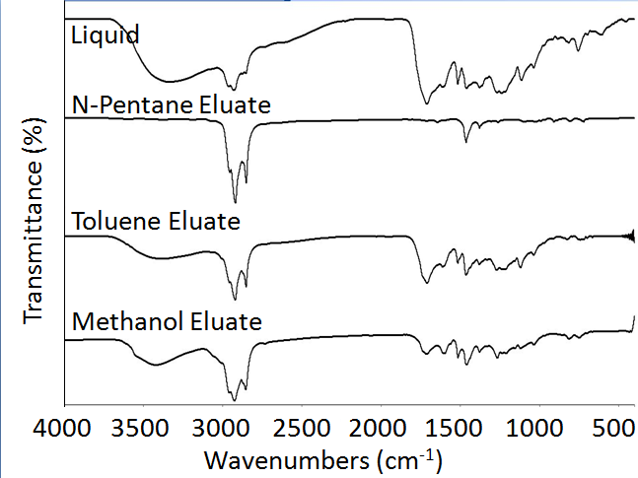 Figure 1. Pyrolysis product yields at different pyrolysis temperatures Figure 2. FTIR spectra of the n-pentane, toluene, methanol eluate and the liquid product samples.
4. Conclusions
FTIR spectra of the n-pentane, toluene, methanol eluate and the liquid product samples demonstrated that the functional groups of the liquids are consistent with those of the liquids and the chromatographic fractions obtained from eggplant stalk. The maximum liquid yield from eggplant stalk were achieved at the pyrolysis temperature of 550°C, under 100 cm³/min nitrogen ﬂow rate. The highest overall conversion of 76.05 wt.% was obtained at 700°C.
References
- R. Alén (Eds.), Biorefining of Forest Resources, Paper Engineers’ Association, Finland, 2011, pp. 55–114.
- A.V. Bridgwater, G.V.C. Peacocke, Renew. Sustain. Energy Rev. 4 (2000) 1–73.
- M.R. Rover, Fuel 153 (2015) 224–230.

