Improved FOS fractionation using inhomogeneous membrane cascades
Zulhaj Rizki^{1,*}, Anja Janssen¹, Remko Boom¹ and Albert van der Padt¹
1 Wageningen University, Food Process Engineering Group, the Netherlands
*Corresponding author: zulhaj.zulhajrizki@wur.nl
Highlights
- Inhomogeneous filtration cascades fractionated FOS into 3 fractions vary in sizes.
- Separation was improved using more stages and altering configurations.
- Optimizing the process considering all performance indicators was done using a multi-criteria decision making approach.

1. Introduction
Fractionating fructo-oligosaccharides (FOS) into multiple fractions that vary in degree of polymerization (DP) is beneficial to produce prebiotics with different functionalities. Membrane separation becomes a favorable option for fractionating FOS due to its mild condition and high selectivity. However, a single stage membrane can only produce 2 fractions at a time and its maximum achievable purity is limited. Using a cascaded multi-stage membrane system overcomes that purity limitation and opens a possibility to extract multiple products at once. We used an inhomogeneous membrane cascade system to fractionate FOS into 3 different products rich in monosaccharides (DP1), DP3 and DP≥5 simultaneously using a side-stream approach (Figure 1.a). Differentiating from the firstly introduced ideal cascade [1], the inhomogeneous cascades allow us to use different set up at each stage [2] resulting a better separation performance. Having an independent system and multiple products raise new design questions: Which set up to use at each stage? And which (product) parameter should be optimized? Aided by a mathematical model, we simulated various possible setups and developed a method to select the best setup using a multi-criteria decision making approach.
2. Methods
A model based on characterization of 3 types of membranes (GE, GH and GK from GE Osmonic, USA, model 1812) was developed to predict the performance of single stage membranes. Such model was later expanded for cascaded systems [3]. A set of combinations was used to simulate the purities, yields and separation factors of products that are rich in DP1, DP3 and DP≥5. The simulated values were then used to develop an optimization procedure to select the best setup with compromised performance. Applying this procedure, we optimized the process by using 4 and 5 stages and altering the configurations (S- and L-strategies) while keeping the stage number at 3.
3. Results and discussion
The fractionation cascades with side stream approach were able to fractionate FOS into 3 different products with enhanced purity compare to the feed having maximum purities of 66% for DP1 (from 9%), 33% for DP3 (from 24%) and 54% for DP≥5 (from 34%). These maxima were achieved by using a 4-stage design. The 4-stages designs create asymmetric configurations towards the top or bottom region resulting in a more specific separation. Similar considerations were used in the S- and L-strategies to improve the purities further while keeping the stage number at 3.
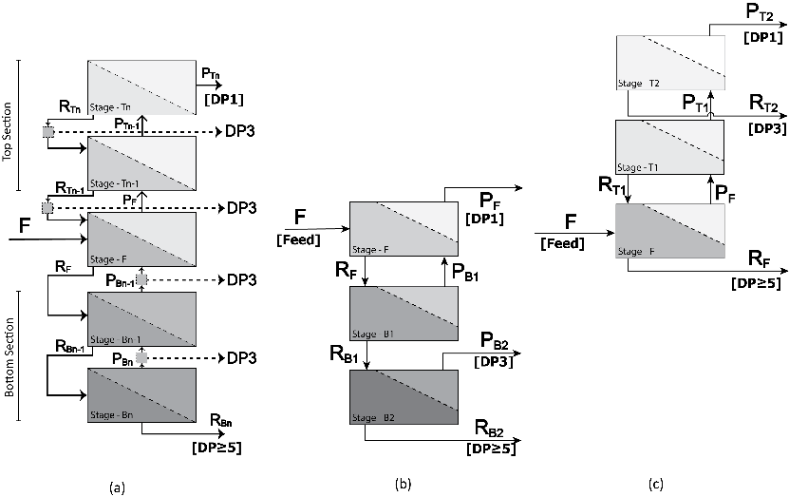
Figure 1. Configuration of (a) generalized fractionation cascades with side streams and example modification with (b) S-strategies and (c) L-strategies for 3 products.
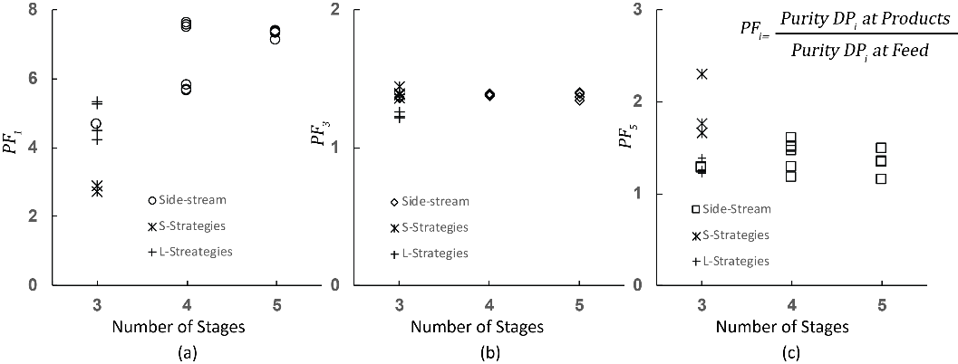
Figure 2. Maximum purification factor of (a) DP1, (b) DP3 and (c) DP≥5 achieved by membrane cascade system using side-stream approach for 3, 4 and 5 stages and modification of 3 stage cascades with S- and L-strategies.

Achieving those maximum purities could only be done by sacrificing the purities of other components or the yields. Using the multi-criteria decision making approach, a setup that is giving compromised performance indicators (purities, yields and separation factors) could be chosen.
4. Conclusions
Fractionating FOS into 3 products was performed using membrane cascaded systems. The system was improved by using more stages and altering the configuration. The approach to improve and optimize a fractionation process that we described here is applicable for other processes (not limited to membrane systems). A predictive model for a single process is required. This single stage model has to be expanded in the comprehensive model to predict the whole system. This comprehensive model needs to be used for optimization.
References
[1] E.N. Lightfoot, et.al. , Biotechnol. Prog. 24 (2008) 599–605.
[2] V. Aguirre Montesdeoca, et.al., J. Memb. Sci. 520 (2016) 712–722.
[3] Z. Rizki, et.al, Sep. Purif. Technol. 221 (2019) 183–194.

