Ferroniobium of the Colombian Guania Shield for obtaining rare earth metals: crystallographic analysis
Michelle Chico^{1*}, Aida Liliana Barbosa²
¹ Chemical Program. Faculty of Exact and natural sciences. Laboratory of research in catalysis and new materials (LICATUC). Universidad of Cartagena. Colombia.
abarbosal@unicartagena.edu.co
Highlights
• Niobium ore deposits in the Guinía-Colombia were studied founded niobium, zirconium, cobalt and titanium.
• The presence of radioactive elements in trace (uranium, thorium, curium, praseodymium) was evidenced in the materials using Raman spectroscopy and FRX.
• Solvometallurgy techniques were used for the separation of REEF and oxide of Nb and Ta, obtaining a solid yellow corresponding with the FeC₂O₄

1. Introduction
The Guinia Shield in the area of Inírida-Colombia has been found pirocloros with the presence of oxides of Ti, W, Ta and Nb often enriched with U, Hf, Zr and rare earth elements. 1
The most effective and frequently applied solution method for mineral specimens containing Ta and Nb implies the use of HF as a leachate reagent, experiencing the formation of different soluble metal fluoride complexes such as Heptafluoruros, Hexafluoruros or Oxifluoruros, [6]. Solvometalurgicos processes are presented as an alternative to conventional metallurgical, which impact environmentally by the use of polluting inorganic acids.
2. Methods
The samples of niobium ore were collected on "El Zancudo" Guinía (Colombia). The specimen was dried and pulverized, passed by sieve 100mesh and was characterized by stereoscopic microscopy, Laser-Raman spectroscopy, and X-ray diffraction powder (XRD) and X-ray fluorescence (FRX)). The extraction of Nb and Ta of Ferriniobio use solvents 2-octanol and Metilisobutilcetona, as extraction agents. [2.4]

3. Results and Discussion
FRX analysis showed high percentages of SnO₂, TiO₂, Nb₂O₅ and Ta₂O₅, percentages about 8% of Fe₂O₃ and ZrO₂, below 3% w/w MnO, W, Al₂O₃, SiO₂. Stereoscopic optical microscopy, show presence of transparent quartz, iron ore with uneven surface, grey metals with metallic sheen that were related to niobium, tungsten and zirconium.

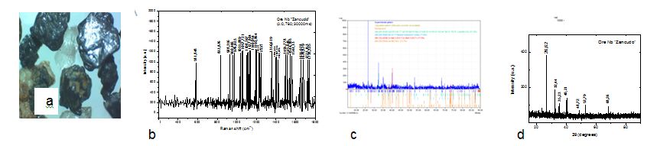

Figure 1. (a) External of optical microscopy Nb ore 3.5x. (b) Raman spectrum
of outer layer (0.780- 30000ms). (c) and (d) DRX pattern Ore Nb
Feldspars were seen as subhedral-shaped crystals of white and pink color, together with magnetite with rhombic faces of metallic luster and black color. Raman signals features in 581.848 cm⁻¹ it associated with stretch Nb-O, possibly of the NbO₂, one observes two bands located both with approximately 677cm⁻¹, assigned to phases of magnetite Fe₃O₄, the peaks or signals quite intense at 1037 cm⁻¹, 1113 cm⁻¹ and 1235 cm⁻¹ were characteristic of hematite Fe₂O₃, the band 833.876 cm⁻¹ was reported to be consistent with uranium oxide [3]. XRD analysis record peaks in 2 θ = 26.62, 2 θ = 32.44, 2 θ = 35.23 and 2 θ = 40.21, were characteristic of metals such as zirconium, titanium, niobium and cobalt.
4. Conclusions

The method of extraction with solvents led to two major products one of them iron oxalate, which was extracted to treat the leachate with metil butyl ketone and the subsequent washing of the loaded metil butyl ketine, which allowed the obtaining of a solid Niobium white, when the solution reached pH 7 by adding ammonia. These results show that the proposed method is potential for the purification of the native mineral.
References
- Cramer, T, Et Al. Caracterización de depósitos aluviales con manifestaciones de tantalio y
niobio (“coltán”) en las comunidades indígenas de matraca y caranacoa, Guainía. INGEOMINASUNAL. 2011.
- T. E. Amer, M. G. A. El-azm, and R. M. Issa, ―Liquid – liquid extraction of tantalum and niobium by octanol from sulfate leach liquor,‖ Arab. J. Chem., vol. 5, no. 1, pp. 31–39, 2012.
- A. Timofeev, A. A. Migdisov, and A. E. Williams-jones, ―An experimental study of the solubility and speciation of tantalum in fluoride-bearing aqueous solutions atelevated temperature,‖ Geochim. Cosmochim. Acta, vol. 197, pp. 294–304, 2017.
- Novoa, L,. Cortes, L. E, Gonzalez, E, Jimenez A,.Cortes,L.G, Ojeda,M and Barbosa,A.L Evaluation of Anticorrosive Effect of Niobium Carbide Coating Applied on Carbon Steel Chemical Engineering Transactions. 57 p.p 1386-1392,2017

Acknowledgement to Colciencias by grant project 004-2016. Geoscience Program.

