Enzymatic hydrolysis of Olive Solid Waste for extraction of polyphenols and reducing sugars using different cellulase enzymes
Carlos Zambra^{1*}, Susana Nieto², Pedro Lozano², Julio Romero³
1 Departamento de Ingeniería Mecánica, Universidad de Talca, Curicó-Chile; 2 Departamento de Química, Universidad de Murcia, Murcia-España; Departamento de Ingeniería Química, Universidad de Santiago, Santiago-Chile
*Corresponding author: czambra@utalca.cl
Highlights
- Olive Solid Waste have high concentration of valuable compound.
- Enzymatic hydrolysis would allow increases the polyphenols concentration and reducing sugar.
- The enzymes can be recovered by means filtration.

1. Introduction
The intake of natural antioxidants and waste valorisation are issues of great importance for improving human health and achieve a modern and efficient industry. Powerful natural antioxidants can be found in high concentrations in waste from the olive oil industry [1]. The high concentration of fiber in the Olive Solid Waste (OSW) suggest that enzymatic hydrolysis with cellulase enzymes would allow to obtain an increase of the polyphenols concentration and reducing sugar. In this work the enzymatic hydrolysis of OSW is studied. One of the main drawbacks associated with the use of enzymes are, in many cases, their high production costs. It is for this reason that the recovery of the enzyme from the mixture obtained from the enzymatic hydrolysis is studied.
2. Methods
OSW samples were obtained directly from an olive oil factory located in the Maule Region, Chile. Three types of cellulase enzymes, Celluclast®, Viscozyme L® and Carezyme®, were used in the enzymatic hydrolysis tests. Before being used the enzymes were filtered in a cartridge vivaflow 50 (Sartorious) of 30,000 MWCO (molecular weight cut off). Once filtered, they were refrigerated at 5 ° C until they were used. Samples of 20 grams of OSW and distillate water were mixed with enzymes in volumes of 2.5 ml and 4 ml to obtain a final volume of 182.5 ml in an Erlenmeyer flask. The enzymatic hydrolysis was conducted at 50°C, pH 4.8 and 170 rpm in an incubator and orbital stirring YIHDER (LM-450D). The duration of enzymatic hydrolysis was 120 min. The total polyphenol content and the presence of reducing sugars were determined by colorimetric methods with the Folin-Ciocalteu and the 3,5-dinitrosalicylic acid (DNS) reagent, respectively. A method to recovery the enzyme was tested. The final mixture of the enzymatic hydrolysis was placed in filters Vivaspin Turbo 15 (30,000 MWCO) Sartorious® and these in turn in a Gemmy centrifuge (PLC-0.5) at 2000 rpm for 30 min. The retained liquid is used to carry out a new enzymatic hydrolysis. The cycle is repeated five times. The recovery of the enzyme is quantified according to the yield in the increase of total polyphenols obtained in each cycle.
3. Results and discussion
Figure 1(a) shows the final concentrations of total polyphenols obtained after 120 minutes of enzymatic hydrolysis with two different volumes of enzyme added (2.5 ml and 4 ml). The total polyphenol content did not exceed 0.01 (g GAE/100 g DM) when hydrolysis was performed without adding enzyme. This value is practically the same to the measured initially (not showed in Fig. 1). All the enzymes tested increase the concentration of total polyphenols. The enzyme Celluclast® achieved the best performance with respect to the increase in total polyphenols (1.01 g GAE/100 g DM for 4ml of added enzyme) while the one with the worst performance was Carezyme® (0.2 g GAE/100 g DM). In figure 1(b) it is observed that the content of reducing sugars has no variation when hydrolysis is performed without adding enzyme (0.45 g glucose / 100 g DM). The enzyme Viscozyme L® showed the best performance to increase the concentration of reducing sugars (19.8 g glucose / 100 g DM for 4 ml of added enzyme). Figure 1 (c) shows the results of total polyphenols after six cycles of enzymatic hydrolysis. The enzyme used in this case was Viscozyme L. Figure 1 (c) shows the results of total polyphenols after six cycles of enzymatic hydrolysis operation. In this study, the increase in the concentration of polyphenols by enzymatic hydrolysis using the liquid retained in the filter, was associated with the quantity of enzyme recovered. Between each one of the cycles of operation the procedure of recovery of the enzyme described in the previous section was carried out. The enzyme used in this case was Viscozyme L. The relative percentage difference of the concentration of total polyphenols reached by the enzymatic hydrolysis decreases up to 68 percent after six cycle of operation
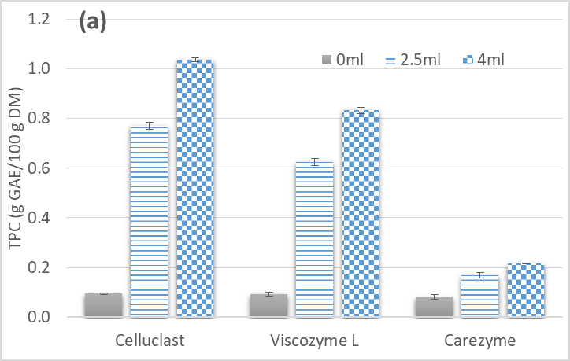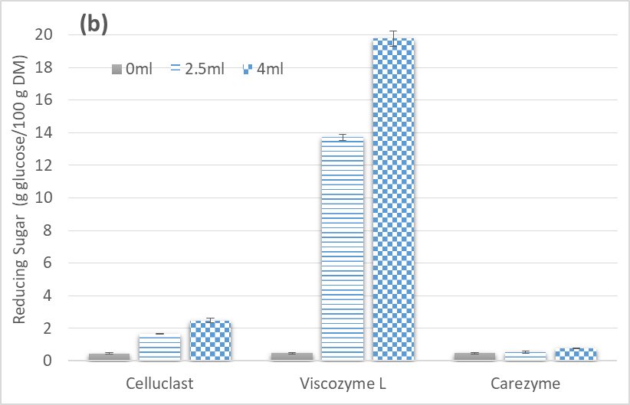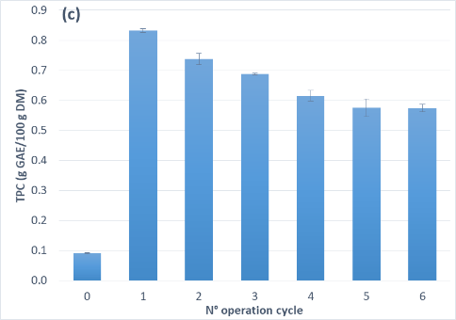
Figure 1. Concentration of total polyphenols (a) and reducing sugars (b) from OSW with three different enzymes and total polyphenols concentration obtained in each operation cycle after the recovery by filtration.
4. Conclusions
In this work was studied the increase in the concentration of total polyphenols content (TPC)) and the reducing sugar (RS) in the OSW using three types of cellulase enzyme. The Celluclast® and Vizcozyme L® shown the best yield for total polyphenol content and reducing sugar increases, respectively.
The physical method studied to recuperate the enzyme shown that its activity to augment the total polyphenols content decrease up to a 68 percent after six operation cycles.
References
- D. Makris, G. Boskou, N. Andrikopoulos, J. Food Comp. Anal. 20 (2007) 125-132

