Experimental analysis on the mixing of two parallel bubbly flows.
Corné Muilwijk*^{,1}, Harry E. A. Van den Akker^{1,2}
¹Bernal Institute, University of Limerick, V94 T9PX, Limerick, Ireland
^{1,2}Transport Phenomena Lab, Department of Chemical Engineering, Delft University of Technology, Van der Maasweg 9, 2629 HZ, Delft, The Netherlands
*Corresponding author: Corne.Muilwijk@ul.ie
Highlights
- Mixing of two parallel vertical bubbly flows of various superficial liquid/gas velocity
- Bubble image velocimetry approach to study mixing patterns
- Gas fraction and bubble velocity measurements using optical fiber probes

1. Introduction
Gas liquid contacting is one of the most important operations in the chemical and biochemical industry. Aerated vessels offer a high degree of mixing, heat and mass transfer, while local shear rates are relatively low. Computational Fluid Dynamics are widely used to assist in the design of new (bio)-reactors. The on-going development of these numerical models, often on the basis of a single bubble size, requires precise experimental data for validation purposes. We present experiments on the mixing pattern of two parallel bubbly flows with an almost uniform (initial) bubble size distribution.¹ We studied mixing patterns of both a uniformly and non-uniformly aerated rectangular flow channel, with and without vertical liquid co-flow.
2. Methods
Fig. 1 shows a sketch of the bubbly flow channel. Two separate parallel bubbly streams (Left and Right) are mixed in a rectangular flow channel after the trailing edge of the splitter plate. The superficial gas and liquid velocities, for each of the inlet compartments, is in the range 0.5-6.25 and 0-50 cm/s, respectively. Large uniform bubbles, 4-8 mm in diameter, are formed by needle spargers² to yield an overall void fraction in the range 2 - 25 %. We studied the mixing pattern
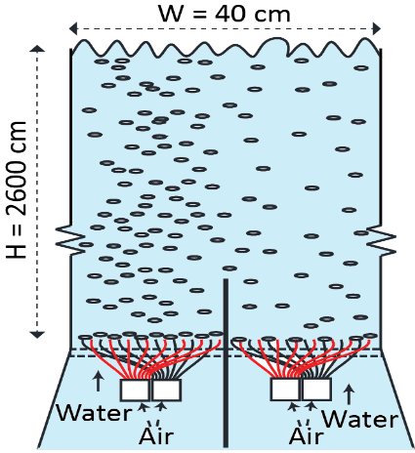
Figure 1. Sketch (not on scale) of the mixing of two parallel bubbly flows with different superficial liquid/gas velocities.
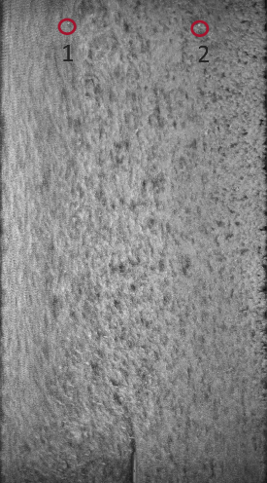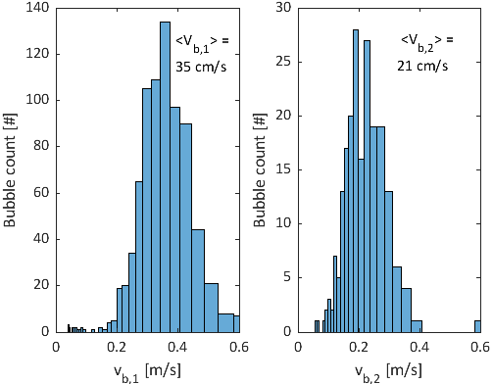
Figure 2. Left: Visualization of bubble streaks. Higher superficial gas velocity on the left size of the column. Bubble probe positions are denoted with a circle. Right: bubble velocity histograms of both monitoring points.
downstream the trailing edge of the splitter plate as a function of the inlet superficial gas and liquid velocities using dual-tip optical fiber probes (local void fraction, bubble velocities and bubble chord lengths), Bubble Image Velocimetry (macroscale mixing pattern) and Laser Doppler Velocimetry (local liquid velocities and turbulence levels).
3. Results and discussion
Fig. 2 (left) shows bubble streaks of an in-homogeneously aerated column (no liquid co-flow). The inlet superficial gas velocities on the left and right side of the column are 1.38 and 1.12 cm/s respectively. A recursive image correlation technique is adopted to calculate the displacement of bubble parcels to obtain local gas velocities for a range of operating conditions. Large self-organizing flow structures arise as a function of the difference in both (left, right) inlet conditions.
Bubble probes are installed in the flow channel as denoted in Fig. 2 by point 1 (left) and point 2 (right) and the measured time-averaged gas fraction (500 s) for both probes is 5.7 and 4.5 % respectively. The right side of Fig. 2 shows the bubble velocity distributions. For the case shown, we observe normally distributed bubble velocities of 35±10 cm/s on the left and 21±6 cm/s on the right, while the bubble chord length distributions are almost identical for both probes. For larger differences in superficial gas velocities between both inlets (left, right), local bubble velocities may start to deviate significantly from vertically up, due to entrainment in a self-organized vortex, and bubble velocity measurements of a dual-tip bubble probe then are subjected to a large measurement uncertainty.
4. Conclusions
We studied mixing patterns of two parallel bubbly flows using a novel bubble image velocimetry approach and dual-tip optical fiber probes. Precise data are obtained on spatial distributions of the local gas fraction, chord lengths and gas velocities with the view of validating CFD simulations.
References
- C. Muilwijk, H.E.A. Van den Akker, Chem. Eng. Res. Des. (2019). submitted
- C. Muilwijk, H.E.A. Van den Akker, Chem. Eng. Sci. 202 (2019) 318–335.

