Enzymatic hydrolysis of Cytisus striatus: acid sulfite pretreatment optimization.
Álvaro Vaz^{1*}, Tânia Gomes², Rogério Simões¹
1 FibEnTech Research Unit, University of Beira Interior, Rua Marquês D'Ávila e Bolama 6201-001 Covilhã, Portugal; 2 University of Beira Interior, Rua Marquês D'Ávila e Bolama 6201-001 Covilhã, Portugal
*Corresponding author: avaz@ubi.pt
Highlights
- Pretreatment conditions affect total recovered sugars (6% up to 69%) and generated degradation products.
- For a given sulfite load, more acidic conditions lead to higher sugar release and further material fragmentation, increasing degradation products.
- Moderate loads of sodium bisulfite (1%) and sulfuric acid (2.25%), release practically all hemicelluloses.

1. Introduction
Ethanol production from lignocellulosic material includes three major steps: biomass pretreatment, which fragments the lignocellulosic matrix to facilitate the enzymes access to the substrate; hydrolysis, where the polysaccharides are converted into fermentable sugars (e.g. glucose and xylose) [1]; and finally, fermentation that produces ethanol or other biologically based chemicals (e.g. lactic acid, succinic acid) [2]. The aim was to study the effect of pretreatment operative variables, namely sodium bisulfite and sulfuric acid loadings, temperature and time, on released sugars in Cytisus striatus enzymatic hydrolysis with a Novozymes® cocktail. Pre-treatment intends lignin and hemicelluloses removal, reduced cellulose crystallinity and lignocellulosic network porosity increase in order to facilitate enzyme access.
2. Methods
Cytisus striatus was chipped with a Retsch Mühle knife mill with 10 mm x 10 mm sieve, being fines removed with 18 mesh screens, resulting a material with 1-2 mm width and 10 mm long. Chips were then submitted to different reaction conditions, with a central composite experimental design 2⁴+star, exploring the following variables: sulfuric acid charge (0-3%), sodium bisulfite charge (0-4 %), maximum temperature (150-190ºC) and time at maximum temperature (0-30 minutes). For each assay, 30 g (o.d.) broom chips were treated in 200 mL stainless steel reactors with 5/1 (v/w) liquid-to-wood chip ratio. The temperature profile was as follows: after impregnation at 90ºC (60 min.), the temperature was raised to its maximum in 90 minutes, remaining at that temperature for 30 minutes. The reactors were then suddenly cooled down with tap running water, and acid hydrolysates were recovered and the solid residues were mechanically disintegrated and thereafter subjected to enzymatic hydrolysis with an enzymatic cocktail from Novozymes® including 6 different enzyme solutions (cellulase complex: 5%, xylanase: 0.25%, β-glucosidase: 0.6%, enzyme complex: 0.4%, hemicellulose: 2%, glucoamylase: 0.06%) suitable for lignocellulosic materials hydrolysis purporting bioethanol production. The cellulase loading (NREL procedure) was 6.6 FPU/mL. The never-dried pre-treated solid residues were placed in 50 mL falcon tubes at 1% solid content (0.4 g o.d. solids/tube) and adjusted with citrate 50 mM buffer solution of pH 5.5 up to a total volume of 40 mL per tube, improving agitation with 0.3 mm glass spheres. All tubes were homogenized in a vortex and inserted horizontally into a 50ºC water bath. Solids were subjected to enzymatic hydrolysis for 7, 15, 24, 48 and 96 hours and the enzymatic hydrolysates sugar content was determined by HPLC.
3. Results and discussion
The different factors effect (NaHSO3 load [A], H2SO4 load [B], temperature [C] and time at T_{max} [D]) on different response variables was mathematically established. As examples, the equations corresponding to the XMG (Xylose + Mannose + Galactose) and to the released sugars are shown:
𝑋𝑀𝐺=14,0+0,39𝐴+3,06𝐵+1,54𝐶+0,54𝐷−0,12𝐴²−0,96𝐴𝐵−0,65𝐴𝐶−0,08𝐴𝐷−0,04𝐵²−5,38𝐵𝐶- −2,40𝐵𝐷 −1,80𝐶² −2,30𝐶𝐷−0,74𝐷² (Eq. 1)
𝑆𝑢𝑔𝑎𝑟𝑠=32,5+7,17𝐴+13,02𝐵+26,54𝐶+8,94𝐷+4,73𝐴²+0,66𝐴𝐵+1,96𝐴𝐶+0,78𝐴𝐷+2,54𝐵²−1,743𝐵𝐶−-0,55𝐵𝐷+1,62𝐶² +1,58𝐶𝐷−0,23𝐷² (Eq. 2)
Standard effects and yield surface response were also obtained and analysed, as seen in Fig. 1 and Fig. 2:
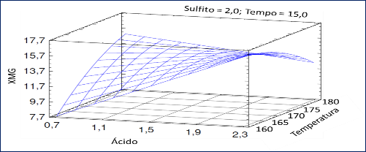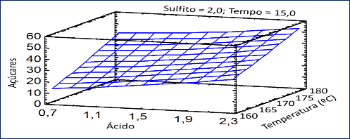
Figure 1. XMG surface response. Figure 2. Sugar surface response.
4. Conclusions
Biomass pretreatment with sodium bisulfite in acid environment alters the feedstock structure and composition, making it more suitable for enzymatic treatment. The pretreatment conditions produce an effect on the amount of total recovered sugars and on the generated degradation products. For a given sulfite load, more acidic conditions lead to higher sugar release and further material fragmentation, but also to an increase in degradation products. Moderate loads of sodium bisulfite (1%) and sulfuric acid (2.25%), release practically all hemicelluloses of the raw material. The enzymatic treatment showed to be very sensitive to the pretreatment conditions. The released sugars percentage in the enzymatic hydrolysis ranged from 6.0% to 68.9%. More acidic conditions increase the rate and extent of the enzymatic hydrolysis of the polysaccharides.
References
- V. Costa, T. Gomes, R. Simões, J. Wood Chem. & Tech. 36-1 (2019): 63-75.
- N. Gil, F.C. Domingues., M.E. Amaral, A.P. Duarte, J. Biobas. Mat. & and Bioener. 6-3 (2012) 292-298.

