CO₂ Reduction Using Glucose in Hydrothermal Media in a Continuous Plant
María Andérez-Fernández,¹* Joao P.S. Queiroz², Eduardo Pérez,¹ Ángel Martín,¹ M. Dolores Bermejo¹
¹BioEcoUVa. Research Institute on Bioeconomy. High Pressure Processes Group. Department of Chemical Engineering and Environmental technology. Universidad de Valladolid, Valladolid, 47011, Spain
² Department of Chemical Engineering, University of São Carlos, Brazil
*Corresponding author: mariaanderezfernandez@gmail.com
Highlights
- For the first time, hydrothermal reduction of NaHCO₃ using glucose has been performed in a continuous pilot plant.
- Yields to formic acid up to 63% were achieved after 10min at 300ºC in batch reactions.
- This work is a starting point to use residual biomass as reductant.

1. Introduction
Several alternatives have been proposed in order to mitigate the potential irreversible damages that can cause the increasing levels of CO₂ in atmosphere. Hydrothermal reduction is one of the most promising procedures for CO₂ conversion into chemicals, such as formic acid, by means of water at high temperature and pressure (high temperature water, HTW), which owns outstanding properties compared to those of water at room temperature, being able of acting in the reaction as solvent, catalyst or reactant. Furthermore, due to the depletion of fossil fuels, lignocellulosic biomass has been envisioned as a plausible substitute for obtaining chemicals and fuels, and HTW has been intensively studied during the past years as an excellent method for its liquefaction and conversion into useful products.
Previous works showed the possibility of combining both CO₂ reduction using several biomass derivatives, from isopropanol to lignocellulosic derivatives^{1,2}. However, these studies have been performed at laboratory scale. In this study, the hydrothermal reduction of sodium bicarbonate (NaHCO₃, as source of CO₂) and glucose conversion was carried out in a continuous pilot plant, showing the possibility to implement the process in CO₂ production focus.
2. Methods
Reactions were performed by two different procedures: batch mode and continuous mode. Batch reactions were previously described². Continuous mode reactions were carried out in a pilot plant, in which a solution of NaHCO₃ and glucose (1.0M and 0.1M, respectively) was pumped up to operational pressure and mixed with a preheated water stream, achieving an instantaneous heating of reactants. Reaction temperature (300ºC) and pressure (200 bar) were kept through the reactor, placed in an oven, and reaction was stopped by a decompression valve and cooling down the outlet. Liquid samples were analyzed using HPLC techniques. Experiments were repeated at least twice to ensure reproducibility, achieving less than 15% of deviation.
3. Results and discussion
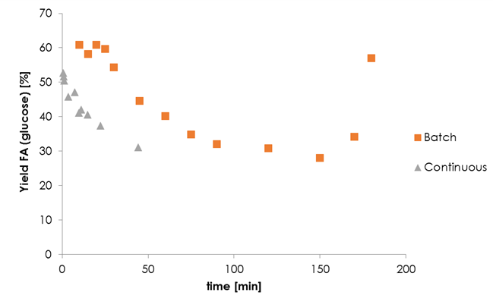
Figure 1. Yield to formic acid (referred to the initial amount of glucose) as a function of reaction time in batch and continuous reactions
As shown in Figure 1, despite the difference in the yield to formic acid achieved at the same reaction time in both reaction methods, there is a clear similitude in the trend that yield follows with reaction time. In batch reactions, yield to formic acid was higher at shorter reaction times, achieving up to 63% after 10 min in batch reactions. However, yield to formic acid decreased when reaction time, probably due to the decomposition of formic acid into CO₂ at high temperatures, achieving the minimum yield at 150 min. After this time, the yield to formic acid increased again, indicating a different mechanism for formic acid production. The same trend is addressed for results obtained in the continuous pilot plant. However, in the continuous facility it is possible to work with residence times as low as 1 minute where maximum yields in continuous are observed.
Higher yields in batch reactions can be explained by the different heating profiles in both reaction systems. While in the continuous systems the heating time for reaching 300ºC could take around 30 min, in the continuous system the heating till 300ºC is instantaneous. In both cases, byproducts obtained from glucose conversion in hydrothermal processes were acetic acid, lactic acid, glycolaldehyde and glyceraldehyde.
4. Conclusions
In this work, the hydrothermal reduction of NaHCO₃ using glucose (lignocellulosic derivative) as reductant achieved a yield to formic acid up to 63% after 10 min of reaction at 300ºC in a batch reactor. In continuous maximum yields are obtained at with residence times of 1 min, decreasing afterwards. Despite a lower yield to formic acid achieved in the continuous pilot plant, it opens the opportunity of implementing the process in those focus of CO₂ production.
Acknowledgments
This project has been funded by Junta de Castilla y León through project VA248P18. MAF acknowledges Junta de Castilla y Leon for predoctoral position (Orden EDU/520/2017). MDB thanks MINECO for Ramon y Cajal position.
References
- Z. Shen, Y. Zhang, F. Jin, RSC Adv. 2 (2012) 797-801
- M. Andérez-Fernández, E. Pérez, A. Martín, M.D. Bermejo, J. Supercrit. Fluids 133 (2018) 658-664

