Continuous In Situ Extraction of Volatile Fatty Acids in an Anaerobic Digestive System.
Gerard James¹, Robert Pott¹
1 Department of Chemical Engineering, Stellenbosch University, Western Province, South Africa
*Corresponding author: rpott@sun.ac.za
Highlights
- Liquid-liquid equilibrium studies were conducted using TOA and TBP in canola oil.
- Extraction efficiencies of VFAs differ between synthetic and AD solutions.
- Continuous extraction of VFAs allow for a pH control setup.

1. Introduction
The global demand for sustainable renewable energy has increased exponentially over the past decade. One of the approaches for renewable energy has been anaerobic digestion (AD) for the production of biogas [1]. However, AD is susceptible to acidification, which can cause the anaerobic digester to fail. Acidification is caused when there is an excessive accumulation of volatile fatty acids (VFAs) in the broth. This accumulation of VFAs reduces the pH of the broth, which can cause further methanogenic consortia decay [2]. Therefore, a more sustainable/preferred approach to AD would be to co-produce VFAs and biogas, which could be achieved by continuous in situ extraction of the VFAs from the AD process using liquid-liquid extraction (LLE). Laboratory-scaled experiments indicate a strong correlation between the degree of VFAs extracted and the pH of the solution. This implies that LLE can be applied to an AD system to control the pH of the system to prevent the accumulation of VFAs [3]. The successful implementation of an in situ pH control process can be used for the continuous removal of VFAs from an AD bioreactor. This energy efficient processing method will increase the productivity of AD and will bring additional revenue to the AD industry, through the sale of VFAs in addition to biogas.

2. Methods
LLE experiments were conducted in batch, using either a synthetic solution of VFAs or AD effluent obtained from a previous student’s work. Equal volume of solvent (organic phase) was added to the aqueous phase and vortexed for 5 minutes. The samples were kept in a shaker incubator at 37°C and 150 rpm, and left for 24 hours to ensure equilibrium was reached. The samples were centrifuged and allowed to settle for 1 hour before determining the VFA concentration in the aqueous phase by HPLC. The VFA concentration for the organic phase was calculated by mass balance. The solvent consisted of 20 vol% of the extractant (either TBP or TOA) and canola oil (diluent). The synthetic aqueous solution contained approximately 14 g/l of VFAs in distilled water. The individual concentration for acetic acid, propionic acid, butyric acid and valeric acid are given as 65%, 15%, 14%, and 6% respectively. Experiments were done in triplicate at the centre point.
3. Results and discussion
Laboratory-scaled experiments suggest that there is a significant difference between the degree of extraction in the synthetic solution and the AD effluent (Figure 1A). This could be due to certain ions present in the AD effluent [4]. A strong correlation can also be seen (from Figure 1A) between the extractive efficiency of the solvent and the pH of the solution. This is largely due to the ability of the solvent to extract VFAs below their pKa value [5]. This suggests that there is a trade-off between the amount of VFAs that can be extracted and the amount of methane production. However, an alternative solution would be to design an in situ LLE unit to control the pH of the digester to prevent acidification, shown in Figure 1B. This would be achieved by continuously removing VFAs to prevent excessive accumulation. Therefore, the digester would be able to co-produce methane and VFAs, which could bring additional income to the AD system. Similar LLE results were achieved using TOA/TBP in lamp oil and oleyl alcohol.
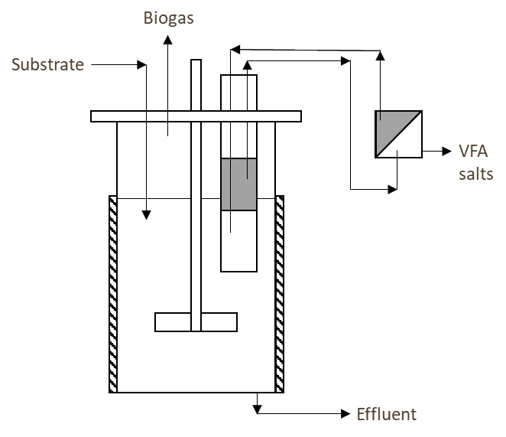
B
A

Figure 1: Liquid-liquid extraction of volatile fatty acids using 20% TOA/TBP in canola oil at various pH: (A) A degree of extraction comparison of synthetic solution and AD effluent, (B) Design of a continuous in situ extraction anaerobic digester to control pH with a back-extraction unit for solvent recovery.
4. Conclusions
Liquid-Liquid experiments were conducted using TOA/TBP in canola oil, at various pHs, to extract VFAs from a synthetic solution and AD effluent. These experiments indicate a difference between the extractability of the solvent in the synthetic solution and the AD effluent. However, this could be explained by certain ions present in the effluent. The results also indicates a strong correlation between the extractability of the solvent and the pH of the solution. As a result, a more sustainable approach would be to implement a continuous in situ extraction of VFAs using LLE to prevent product inhibition of the methanogens.
References
[1] N. A. Mostafa, ‘Production and recovery of volatile fatty acids from fermentation broth’, Energy Convers. Manag., vol. 40, pp. 1543–1553, 1999.
[2] T. Hori et al., ‘Involvement of a novel fermentative bacterium in acidification in a thermophilic anaerobic digester’, FEMS Microbiol. Lett., vol. 361, no. 1, pp. 62–67, 2014.
[3] V. . Yabannavar and D. I. . Wang, ‘Extractive Fermentation for Lactic Acid Production’, Biotechnol. Bioeng., vol. 37, pp. 1095–1100, 1990.
[4] E. Reyhanitash, B. Zaalberg, S. R. A. Kersten, and B. Schuur, ‘Extraction of volatile fatty acids from fermented wastewater’, Sep. Purif. Technol., vol. 161, pp. 61–68, 2016.
[5] E. Alkaya, S. Kaptan, L. Ozkan, S. Uludag-Demirer, and G. N. Demirer, ‘Recovery of acids from anaerobic acidification broth by liquid-liquid extraction’, Chemosphere, vol. 77, no. 8, pp. 1137–1142, 2009.

