A predictive operating control system based on Data Driven Bayesian Networks
Tomaso Vairo^{a-b}*, Margherita Pettinato^{b}, Bruno Fabiano^{b}
a ARPAL, Grandi Rischi, via Bombrini 8, 16149 Genoa Italy
b DICCA – Genoa University, via Opera Pia 15, 16145,Genoa, Italy
*Corresponding author: tomaso.vairo@edu.unige.it
Highlights
- Data Driven Models
- Process control
- Dynamic risk management

1. Introduction
In these last years, on one hand the industrial world experienced radical technological advances in connection with communication and fast-developing societal progresses requiring further research and applications for sustainability and process safety improvement. On the other hand, especially in Europe, a large part of industrial process facilities date back to the 1960’s and 1970’s. Operational errors are identified as one of the most important causes of the deterioration of the plant equipment, consequently, the operational control is one of the main systems to manage and slow down the effects of aging [1],[2]. This paper reports a first step towards the implementation of a digital twin of an upper tier Seveso plant, which can predict the behavior of the system (failures, risks, malfunctions, errors) in order to operate effectively in safety. The system, based on machine learning algorithms and Bayesian reasoning, learns continuously from the data provided by the physical system. From the operational experience of the coastal storage facility, it is clear how most of the accidental events are due to a wrong arrangement of the valves, to abnormal transfer pressures, to pump failures and pipe deterioration. This paper is focused on building an operational management system, based on the operational instruction, suitable to predict operational errors and accordingly avoiding them and thus protecting asset integrity and improve aging management.
2. Methods
Data-driven modelling can be considered as an approach to modelling that focuses on using the Machine Learning methods in building models that would complement the “knowledge-driven” models describing physical behaviour. Bayesian Networks (BBNs) were proven to be a robust probability reasoning method under uncertainty, providing a tool for incorporating these types of evidence [3]. Starting from the operating manual, various coupled Bayesian Belief Networks were built. So, the asset integrity management was an upper layer which receive and send data to the lower levels. Top events and risk assessment for the case-study of the discharge of diesel oil from a ship moored at the “Beta-ponente” pier were evaluated. The BBNs were then updated, on one hand, with the reliability parameters (results of the inspections or failures on demand - hard evidences) and, on the other one, with the evidences of the ongoing activities, which represent the likelihood coefficients (soft evidences).
3. Results and discussion
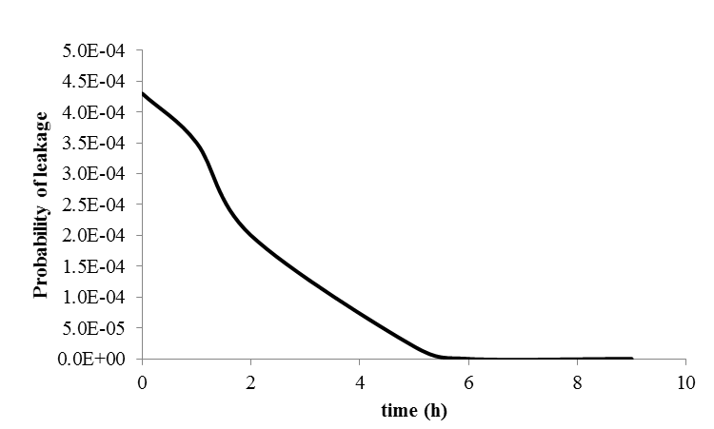
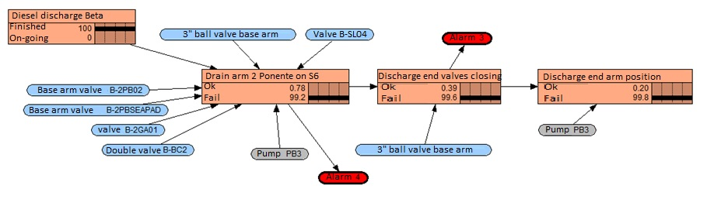
The decision-making network carried out the steps reported in Figure 1.a, which is the BBN structure as learned from the operating manual. The networks were then updated by the data from the plant (state of the valve – open, close, pressure in the pipelines), which are hard evidences and, on the other hand, with the evidences of the ongoing activities, which represent the likelihood coefficients (soft evidences).
b.
a.

Figure 1. a) Decision-making BBN for ending the diesel discharge from BETA pier; b) “Good" evidences: trend of the posterior probability failures in the collectors pit.
The combination of the risk analysis BBNs and the operational BBNs allowed to manage the whole cycle of the operations, giving, step by step, the updated probability of failure (Figure 1.b). The proposed system represents a tool that in real time allows to manage the operations focusing on safety and, combined with proper advanced analytics applications, allows anticipating what should be done to avoid upcoming incidents.
4. Conclusions
Data Driven BNs are a robust method for modeling complex systems in the probability and uncertainty analysis. The results of the application of the method allow identifying which, among the basic failures, are the most influencing on the probability of the top events occurrence, and therefore, to have a more precise indication on the maintenance priorities. Additionally, the relationship between the risk trend represented as a probability function and the evidences during the operation in progress was analyzed. So both aspects (risk management and operational management) can be improved together.
References
- Vairo T., Reverberi A.P., Milazzo M.F., Fabiano B. 2018. Aging and Creeping Management in Major Accident Plants according to Seveso III Directive. Chemical Engineering Transactions 67, 403-408.
- Kalantarnia M., Khan F., Hawboldt K. 2009. Dynamic risk assessment using failure assessment and Bayesian theory, Journal of Loss Prevention in the Process Industries, 22, 600–606.
- Yang, M. Kahn, F., Lye, L. 2013. Precursor-based hierarchical Bayesian approach for rare event estimation: a case of oil spill accident. Process Safety and Environmental Protection, 91(5), 333-342.

