e-BioPond® – added value from food industry secondary products and wastewater for a sustainable Spirulina production
Andrea Schievano¹, Francesca Girotto^{2*}, Laura Piazza²
1 e-BioCenter – DESP, Università degli Studi di Milano, Via Celoria 2, 20133, Milano (Italy);
2 DESP, Università degli Studi di Milano, Via Celoria 2, 20133, Milano (Italy).
*Corresponding author: francesca.girotto@unimi.it
Highlights
- Arthrospira platensis is sustainably grown on food industry wastewaters.
- Microbial electrochemical technologies are introduced through the e-BioPond®.
- Inorganic carbon and dissolved nutrients from the oxidized wastewater are the growth medium.

Abstract
Organic-rich secondary products of food industry and wastewaters are important sources of nutrients which should be valorised as an important resource rather than being disposed as a waste. We propose a technological application to recover these nutrients for a sustainable Spirulina (Arthrospira platensis) cultivation. Spirulina is a microalgae culture whose nutritional value and properties have attracted the attention of both researchers and industrialists. Commonly microalgae cultures are grown is an inorganic medium, which negatively affects the costs of the process. Through the alternative sustainable microalgae cultivations using the e-BioPond, microbial electrochemical technologies are introduced.
In e-BioPond (patent pending Italian deposit 102018000010683 - Nov 29th, 2018), a separation between the microalgae culture and wastewater is obtained using low-cost composite membranes (international patent pending n. 102017000110538 - ref E0116619), with the shape of pipes or panels (microbial electrochemical pipe/panel, MEP). The pore dimensions of such materials (<500 nm) is smaller than the microbial cells. This keeps the two environments separated in terms of microbial contamination.
Within the inner volume of MEPs, a conductive material acts like a bioanode, where wastewater flows and electroactive microorganisms anaerobically oxidize the organic fractions and liberate CO₂/HCO₃- and minerals (NH₄⁺, NO₃⁻, etc.). On the microalgae-side, another conductive layer acts like a biocathode, where electroactive microorganisms reduce the photosynthetic oxygen.
Simultaneously, inorganic carbon and dissolved nutrients are allowed to diffuse through the MEP to the cathodic chamber, where they are used as growth medium by microalgae.
In particular, the first lab scale tests enabled to grow around 40 mg_{TSS} L⁻¹d⁻¹ of Spirulina when the anodic chamber was fed with 12 gCOD/L. COD removal rate was 0.65 gCOD L⁻¹ d⁻¹, dissolved oxygen in the cathodic chamber ranged between 15 and 18 ppm, and the measured electrical power density was 4 W/m².
The final goal of the project would be to test the quality of the Spirulina biomass that can still be obtained from this sustainable system and, consequently, proceed with the extractions of proteins and pigments to be used in food, pharmaceutical and feed industries.
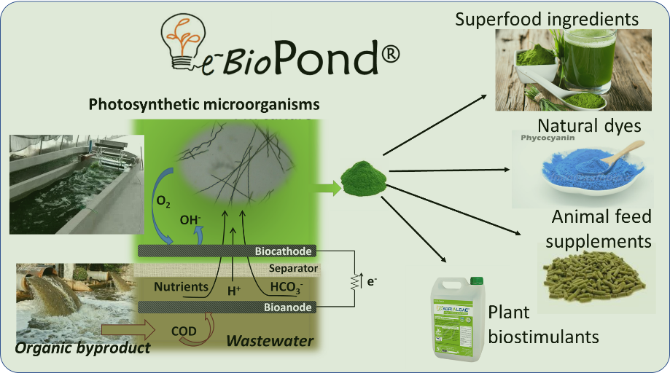
Figure 1. e-BioPond® mechanism.

