Modifying Biomaterials as Alternative Antibody Scaffold to Detect Breast Cancer Cells

Samar Damiati ^{1,2,}*, Martin Peacock ³, Rami Mhanna ⁴, Sindre Søpstad ^{3,5}, Uwe B. Sleytr ⁶, Bernhard Schuster ¹
1 Institute for Synthetic Bioarchitectures, Department of Nanobiotechnology, University of Natural Resources and Life Sciences (BOKU), Vienna, Austria
2 Department of Biochemistry, Faculty of Science, King Abdulaziz University (KAU), Jeddah, SA
3 Zimmer and Peacock Ltd, Royston SG8 9JL, UK
4 Biomedical Engineering Program, American University of Beirut, Beirut, Lebanon
5 Department of Microsystems, Faculty of Maritime and Natural Sciences, University College of Southeast Norway, Borre, Norway
6 Institute for Biophysics, Department of Nanobiotechnology, University of Natural Resources and Life Sciences (BOKU), Vienna, Austria
*Corresponding author: samar.damiati@gmx.us

Highlights
- Development of an acoustic sensor to detect breast cancer cells (MCF-7).
- Folate-modified S-layer lattice as antibody-presenting biosensing matrix
- Highly expressed folate receptor on the cell membrane of some cancer cell lines.

1. Introduction
Designing an interface matrix with good biocompatibility for efficient detection of target cancer cells is a critical step in biosensor fabrication^{1,2}. Antibody alternatives are attracting more attention to overcome limitations associated with antibody-based bioreceptors, such as high cost and density and orientation of the antibodies on the sensor surface. Exploiting biomaterials capable to present ligand molecules in an optimal density and orientation leads to the fabrication of biosensors with good selectivity and sensitivity. Excellent matrices are monomolecular arrays of protein subunits forming surface layers (S-layers), which are the common structure of the outer cell envelope on almost all archaea and many bacteria³. In this study, S-layer proteins were modified with folate to target the overexpressed folate receptors on breast cancer cells (MCF-7). Acoustic detection of MCF-7 was assessed using quartz crystal microbalance with dissipation (QCM-D) monitoring.
2. Methods
Folate was bound to the isolated S-layer protein SbpA from Lysinibacillus sphaericus CCM 2177². The QCM-D measurements were run for modified SbpA and MCF-7 cells at 27 and 37 ± 0.02◦C, respectively. To evaluate the efficiency of the developed biosensor, suspensions of MCF-7 cells at different cell densities (1 × 10⁴, 1 × 10⁵, and 5 × 10⁵ cells/mL) were exposed to the folate-modified S-layer lattice.
3. Results and discussion
The fabricated acoustic biosensor showed the efficient recognition of MCF-7 cells in situ and in real-time with a detection limit of 1 × 10⁵ cells/mL. The direct recognition of MCF-7 cells on the developed QCM-D sensor was evaluated by monitoring the shifts in the frequency (ΔF) and dissipation (ΔD) (Figure 1). The obtained results revealed a strong shift in ΔF, which is due to the binding of the MCF-7 cells to the sensor surface. Moreover, the recognition of the folate presented on the S-layer lattice by the folate receptors of the MCF-7 cells correlated directly with the MCF-7 cell density. It is known that the cell capture efficiency remarkably increases when the sensing layer has low thickness. Besides the small thickness of the S-layer lattice nanostructure, functionalization with folate instead of adding an extra antibody layer reduces the thickness of the biosensing layer. Moreover, immobilization of antibodies in proper orientation is not a matter because folate was used as an antibody alternative to detect breast cancer cells. However, the nature of the sensor surface has highly affected the interaction between the functionalized sensor and MCF-7 as cell attachment was influenced by the hydrophilicity and wettability of the modified S-layer lattice.
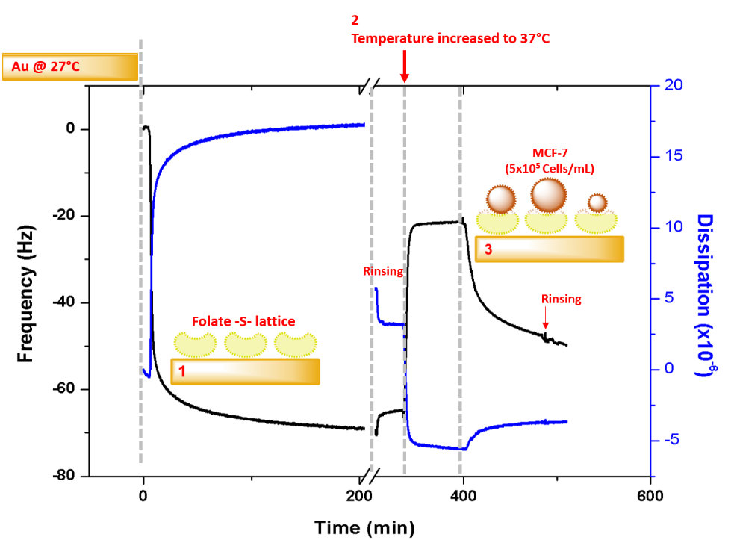
Figure 1. Development of folate-S-lattice platform and the subsequent capturing of MCF-7 cells on MCQ-D sensor.
4. Conclusions
A careful selection of biomaterials that can be assembled together to decorate sensor surfaces can improve the selectivity and sensitivity of diagnostic biosensors. S-layer proteins can be advantageous biomaterials due to their ability to self-assemble to form a nanostructure lattice, which can be easily functionalized with folate to develop functional sensors. The developed biosensor with the folate-modified S-layer lattice as alternative antibody scaffold exhibited well performance for breast cancer detection that can be exploited in future to test the cellular response to chemotherapeutic agents.
References
- B. Schuster. Biosensors 8 (2018) 40.
- S. Damiati, M. Peacock, R. Mhanna, S. Søpstad, U.B. Sleytr, B. Schuster. Sens. Actuator. B. 267 (2018) 224–230.
- U.B. Sleytr, B. Schuster, E. Egelseer, D. Pum. FEMS Microbiol. Rev. 38 (2014) 823–864.

