Influence of fluid dynamics conditions on Pb-hematite nanoparticles mass transfer coefficient in Rushton equipped stirred tank reactor
Giorgio Vilardi^{1*}, Marco Stoller¹, Nicola Verdone¹, Luca Di Palma¹
1 Dept. of Chemical Engineering Materials Environment, Sapienza University of Rome, via Eudossiana 18, Rome, 00184
*Corresponding author: giorgio.vilardi@uniroma1.it
Highlights
- A CFD model was successfully applied to predict the mass transfer coefficients
- A notable Lead sorption capacity of 38 mg/g has been obtained by nano-hematite
- The coefficients of Sh correlation from predicted and regressed k_{L} were in agreement
1. Introduction
Only recently it has been recognized that various properties of iron (hydro)oxide, such as structure and stability besides the reactivity, might vary as a function of the mean particle’s size [1]. In particular, the structure of hematite, α-Fe₂O₃, when it is of maximum particle’s size of 40 nm, becomes similar to that of goethite, α-FeOOH [1]. It has already been demonstrated that when the hematite nanoparticles mean size is close to 40 nm, the surface characteristics of the minerals are similar to those of goethite for approximately 60% [1]. These characteristics are suitable in heavy metals separation processes from wastewater streams, by means of sorption phenomenon. In this work, hematite nanoparticles (nHP) have been synthetized using a Spinning Disk Reactor, according to a previous study [2] and have been employed in a Rushton equipped agitated vessel for the removal of Pb cations in aqueous solution. The kinetics of the process has been evaluated and modelled according to a film-diffusion mass transfer model and the influence on mass transfer coefficient of impeller Reynolds number (Re_{I}) and clearance (C) were evaluated.
2. Methods
The nHP were synthetized according to a previous work [2]. The particles were characterized by a unimodal size distribution and a mean size of 46 ± 1.8 nm and a pH of zero charge of 8.3. The particles were used for the removal of Pb (50 mg/L) at a concentration of 2 g/L (the optimal concentration and pH were found according to preliminary tests) and a pH higher than the pH of zero charge (pH=9.5) to maintain the particle’s surface negatively charged and to favour the sorption of Pb. From equilibrium tests (25°C) using Pb solutions (10-100 mg/L) it has been observed that the Langmuir model was the most suitable one (compared with Freundlich and SIPS) to describe the experimental trend. The regressed isothermal parameter values were b, equilibrium constant, equal to 0.22 L/mg and q_{max}, maximum sorption capacity, equal to 38 mg/g (data not showed). The Re_{I} was varied in the range 1.4-3.5x10⁴, to maintain full turbulent conditions, by varying the impeller rotational velocity (500-1250 rpm). The dimension of the tank diameter, T (m), was 0.123 m, whereas the liquid height, H (m) was fixed equal to T. The impeller diameter, D_{i} (m), was fixed equal to 0.33T, whereas C was varied as 0.15T, 0.25T, 0.33T and 0.4T (data not showed). The number of baffles was 4 and their dimension was 0.1T. The tests were conducted with two identical reactors, and at selected time steps, the same liquid aliquot was withdrawn from the two reactors. The former was used to re-fill the first reactor, to keep its volume constant and to avoid the variation of the hydrodynamic field, whereas the second one was used for the analysis. The residual Pb concentration was measured by a Flame Absorption Spectroscopy instrument (Agilent). The kinetic experiments were interpreted according to a mass transfer model reported in a previous work, where also the fluid dynamic model (RANS + k-ε model) of the stirred tank has been described [2]. The regressed liquid film mass transfer coefficient, k_{L} (m/s), and the simulated ones (obtained from CFD simulations) were used to evaluate the empirical coefficients of the experimental relation between Sherwood, Reynolds and Schmidt numbers, as reported below:
$$Sh=\frac{{d_{p}k}_{L}}{D_{Pb}}=\left[2+α{{Re}_{p}}^{c}{Sc}^{d}\right] (1)$$
$${Re}_{p}=\frac{ε^{1/3}d_{p}^{4/3}}{υ} (2)$$
$$Sc=\frac{D_{Pb}}{υ} (3)$$
where ε (W/kg) is the specific power per unit of mass dispersed in the vessel, D_{Pb} (m²/s) is the Pb bulk diffusion coefficient and ν (m²/s) is the kinematic viscosity of the solution.
3. Results and discussion
The increase of impeller rotational velocity, i.e. Re_{I} and turbulence, favored the mass transfer phenomenon and led to a reduction of required residence time in the agitated vessel to reach the asymptote (Figure 1a). The empirical correlation among Sh, Re and Sc numbers was employed as model to fit both predicted and regressed k_{L} values and the obtained empirical coefficients (α, c and d) were quite similar, considering the accordance among the k_{L} values (Figure 1b)
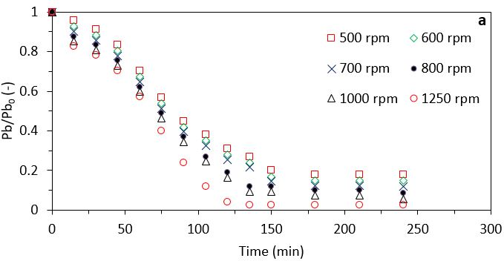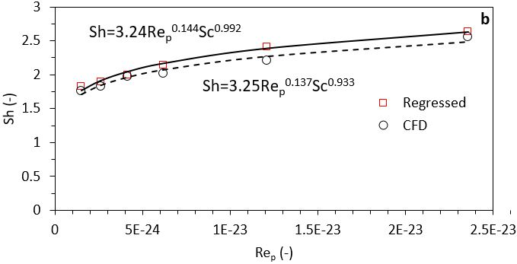
Figure 1. Pb sorption kinetics at different impeller rotational velocities (a) and Sh correlation obtained from CFD predicted and regressed k_{L} values..
4. Conclusions
The k_{L} obtained from CFD simulations were close to that obtained from data regression, as well as the empirical coefficients of Sh correlation with Re and Sc numbers. The nanohematite particles were able to sorb a considerable amount of Pb cations in alkaline environment and the process may be intensified by an accurate selection of impeller rotational velocity and reactor geometry.
References
- L. E. Barton, K. E. Grant, T. Kosel, A. N. Quicksall, P. A. Maurice, Env. Sci. Tech. 45 (2011) 3231-3237.
- G. Vilardi, M. Stoller, L. Di Palma, N. Verdone, Chem. Eng. Trans. 74 (2019) 101-106.

