Effect of the diamine monomer on the structural and desalination properties of thin film composite membranes.
Isam Aljundi¹
1 Chemical Engineering Department, King Fahd University of Petroleum and Minerals, Dhahran, Saudi Arabia.
*Corresponding author: aljundi@kfupm.edu.sa
Highlights
- Thin Film Composite membranes were prepared from different diamine monomers.
- Polypiperazine membrane showed the highest salt rejection.
- Strong correlation was found between the operating temperature and the salt rejection.
- Increasing the operating pressure or the feed velocity have positive impact on the permeate flux.

1. Introduction
Interfacial polymerization (IP) is the most important method for commercial fabrication of thin-film composite (TFC) RO and NF membranes. The first interfacially polymerized TFC membranes were developed by Cadotte et al. [1] and represented a breakthrough in membrane performance for RO applications. Since then, several methods have been adopted to improve the performance of the polyamide selective layer in terms of enhancement of permeate flux, salt rejection, fouling and chlorine resistance. Among those methods is to change the diamine monomer used in the IP aqueous phase. However, a systematic study on the effect of the side chain of on the aromatic or cycloaliphatic diamine monomers is lacking in the literature. In this project, the effect of the diamine side-chain was investigated in terms of the structure and desalination properties (salt rejection and permeate flux) of the membrane.
2. Methods
The selective polyamide layer of the membrane was prepared by reacting the diamine (2 wt% in distilled water) with TMC in hexane (0.2 g TMC in 100 mL hexane) on top of a previously prepared polysulfone layer. The membranes were dried in a muffle furnace at 75 °C for 5 min for further crosslinking.
The permeate flux and rejection were measured using a cross-flow setup with an effective membrane area of 14 cm2 at different operating conditions of temperatures and pressures. Four diamine were used: Piperazine (PIP), m-xylenediamine (XLN), 1,4-Bis(3-aminoprpyl)piperazine (DAPP), 1-(2-Aminoethyl)piperazine (EAP).
In addition, the effect of operating conditions (T, P, feed velocity, and salt concentration) on the performance of the membranes were also investigated.

3. Results and discussion
The surface morphology of the prepared membranes is shown in Figure 1. It reveals rough surfaces with typical ridge and valley structures of polyamide membranes.

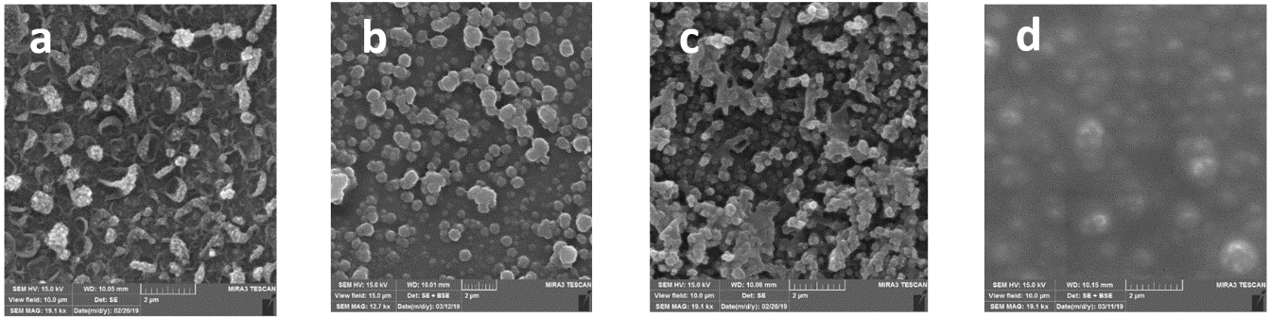
Figure 1. SEM images of the (a) PIP, (b) EAP, (c) XLN, (d) DAPP membranes.
The performance of each membrane was evaluated using different salts. PIP membrane showed the best performance among all membranes where the sulfate rejection was higher than 97%. However, the rejection of sodium chloride was about 73% which is considered high for a nano-filtration membrane. The overall performance was poor for the XLN membrane, however it showed the lowest rejection of NaCl which is advantageous in some applications such as the treatment of fracturing fluids.

Figure 2. Salt rejection of membranes prepared from different diamine monomers.
4. Conclusions
Four different diamines were used to prepare nanofiltration membranes. The best performing membrane was the one with PIP monomer which showed high rejection along with excellent permeate flux. The hydrodynamics study of the desalination process showed a strong correlation with Reynold’s number. In addition, results showed that increasing the operating pressure and Temperatures has positive impact on the permeate flux. However, the salt rejection deteriorated as the temperature increased. Changing the salt concentration in the feed water did not show significant effect on the membrane performance.
References
- J. Cadotte, R. Forester, M. Kim, R. Petersen, T. Stocker, Desalination 70 (1988) 77–88.

