Efficient depletion of a fibroblast growth factor 2 variant during polishing using hydrophobic interaction chromatography
Dominik Sauer¹, Magdalena Mosor¹, Alois Jungbauer^{1,2}, and Astrid Dürauer^{1,2*}
1 Austrian Centre of Industrial Biotechnology (ACIB), Muthgasse 11, 1190 Vienna, Austria
2 Department of Biotechnology, University of Natural Resources and Life Sciences Vienna, Muthgasse 18, 1190 Vienna, Austria
*Corresponding author: astrid.duerauer@boku.ac.at
Highlights
- This two-step purification delivers FGF-2 from E. coli with distinctive quality standards
- Polishing by HIC efficiently depletes a N-terminally degraded FGF-2 variant
- The full length product is recovered in the eluate with 100% yield
- HCP and dsDNA are depleted under their limit of quantification

1. Introduction
Fibroblast growth factor 2 (FGF-2) stimulates cell proliferation and differentiation via binding to the tyrosine kinase receptor and is an important therapeutics applied for tissue repair in regenerative medicine and for cancer treatment [1,2]. It is successfully produced by overexpression in the bacterial host E. coli [3,4]. During biopharmaceutical production a consistent product quality is of high importance. Typically, during capture the majority of process related impurities are depleted due to their properties which are highly differing from the product ones. In contrast, the polishing step is responsible to remove product variants of high similarity.
2. Methods
In the present study a two-step purification process for FGF-2 from clarified E. coli homogenate was developed. As capture step an ion exchange process was applied. The relative amounts of target product, host cell proteins (HCPs), dsDNA, endotoxin, monomer content, and high molecular weight impurities differed along the elution peak [4]. This information on the quality of the eluate is currently only available from time and labor intensive offline measurements. The holding step implemented for this purpose lead to degradation of FGF-2 generating product-related impurities. For robustness and quality assurance a polishing method based on HIC was integrated to assure the depletion of this process-related impurities and the separation of those product variants. The ion exchange eluate was purified using the HIC resin Toyopearl® Hexyl-650C. Its performance was compared to several other HIC resins regarding their impurity depletion.

3. Results and discussion
Toyopearl® Hexyl-650C performed superior compared to the other candidates. The product variants were effectively separated with a step yield of 100%. The HCP and dsDNA content after the HIC step was below the limit of quantification. Endotoxin content was depleted to 0.02 EU/µg FGF-2. The quantification of product variants was performed by an analytical ion exchange HPLC method.
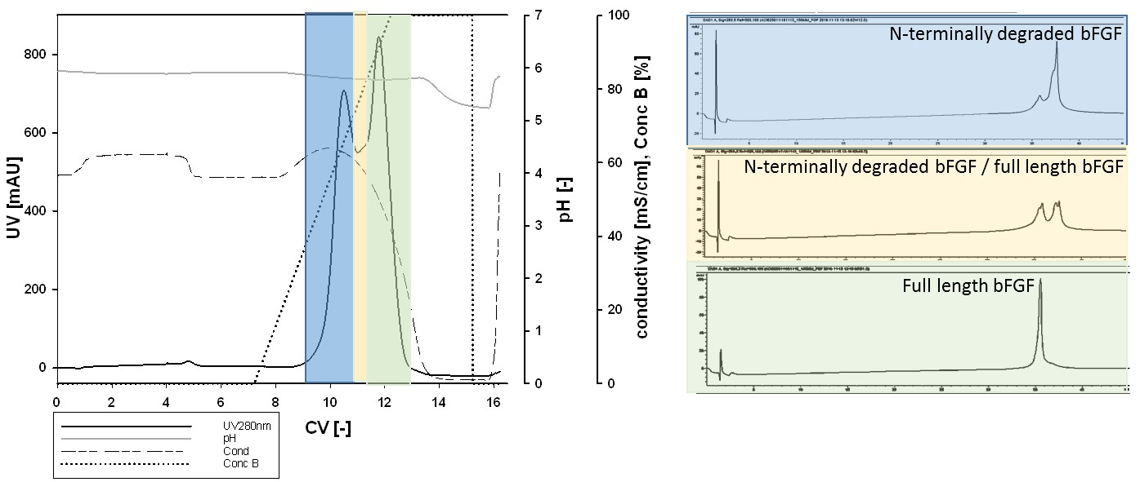
Figure 1. The HIC resin Toyopearl-Hexyl-650C (Tosoh, Japan) enabled the efficient separation of the N-terminally degraded product variant from the full length basic fibroblast growth factor: HIC chromatogram, elution was performed within 5CV with a linear gradient from 0 to 100% buffer B containing 10 mM Na-phosphate (left); Analysis of HIC eluate by IECX HPLC with gradient pH 7 – 10.5 (right)
4. Conclusions
The established polishing method by HIC enables the efficient depletion of the degraded product variant only differing in the loss of eight N terminal amino acids from the full length FGF-2. Toyopearl® Hexyl-650C resin separated the degraded product variant effectively while recovering the full length product with 100% yield. Implementing this polishing step into a two-step purification process started with a CIEX capture step a highly effective separation for FGF-2 was developed which meets distinctive quality standards defined by regulatory bodies. HCP and dsDNA were depleted under their LOQ.
References
1. Burgess, W. H., Maciag, T., The heparin-binding (fibroblast) growth factor family of proteins. Annu Rev Biochem (58) (1989) 575-606.
2. Nunes, Q. M., Li, Y., Sun, C., Kinnunen, T. K., Fernig, D. G., Fibroblast growth factors as tissue repair and regeneration therapeutics. PeerJ (4) (2016) e1535, doi: 10.7717/peerj.1535
3. Soleyman, M.R., Khalili, M., Khansarinejad, B., Baazm, M., High-level expression and purification of active human FGF-2 in Escherichia coli by codon and culture condition optimization, Iranian Red Crescent Medical Journal 18(2) (2016), doi: 10.5812/ircmj.21615
4. Sauer, D.G., Mosor, M., Frank, A.C., Weiss, F., Christler, A., Walch, N., Jungbauer, A., Dürauer, A. A two-step process for capture and purification of human basic fibroblast growth factor from E. coli homogenate: Yield versus endotoxin clearance, Protein Expr Purif (153) (2019) 70-82.

