Microwave processing of hydrocolloid membranes made with agro-industrial orange waste
Helbert Antonio Portugal Ochoa ^{1, *}, Luis Felipe Miranda Zanardi ¹
1 San Agustin National University, Arequipa, Peru
*Corresponding author: helbertportugal@gmail.com
Highlights
- Microwaves.
- Orange waste.
- Hydrocolloid membranes.

1. Introduction
The application of microwaves in the processing of different materials has a great potential because the dipolar polarization mechanism associated with it speeds up the heating and also different chemical reactions [1]. On the other hand, the agro-industrial residues of orange have in their composition mainly pectin, cellulose, hemicellulose and lignin [2], which can be used instead of being treated as waste.
2. Methods
Different solutions containing glycerin, pectin and orange waste, according to a mixture design, were homogenized and subjected to microwave radiation (2.45 GHz) for 2 minutes. After the radiation treatment, semi-rigid membranes were obtained, which were evaluated by tensile test (ASTM D638-14). In addition, the molecular structure of both the solutions and the resulting membranes were evaluated using FTIR infrared spectroscopy.
3. Results and discussion
Through infrared spectroscopy, important changes were observed in the hydroxyl group band after exposure to radiation. The presence of glycerin in high concentrations favored the formation of intermolecular hydrogen bonds, which was evidenced in low energy OH bands. On the other hand, the presence of high concentrations of pectin or lignocellulosic residues meant high energy bands, which implied that few intermolecular forces were generated due to the presence of branches in the polymer chains, mainly in the residues. In the mechanical evaluation, the tensile strength and the nominal strain at break were obtained as responses. The strength was greater in the presence of pectin and lower when the proportions of citrus or glycerin residues increased, this because the glycerin tends to increase the intermolecular spaces and weakens the polymer-polymer forces. The strain was more dependent on the presence of residues than glycerin. The higher the residue concentration, the lower the deformation. These results are explained by the weak interaction between glycerin and polymer chains with branches.
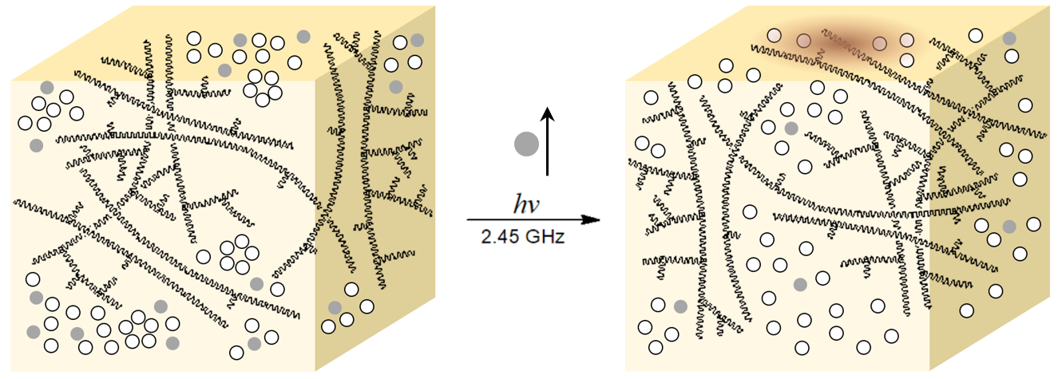
Polymer chain Glycerin Water
Figure 1. Effect of microwave radiation in mixtures of glycerin and orange waste.
4. Conclusions
Microwave processing of solutions containing pectin, glycerin and orange waste generates hydrocolloid membranes with acceptable mechanical properties because the radiation improves intermolecular forces.
References
- P. Lidström, J. Tierney, B. Wathey, J. Westman, Tetrahedron 57 (2001) 9225-9283.
- G. Aravantinos, V. Oreopoulou, C. Tzia, C.D. Thomopoulos, LWT 27 (1994) 468-471.

