Synthesis and Characterization of CaCO₃ Nanoparticles by Sol-gel Citrate Method: Effect of Citric Acid Concentration
Merve Şener, Çağla Gül Güldiken, Hasan Ferdi Gerçel
Department of Chemical Engineering, Eskişehir Technical University, Eskişehir 26555, Turkey
*Corresponding author: hfgercel@eskisehir.edu.tr
Highlights
- Cost-effective and eco-friendly CaCO₃ nanoparticle synthesis process was developed.
- Calcination temperature was decreased using a sol-gel citrate method.
- Effect of citric acid concentration on particle size and morphology were investigated.
1. Introduction
CaCO₃, one of the most abundant minerals in nature, is used in wide range of engineering applications. CaCO₃ nanoparticles can be utilized as reinforcing agents in polymer matrix nanocomposites to enhance the mechanical properties and reduce cost [1, 2]. In the present study, CaCO₃ nanoparticles were synthesized via a sol-gel citrate method. Citric acid (CA) was used an organic additive in the CaCO₃ nanoparticle synthesis to achieve a homogeneous size distribution and smaller sized CaCO₃ particles. CA is non-toxic and non-carcinogenic contrary to the hydrazine-based additives which are commonly used for the same purposes. The chemical structures and morphologies of the synthesized nanoparticles were analyzed by Fourier transform infrared spectroscopy (FTIR) and scanning electron microscopy (SEM), respectively.
2. Methods
1 M aqueous solutions of Ca(NO₃)₂.4H₂O, as the precursor, were prepared. CA was added to the solution at weight ratios of 0.25 and 1.5 based on the weight of Ca(NO₃)₂ and heated to 70ºC under constant stirring. Chemical reaction between the precursor and CA was conducted at 70°C for 24 hours. The resulting homogenous solution, obtained from the hydration reaction, was dried at 125°C for 24 hours. The porous and quite swelled product were grinded and then calcined at 600°C for 5 hours. Finally, the calcinated samples were washed several times with deionized water by ultrasonic mixing, centrifuged and dried at 105ºC for 12 hours. The synthesized nanoparticles named CaCO₃_0.25CA and CaCO₃_1.5 CA.
The chemical structure of the synthesized nanoparticles was characterized in KBr disks by using a Perkin Elmer Frontier FTIR spectrometer between 400 and 4000 cm⁻¹. The morphology and particle size of the samples were investigated by using a scanning electron microscope (Carl Zeiss/Supra 40VP) at an accelerating voltage of 15 kV. All the samples were dried and sputter coated with Au/Pd prior to SEM analyses.
3. Results and discussion
Based on the FTIR spectra of the CaCO₃_0.25CA and CaCO₃_1.5 CA nanoparticles, shown in Figure 1, the wide band at 3645 cm⁻¹ arises from the stretching mode of hydroxyl groups of Ca(OH)₂. The weak peak at 2885 cm⁻¹ are assigned to the long alkyl chains of CA. The strong peak observed at 1428 cm⁻¹ corresponds to the C=O stretching vibrations. The sharp peaks at 875 and 712 cm⁻¹ indicates the existence of carbonate group. The FTIR spectra of both nanoparticles, which are differing in CA concentration, are consistent. This result shows that increasing CA concentration does not damage the chemical structure of the synthesized nanoparticles [1-3].
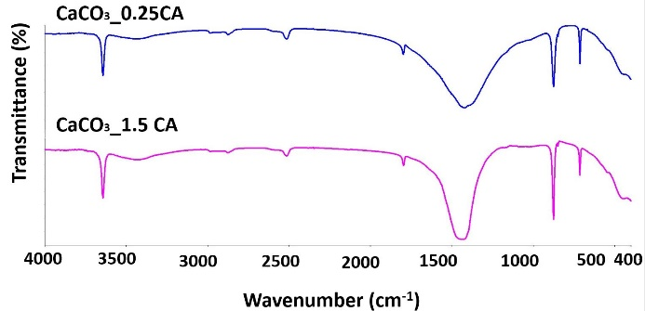
Figure 1. FTIR Spectra in Different CA Concentrations

SEM micrographs of the CaCO₃_0.25CA and CaCO₃_1.5 CA nanoparticles at 20kX magnification are presented in Figure 1(a, b). It is clearly seen that the particle size decreases with the increasing CA concentration. However, the decrement in particle size leads to aggregation of nanoparticles.

a) b)

Figure 2. SEM micrographs of the (a) CaCO₃_0.25CA (b) CaCO₃_1.5 CA nanoparticles at 20kX magnification
4. Conclusions
The chemical structure of the nanoparticles has not been harmed by the addition of CA up to a mass ratio of 1.25 to the precursor. The upper limit for CA mass ratio in synthesis process can be determined in further studies. Based on the result that the particle size decreases with increasing CA concentration during the synthesis process, it can be deduced that nanoparticles with desired sizes can be synthesized by changing the CA concentration. In future studies, different surfactants can be used in the synthesis process to prevent nanoparticle agglomeration due to the particle size decrement.
References
[1] D. Uzunoğlu, A. Özer, IJARSET 2(3) (2018) 245-253.
[2] A. Barhoum, G. Van Assche, A. S. H. Makhlouf, H. Terryn, K. Baert, M.P. Delplancke, H. Rahier, Cryst. Growth. Des. 15(2) (2015) 573-580.
[3] Ghiasi, A. Malekzadeh , Cryst. Res. Technol. 47 (2012) 4 471 – 478.

