Effect of Organo-Modified α−Sepiolite Content on Thermal and Mechanical Properties of Poly(ethylene oxide) Composite Films.
Çağla Gül Güldiken, Hasan Ferdi Gerçel
Department of Chemical Engineering, Eskişehir Technical University, Eskişehir 26555, Turkey
*Corresponding author: hfgercel@eskisehir.edu.tr
Highlights
- α-Sepiolite is modified with poly(ethylene glycol) through hydrogen bonding interactions.
- Thermal stability of the composite is improved with modified α-sepiolite.
- Tensile properties are enhanced by modified clay addition to the structure.

1. Introduction
The incorporation of inorganic additives into a polymer matrix can improve the properties such as thermal stability, mechanical strength, ion exchange abilities, and solvent resistance [1,2]. Recently, clays have become increasingly popular as inorganic fillers in the field of organic-inorganic hybrid materials due to their superior properties such as their high surface area for polymer–filler interactions, small particle size, lightweight and low cost. In the present study, organo-modification of α-sepiolite, a natural clay, was performed using poly(ethylene glycol) (PEG) to improve the compatibility of the inorganic phase with the organic matrix. The modified α-sepiolite was introduced in the poly(ethylene oxide) (PEO) matrix to develop a composite film. The effect of modified clay additive on the mechanical and thermal properties was studied by comparing with the neat PEO film.
2. Methods
α-Sepiolite (Eskisehir/Turkey) was dried at 105°C for 24 hours and then ground into powder. PEG (Mw=950–1050) and α-sepiolite (1:1, wt/wt)) were added to water-ethanol (99.8%) (1:2, v/v) solution and ultrasonicated for 30 minutes. The resulting mixture was stirred overnight. Finally, the solution was poured into a petri dish, dried at 105°C for 24 hours and ground into powder. The obtained organo-modified clay was named PEG_α-Sepiolite. PEG_α-Sepiolite was distributed homogeneously in ethanol by ultrasonic mixing. PEO (Mw=40000) was dissolved in water (10%, w/v) under constant stirring at 70°C for 24 hours. The resulting transparent and viscous PEO solution was transferred into a beaker and the previously prepared PEG_α-Sepiolite/ethanol mixture was added gradually under ultrasonic mixing. The obtained PEO solution with 1% PEG_α-Sepiolite additive was casted onto a flat glass substrate (20 cm x 20 cm) and dried at 50°C for 24 hours. The resultant semi-transparent film named PEO/PEG_α-Sepiolite composite film. Neat PEO film was prepared following the same film preparation procedure except for the PEG_α-Sepiolite addition for comparison purposes and named PEO_control film. FTIR spectra of neat and PEG_α-Sepiolite samples were recorded as KBr pellets using a Frontier spectrometer (Perkin Elmer). Thermogravimetric analysis (TGA) of the film samples was performed using a STA6000 thermogravimetric analyzer (Perkin Elmer) with a heating rate of 10ºC/min, under flowing nitrogen at a rate of 50 mL/min. The mechanical tests of the films were carried out using an Instron Mechanical Testing Machine 5581 test system following ASTM D882 method.
3. Results and discussion
FTIR spectra of the natural α-sepiolite and PEG_α-Sepiolite are presented in Figure 1. The shoulder, observed at 3690 cm⁻¹ in the FTIR spectrum of neat α-sepiolite, is assigned to the -OH stretching vibrations of Mg-OH constituent of α-sepiolite and shifted to 3685 cm⁻¹ with PEG modification. The wide band at 3570 cm⁻¹, indicating the -OH stretching vibration of bound water, shifted to 3566 cm⁻¹ with PEG modification. The weak bands, observed at 1211 and 1018 cm⁻¹ in the FTIR spectrum of neat α-sepiolite, corresponding to the stretching of Si–O in the Si–O–Si groups [3] disappeared after organo-modification with PEG. A new peak, indicating C-H stretching, was formed at 2932 cm⁻¹ after the organo-modification. These differences may be resulting from the formation of new hydrogen bonding interactions between surface hydroxyl groups of α-sepiolite and PEG molecules, indicating the compatibility of α-sepiolite with PEG. Based on the TGA thermograms of the PEO_control and PEO/PEG_α-Sepiolite composite films, shown in Figure 2, both films represent a single-step thermal degradation behavior and the decomposition temperature increases from 355ºC to 370ºC with α-sepiolite incorporation. Tensile strength was increased from 12 MPa to 18 MPa and Young's modulus increased from 240 MPa to 360 MPa by α-sepiolite addition to the structure.
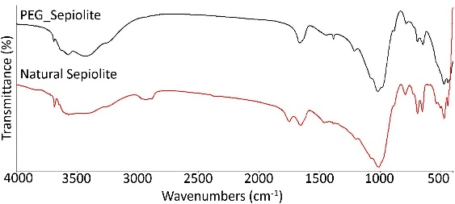 | 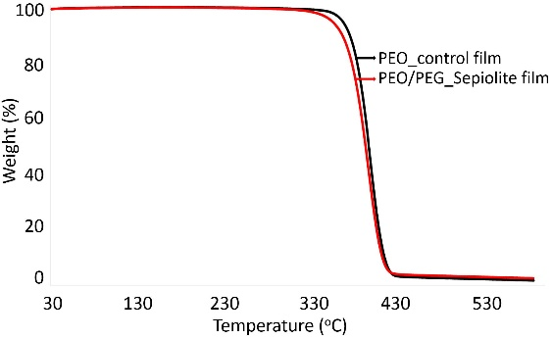
Figure 1. FTIR spectra of the natural α-sepiolite and PEG_α-Sepiolite. | Figure 2. TGA thermograms of the PEO_control and PEO/PEG_α-Sepiolite composite films.
4. Conclusions
Based on the newly formed, disappeared, and shifted frequencies in the FTIR spectra after the modification process, it can be concluded that the organo-modification was achieved. α-Sepiolite, distributed at 1% by weight in the polymer matrix, has improved the thermal stability and mechanical strength of the resulting composite material. Considering the biocompatibility characteristic of PEO and α-sepiolite, potential use of the developed composite film in biomedical fields such as drug release and tissue engineering can be investigated in further studies.
Acknowledgements
This research was supported by Eskisehir Technical University Scientific Research Projects Committee. (Project No: 1709F507)
References
- Ş. Uğur, Ö. Yargi, A. Elaissari, Ö. Pekcan, Macromol. Symp. 281 (2009) 168–173
- H. M. Wilhelm, M. R. Sierakowski, G. P. Souza, F. Wypych, Carbohydrate Polymers. 52 (2003) 101-110.
- M. Alkan, G. Tekin, H. Namli, Microporous and Mesoporous Materials. 84 (2005) 75-83.

