All in One - Advanced technologies for complex low-cost microfluidic devices in glass, silicon and quartz
Klaus Kadel¹, Alexander Schilling¹, Jing Becker², Claas Müller²
1 Affiliation and address Little Things Factory, D-56479 Elsoff, GERMANY;
2 Microfabrication Center, IMTEK, Department of Microsystem Engineering,
University of Freiburg, Georges-Koehler-Allee 103, D-79110 Freiburg, GERMANY
*Corresponding author: k.kadel@ltf-gmbh.de
Highlights
- Multi level laser etching in glass silicon and quartz [Calibri 10].
- 3-D shaped nozzles with six levels in the bottom and the top layer
- Hermetically sealed electrical connectors through the glass

1. Introduction
The controlled generation of liquid micro droplets with uniform characteristics will be one of the future key technologies in research and in industrial production. The Little Things Factory covers the whole portfolio to set up new functionalities for microfluidic systems in glass and we describe recent innovations in this field.

We will show, what are state of the art manufacturing methods to make chips out of glass or quartz with different levels and different types of structures in one setup. Figure 1 shows an example of such a multilevel structure, with grids of posts and cavities, mixing structures and additional structures for detection.

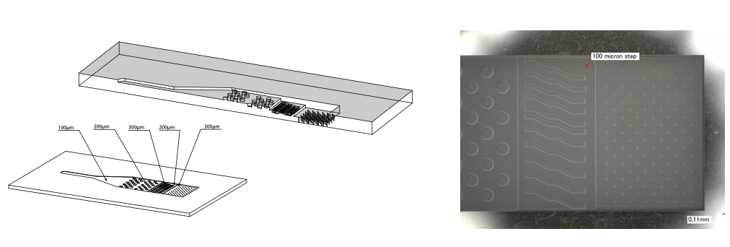
Fig. 1: Multilevel structure with five different levels and various types of structures realized in glass

2. Advanced methods of droplet generation
Figure 2 shows a prototype of the flow focusing chip (FFC). This chip was designed to modify the droplet diameter over the flow ratio and to create swarms of droplets. The FFC consists of a droplet generator combined with a reaction zone. The droplet generator of this chip consists of two 3-D laser etched nozzles, and the microchannels inside the inlet and outlet nozzles have been etched to different levels into the bottom as well as the top glass layer. In this work, six different levels have been applied to define the inlet and outlet nozzle structures in the bottom and the top glass layer.
3. Results and discussion
For a flow rate of 1,6µl/min the pressure loss in the central line was measured to 3.3bar, for the lines for the sheath flow to 2.6bar. The droplet size measured for different mixing ratios can be seen in figure 2. We will present how the droplet size can be modified by changing the flow rate in the central line or for the sheath flow and what happens when changing from Toluene to Cyclohexane.
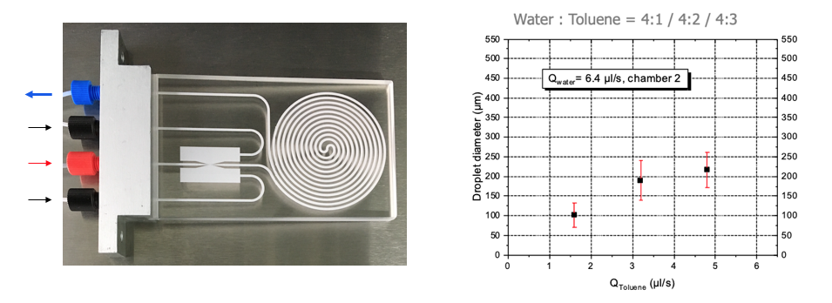
Fig. 2: Flow focusing chip with a droplet generator on the left and the reaction zone on the right. The right picture shows the measured droplet size for different mixing ratios of Toluene and Water

Through Glass Vias (TGV)
We will introduce new possibilities to combine microfluidics with hermetically sealed electrical connectors for various applications that needs electrodes in contact with fluids or electrodes isolated from fluids. The connectors are made of highly conductive silicon to have hermetically sealed feed troughs with a conductivity in the range of 0.01 to 0.02 Ωcm. Figure 3 show possible layouts (left side) and an example how to integrate such a TGV into a fluidic application. So, one can use the two orders of magnitude higher thermal conductivity of silicon compared to that to glass to have different temperatures on the chip, or one can heat or cool a fluid or run the chip on different temperature levels.
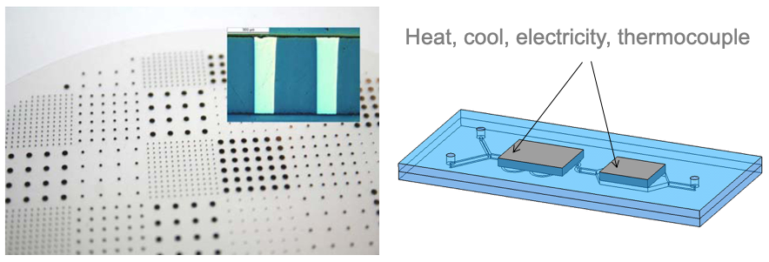
Fig. 3: TGV in glass and cross section (above) and integration in a fluid chip (below)

The conductive silicon could be in contact with the fluid, or not, just ending close to a channel or besides, so the silicon is isolated by a layer of glass to use the electric field. Possible applications may be the steering of fluids, catching cells, electrophoresis or electro kinetic actions. So, integrating a TGV in a fluidic device gives access to digital microfluidics.

