Recovery of cobalt from acidic solutions by ion exchange through electrodialysis.
Gerardo Cifuentes¹, Gonzalo Muñoz, Belén Garrido, *Jorge Manríquez¹, Magdalena Cifuentes-Cabezas²
¹ Full Professor, Metallurgical Engineering Department, University of Santiago of Chile, Avda. L. B. O’Higgins 3363, Estación Central, Santiago, Chile. ² Department of Chemical and Nuclear Engineering, University Research Institute for Industrial, Radiophysical and Environmental Safety (ISIRYM), Universitat Politècnica de València, C/Camino de Vera s/n, 46022 Valencia, Spain
*Corresponding author: jorge.manriquez@usach.cl
1. Introduction
During copper extraction processes from oxidized minerals to produce cathodic copper the cobalt is accumulated in the refine and in leaching piles by means of mechanical drag and electrolytic purges, reaching concentrations of 60 to 110 mg/L. However, during the electrodeposition process, cobalt salts are added to the electrolyte to stabilize the surface of lead anode with a layer of $PbO_{2}- β$, improving its quality and, consequently, reducing the formation of ladder slats that provide an increase in the cathodic quality. This article presents the results of study of cobalt recovery through electrodialysis using ionic exchange membrane cationic.
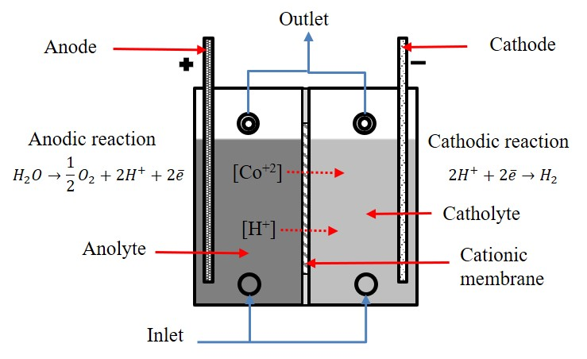
2. Methods
Figure 1. Scheme Electrodialysis cell
The electrodialysis circuit consists of a cubic cell of two chambers with a cation exchange membrane were placed between the electrodes, at a distance de 10 cm, to form a separate anolyte and catholyte chambers (see Figure 1). Catholyte of volume 1 dm⁻³ containing 1 to 1,6 mol dm⁻³ $H_{2}SO_{4}$ and two anolytes 3 dm⁻³ in volume containing, the first: cobalt ions at a concentration of 100 mg dm⁻³ and 0,1 mol dm⁻³ HCl and the second: cobalt ions at a concentration of 100 to 1,000 mg dm⁻³ and 0.1 to 0.5 mol dm⁻³ $H_{2}SO_{4}$. Catholyte and anolyte were circulated to each chamber using separate pumps. The flow rate of both electrolytes was kept constant at 1 dm⁻³ min⁻¹. A stainless-steel cathode was used. The electrolytes are fed from the lower and the outlet is from top by gravity.
Anodic overpotential curves (SPA) to determine the material of anodic electrode were realized (graphite or titanium) in order to avoid the formation of chlorine gas. To determine the current intensity of work potential-current curves (CVC) were realized to the cationic membrane.
Finally, electrodialysis test was carried out for 8 h at 25 and 40°C and different current intensity
depending on the results of the SPA and CVC curves, the parameters are show in Table 1.
Table 1 Parameters of electrodialysis test
Test | Current  intensity (A) | T (°C) | Acid in anolyte  (M) | $H_{2}SO_{4}$ in Catholyte  (M) | Cobalt  (mg dm⁻³)
1 | 0.02 | 25 | 0.1 HCl | 1 | 100
2 | 0.02 | 25 | 0.1 $H_{2}SO_{4}$ | 1.6 | 100
3 | 0.02 | 25 | 0.1 $H_{2}SO_{4}$ | 1.6 | 1,000
4 | 1.5 | 40 | 0.5 $H_{2}SO_{4}$ | 1.6 | 1,000
5 | 3 | 40 | 0.5 $H_{2}SO_{4}$ | 1.6 | 1,000

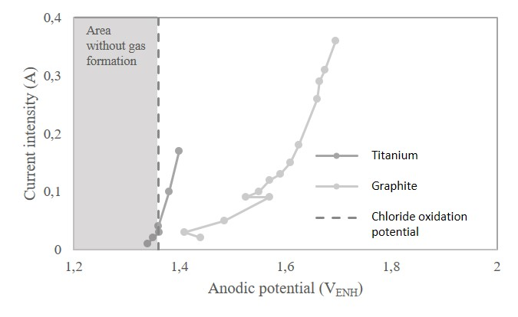
3. Discussion and Conclusions
Figure 2. Anodic overpotential for titanium and graphite anode, and the area without gas formation.
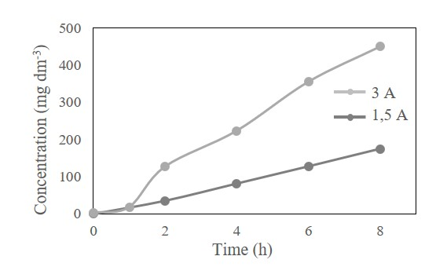
The results of SPA curves (Figure 2) indicate that there is no gas formation to 0.03 A, using titanium anode while if using graphite anode there is gas formation according to the equation $2Cl^{-}→Cl_{2}+2\overline{e} \left(E°=-1.36V_{ENH}\right)$. On the other hand, the CVC curves indicate that there was not limit current in the 0 to 3 A section for all solutions (Figure 3). Then, a test was performed at 0.02 A in chloride medium (test 1), however, no cobalt traces were found in the catholyte. The test 2 and 3 was performed at 0.02 A in sulphate medium to different cobalt concentrations, but no cobalt traces were found in the catholyte.
Figure 3. Profile concentration of cobalt in catholyte, mol dm⁻³.
The test 4 and 5 were developed using a cationic membrane with less electrical resistance, it can see from in figure 3 that it was found cobalt in the catholyte in concentrations of 173.3 and 449.2 mg dm⁻³, respectively. In conclusion, is possible recovery cobalt from acid solutions through ionic exchange with recovery rate of 21.7 and 55.85 mg dm⁻³ h⁻¹ to 1.5 and 3 A, respectively with 0.45 and 0.48 Wh mg⁻¹ specific energy consumption. These results give foot to continue the study of this processes and achieve recoveries on 1,000 mg dm⁻³, optimizing the process with the use of electrodes and membranes of less electrical resistance.

References
- Cooper, W.C.,1985. Advances and future prospects in copper electrowinning, 789-805.
- Boss, F. E. E. et.al., 1927. Means for protecting storage battery grids. US Patent No. 1,826,724.
- Krivolapova V. et. al., 1941. An investigation of the corrosion of lead in oxidizing media, 335-341.
- Koch,D.F.A., 1959. The effect of cobalt on a lead anode in sulfuric acid. Electrochim, 32-38.
- Collana M., 2009. Desarrollo de módulos de electrodiálisis para la desalinización de aguas salobres, determinación de parámetros físicos y evaluación experimental de modelo difusional, Lima, Perú.
- J. J. Krol, M. Wessling, H. Strathmann, 1991. Concentration polarization with monopolar ion exchange membranes: current-voltage curves and water dissociation, 145-154.
- Cifuentes, G., et al. , J. Chil. Chem. Soc. 60 (2015) 4, 2711-2715.
- Rubinstein y Shtilman, 1979. Voltage against current curves of cation-exchange membranes, 231-246.

